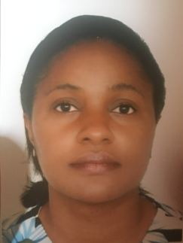
Title: Epidemiological profile and therapeutic itinerary of women with breast cancer in three first category hospitals in Yaounde
Name: Esso Endallè Linda
Department of Family Health, Ministry of Public Health, Yaounde Cameroon

Breast cancer is responsible for 10.7 deaths per 100,000 women in Cameroon. This study aimed at establishing the epidemiological profile and determining the therapeutic itinerary of women with breast cancer in three main hospitals in Yaounde.
A cross-sectional descriptive study was carried out in three main hospitals in Yaoundé from May to July 2017. A pre-tested questionnaire was administered to every women with breast cancer. Data were collected on socio-demographic characteristics, risk factors, period of first consultation, anatomo-pathological grade of the cancer and therapeutic itinerary. Chi square test was used for comparison of proportions and odd ratios were generated with multivariate logistic regression models.
Of the 158 patients interviewed, median age was 47 years. Family history of breast cancer was found in 27% (n=42) of patients. Invasive ductal carcinoma accounted for 58% (n=92). Diagnosis was done at stage 3 of the disease in 69% (n=109) of cases and 51% (n=80) had their first consultation at least 3 months prior to diagnosis. Fifty-four percent (n=86) had interrupted treatment, of which 78% (n=67) were due to financial reasons. Traditional medicine was used by 49% (n=42) of women interrupting medical treatment. Residency in urban area was a significant favorable factor for early first medical consultation (OR=4.0, p=0.03).Higher education and monthly income were protective factors of discontinuing medical treatment (OR=0.3 and 0.3, p=0.04 and 0.02).
Diagnosis is made at an advanced stage of the disease because of delayed first medical consultation. Sustainable funding mechanism for treatment should be put in place. (247 words)

Biography

Dr Esso Linda is a general practitioner since 2006 with a master of public health since 2012. She has worked in a department of gynecology and obstetrics for two years and is currently Head of Maternal Health Service at the Department of Family Health of the Ministry of public health of Cameroon. As such she is responsible for all the activities related to women's health: maternal and perinatal death surveillance and response, campaign for repairing obstetric fistula, family planning, training of providers to obstetric and neonatal care. (87 words)
Presenting author details
Full name: Esso Endallè Linda
Contact number: (237) 699202587
Twitter account: Linda Esso
Linked In account: Linda Esso
Session name/ number: Breast cancer
Category: Poster presentation

