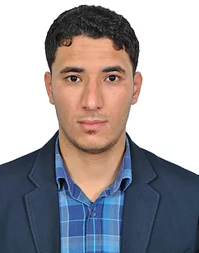
Title: A distributed and safe weighted clustering algorithm for mobile wireless sensor networks
Name: Amin DAHANE
Intelligent Systems Research Laboratory (LARESI), ORAN, ALGERIA

Wireless networking is a research field that attracts more and more attention among researchers. It includes a variety of topics involving many challenges. The main concern of clustering approaches for mobile wireless sensor networks (WSNs) is to prolong the battery life of the individual sensors and the network lifetime. For a successful clustering approach the need of a powerful mechanism to safely elect a cluster head remains a challenging task in many research works that take into account the mobility of the network. The approach based on the computing of the weight of each node in the network is one of the proposed techniques to deal with this problem.
In this work, we propose a distributed and safe weighted clustering algorithm (ES-WCA) for mobile WSNs using a combination of five metrics. Among these metrics lies the behavioral level metric which promotes a safe choice of a cluster head in the sense where this last one will never be a malicious node. Moreover, the highlight of our work is summarized in a comprehensive strategy for monitoring the network, in order to detect and remove the malicious nodes. We use simulation study to demonstrate the performance of the proposed algorithm. Also, we present a virtual laboratory platform (VLP) baptized Mercury allowing students to make practical work (PW) on different aspects of mobile wireless sensor networks (WSNs). Our choice of WSNs is motivated mainly by the use of real experiments needed in most courses about WSNs. These experiments require an expensive investment and a lot of nodes in the classroom. The platform presented here aims at showing the feasibility, the flexibility and the reduced cost of such a realization. We demonstrate the performance of the proposed algorithms that contribute to the familiarization of the learners in the field of WSNs.

Biography
Amine Dahane received Master degree in Computer Systems and Networks from the University of Bechar in 2011. His Ph.D. degree, in 2017, in Electronics from the University of Sciences and Technology of Oran (USTO, Algeria) and member of LARESI Laboratory (Research in Intelligent Systems Laboratory) from 2011. His main research interest includes wireless sensor networks, their security, routing and management, Intrusion detection.

Presenting author details
Full name: Amin Dahane
Contact number:+213698132193
Site WEB: http://amineustolaresi.wixsite.com/dahane-amine
(ORCID ID): http://orcid.org/0000-0001-6998-208X
Category: (Oral presentation)

