Power Optimization Considerations in Wireless Sensor Networks
Feroze Mohamed, | Mahesh Patil
Amphenol Advanced Sensors | Amphenol Advanced Sensors
Amphenol | Amphenol
Hyderabad, India | Hyderabad, India
feroze.mohamed@amphenol-sensors.com | mahesh.patil@amphenol-sensors.com

Abstract— Wireless Sensor networks are ubiquitous today and the exponential growth of sensors in every sector has fuelled the need for a reliable and optimized power scenarios. The IOT – internet of things space has captured the imagination of sensor companies, information technology companies and solution providers having end products in the control and measurement space. With the proliferation of sensors and hence the data, the power optimization of the system comprising of the fundamental elements such as the sensor, the analogue/digital electronics and the RF transceivers has become a major subject of interest and challenge for the embedded engineers. This paper deals with the RF system for temperature measurement in a mission critical domain like the pharmaceutical, warehousing industry and details out methodologies in key areas for power optimization. The paper is divided into segments of the microcontroller forming the heart of the system, the algorithms embedded in the microcontroller, the analogue portion of the measurement system, the RF transceiver as a system and the overall interaction of these key elements. Also this paper has a design of experiments listed with the mesh parameters of signal strength, distance from the gateway and the impact of these on the power consumption pattern. The battery becomes a key challenge to address as the power source has to be very efficient in terms of reliability, density and cost.
- INTRODUCTION
Wireless sensor networks (WSN) are gaining the ground in all sectors of life. Monitoring seems to be the key word. A node in the sensor network includes a microcontroller, data storage, sensor, analogue-to-digital converters (ADC), a data transceiver, controllers that tie the pieces together, and an energy source. These nodes have the capability to sense the environment, compute simple tasks, and communicate with each other to form a huge wireless sensor networks (WSN). Gathered information (e.g. temperature, humidity, voltage, current etc.) are transmitted in a multi-hop fashion over direct neighbours to a data sink, where the data is interpreted. With methods like self-configuration and self-organization, the network reacts to node failures. Due to the tiny desired node’s size, the dimensions of the communication module and the battery are limited. Consequently, the smallest resource within a network is the available energy. Therefore, achieving a long lifetime of a sensor network requires low power hardware. After deploying a sensor network over an area of interest, sensor nodes initially have no position information. A node’s position is very important, because measurements without a location where they were gathered are generally useless. Furthermore, node coordinates such as distance of nodes between each other and the gateway enable energy aware geographic routing based on communication and signal strength.
- SYSTEM DETAILS

- Block Diagram
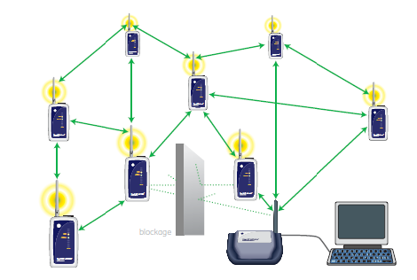
Figure.1. Block diagram RFVP
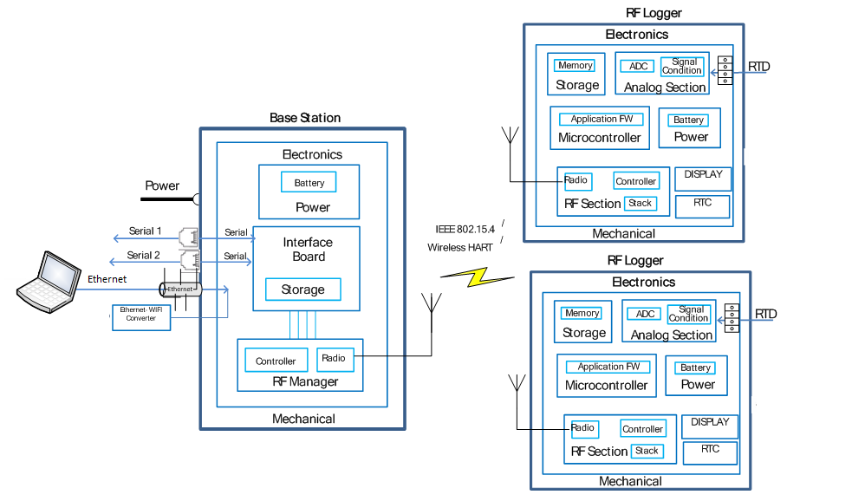
Figure.2. Internal Block diagram RFVP

- Logger
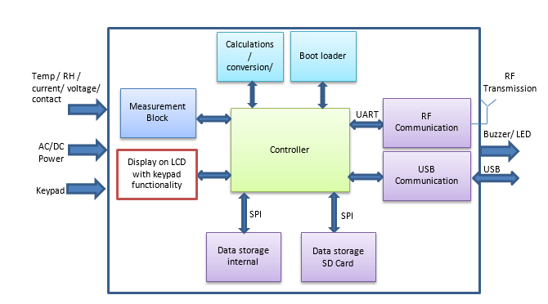
Figure.3. Block diagram for Logger
- Sensors
A sensor is a device that detects and responds to some type of input from the physical environment. The specific input could be light, heat, motion, moisture, pressure, or any one of a great number of other environmental phenomena. The output is generally a signal that is converted to human-readable display at the sensor location or transmitted electronically over a network for reading or further processing.
These are the different type of Sensors. The main sensors focused in this paper is mentioned as follows
- Temperature: RTD
- (TC)Thermocouples
- Voltage and current sources
- RH (Relative Humidity)
Temperature sensors are measurement devices that determine temperature by sensing a corresponding physical characteristic, such as electrical resistance, electromagnetic field, or thermal radiation. The way a temperature sensor works depends upon the physical property that is measured. Sensor options include:
- Thermocouples
- Resistance temperature detectors (RTDs)
- Thermistors
- RTD Vs Thermocouple
RTD consumes more current when compared to thermocouple. RTDs are superior to thermocouples in that their readings are more accurate and more repeatable. Repeatable means that users reading the same temperatures produce the same results over multiple trials. RTDs producing more repeatable readings means that their readings are more stable, while their design ensures that RTDs continue producing stable readings longer than thermocouples but at the cost of higher power consumption.
A humidity sensor senses, measures and reports the relative humidity in the air. It therefore measures both moisture and air temperature. Relative humidity is the ratio of actual moisture in the air to the highest amount of moisture that can be held at that air temperature.
Current sensors measure AC and/or DC current levels. The most important distinction to make when selecting a current sensor is whether AC and/or DC current needs to be measured. Another important specification to consider is if the sensor needs to be in-line with the circuit or if it works by being clamped around the wire to be measured.
Electrical voltage sensors measure AC and/or DC voltage levels. They receive voltage inputs and provide outputs as analogue voltage signals, analogue current levels, switches, or audible signals. They can also provide frequency and modulated frequency outputs.
The key design consideration for power consumption calculation is also based on type of sensors used. Considering the case of temperature measurement there is a difference in current consumption while using thermocouple and RTD. Examining the data sheet of temperature sensors and undergoing practical tests is a mandatory design exercise. In case of voltage or current sensor there would be an auxiliary power source for a sensors to function. The strategy adopted for optimizing power consumption can be based on sampling frequency, beyond the sampling frequency the active sampling duration also can be optimized.
Table 1. Sensor Type vs Current Consumption
 | mS(p.u) | uA(p.u)
1 RTD | 1.0 | 12.1
1 RTD + RH | 1.1 | 12.2
RTD + Voltage + RH | 1.6 | 12.2
RTD + Current + RH | 1,6 | 12.2

From the above table it can be observed that the RTD consumes more current while RH, which is a digital sensor, consumes relatively low current and the Voltage and Current sensors consume no current as they source from an external power supply. Hence the battery capacity has to take into consideration the current consumed by the RTD and RH sensors.
- Batteries
Due to the small dimensions of sensor nodes, batteries have to be designed with a small size in consideration. Thus, the available energy resources – whether batteries, energy harvesting, or both – limit their overall operation. On the contrary, wireless sensors need to operate for long periods of time in most settings to continuously collect corresponding data. To ensure long time operation, the energy of the battery must be used wisely. There are numerous battery types available for wireless sensor nodes. When comparing different battery technologies, several criteria should be considered. They include energy density, cycle life, environmental impact, safety, cost, available supply voltage, and charge/discharge characteristics.

Alkaline Batteries vs. Lithium Batteries
- Power: A major advantage of lithium batteries vs. alkaline batteries is that lithium batteries last much longer ^{[1]}.
- Price: Alkaline batteries compared to lithium batteries – alkaline cost substantially less than lithium batteries.
- Voltage: If you decide to replace alkaline with lithium, it’s important to check the replacement has both the appropriate voltage and type/size. Energizer e2 lithium AA batteries produce 1.5 volts, so they can be used to replace any regular alkaline AA units in most cases.
- Operating Temperature: Lithium batteries perform even in the most extreme temperatures, making lithium batteries perfect for outdoor devices. Lithium batteries operate in extremely cold climates or extremely hot climates where alkaline batteries cease to function.
- Weight: Lithium batteries are much lighter than alkaline batteries. This is a great convenience for portable devices.
The effect of variation in consumption patterns has the effect on the ampere hours available from the battery
Also the effect of temperature is a very vital role for ampere hour consumption and battery life so these variation in temperature together decides the behaviour of batteries and hence the power consumption patterns.
The strategy used for understanding the state of charge at any point of time for non-rechargeable batteries can be approximated using cumulative power consumption calculations based on experiential readings. There are sophisticated methods available for measuring state of charge also for rechargeable batteries.
Battery Performance with Load and Temperature:
The performance of the battery changes with change in the ambient temperature. For example, the effective mAh of the SAFT LS14500^{[2]} battery can be seen to drastically change with change in temperature.
Table 2. Temperature vs Effective milliAmp hour
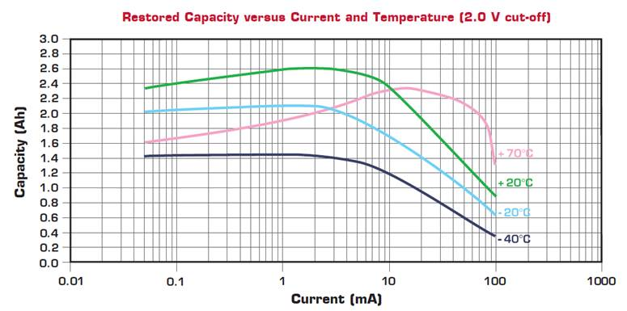  T (C)  Figure.4. Battery Capacity Vs Temperature | Effective mAh
-40 | 1400
-20 | 2050
20 | 2600
70 | 2050

- Microcontroller
Selecting the proper microcontroller unit (MCU) for your application is one of the critical decisions which control the success or failure of your project. There are numerous criteria to consider when choosing an MCU. The main goal is to select the least expensive MCU that minimizes the overall cost of the system while still fulfilling the system specification. The overall cost of the system includes everything, such as engineering research and development (R&D), manufacturing, warranty repairs, updates, field service, upward compatibility, ease of use and so on.
Selection criteria of MCU
The main criteria in selecting a microcontroller is listed here in the order of importance
- Low power controller with required number of peripherals.
- Required number of GPIO pins
- Memory of controller

Power consumption depends upon
- MCU Size
- MCU Supply Voltage
- Clock Frequency
- Operating modes

Micro-Controller Sleep Modes:
The microcontroller selection is based on least the power consumption and availability of low power modes. The MSP430 has seven low power modes, of which Mode 3 is best suited for our application. As tabulated ^{[3]} below, it can be observed that the microcontroller’s typical current changes with the ambient temperature.
Table 3. Microcontroller Sleep mode current based on ambient Temperature
 |  |  | -40°C |  | 25°C |  | 60° | 85°C
 |  |  | TYP |  | TYP |  | TYP | TYP
Low-power mode 3 (uA p.u) |  |  | 1.0 |  | 1.3 |  | 4.4 | 6.6
The Low Power Mode 3 disables the CPU, Master Clock Source and Secondary Clocks while maintaining the Auxiliary Clock for external dependency peripherals to continue working.
Analog front end
This forms a very vital part of power consumption, Analog to digital controller section is the key gateway for the raw sensor data to be converted to a format which is comprehensible for an RF Transmission. The duty cycle of the ADC has to be determined based on the sampling rate, accuracies and resolutions required and the core design of the section.

Sampling Duty Cycle Vs Power
The power consumption of the system will vary with respect to the duty cycle of the sampling rate. The below table shows the power consumption of the system with three different sampling duty cycles of 5 Seconds, 60 Seconds and 10 Mins.
Table 4. Sampling Duty vs System Power consumption
 | Single RTD
 | 5Sec | 60 Sec | 10 Min | Units
Average Current | 429 | 429 | 429 | uA
Sampling Current | 5260 | 5260 | 5260 | uA
Sample Duration | 0.433 | 0.433 | 0.433 | Sec
Active Duration (Per hr) | 311.76 | 25.98 | 2.598 | Sec
Sleep Duration (Per Hr) | 3288.24 | 3574.02 | 3597.402 | Sec
Active Current | 455.52 | 37.96 | 3.80 | uAh
Sleep Current | 391.85 | 425.90 | 428.69 | uAh
Life time of battery in Days | 255.69 | 467.09 | 500.98 | Days
Life time of battery in Years | 0.70 | 1.28 | 1.37 | Yrs

The average life time of a battery depends on the sampling time, sampling current, sample duration, battery capacity per hour. The above table describes the life time of battery in days and years based on the sampling time and other related parameters.
- RF transceiver
RF transceivers are electronic devices that receive and demodulate radio frequency (RF) signals, and then modulate and transmit new signals. They are used in many different video, voice and data applications. RF transceivers consist of an antenna to receive transmitted signals and a tuner to separate a specific signal from all of the other signals that the antenna receives. Detectors or demodulators extract information that was encoded before transmission. Radio techniques are used to limit localized interference and noise. To transmit a new signal, oscillators create sine waves which are encoded and broadcast as radio signals.
Selecting RF transceivers requires an understanding of modulation methods and radio techniques.
- Amplitude modulation
- Frequency modulation
- On-off key
- Amplitude shift key
- Frequency shift key
- Phase shift key
Important specifications for RF transceivers include data rate, sensitivity, output power, communication interface, operating frequency, measurement resolution, and maximum transmission distance.
- Packet Structure [4]
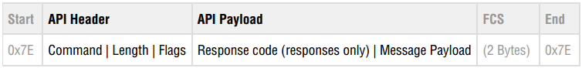

Operating life for a logger depends on the logger’s range, radio sensitivity, data rate and the number of loggers in the network. The design of experiment was conducted by increasing the number of loggers in a mesh with change in stability (radio sensitivity), and also by increasing the distance. It was observed to have a major impact in the current consumption for the loggers in the first hop while the loggers in the last hop had significantly lesser current drawn. The experiment was repeated with 15 loggers spread evenly across 3 hops and the same was repeated with 50 loggers evenly spread across 5 hops.

- RESULTS
3 Hops with 5 loggers in each hop with a total of 15 loggers

Table 5. No of Loggers per Hop Vs Current consumption with 15 loggers
 |  |  |  |  | Power Consumption (uA) ^{[5]}
S# | Hops | Loggers / Hop | Total Loggers | Stability | HOP  1 | HOP  2 | HOP  3 | HOP  4 | HOP 5
1 | 3 | 5 | 15 | 100 | 2.35146 | 1.5523 | 1 | NA | NA
2 | 3 | 5 | 15 | 80 | 2.43137 | 1.6 | 1.06695 | NA | NA
3 | 3 | 5 | 15 | 60 | 2.56429 | 1.675 | 1.17155 | NA | NA
4 | 3 | 5 | 15 | 50 | 2.65333 | 1.73 | 1.25523 | NA | NA
5 | 3 | 5 | 15 | 40 | 2.75831 | 1.78852 | 1.38494 | NA | NA
6 | 3 | 5 | 15 | 30 | 2.90052 | 1.87173 | 1.59833 | NA | NA
7 | 3 | 5 | 15 | 20 | 3.09938 | 1.98965 | 2.02092 | NA | NA

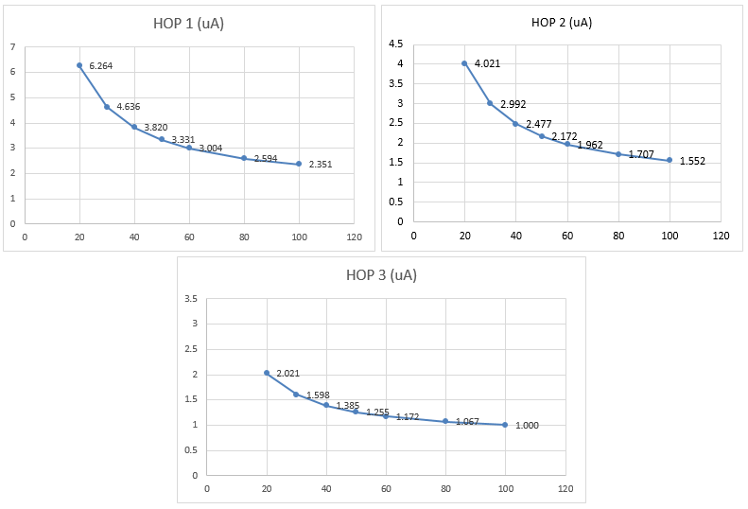
Figure.5. No of Loggers per Hop Vs Current consumption with 15 loggers

5 Hops with 10 loggers in each hop with a total of 50 loggers

Table 6. No of Loggers per Hop Vs Current consumption with 50 loggers

 |  |  |  |  | Power Consumption (uA)
S# | Hops | Loggers / Hop | Total Loggers | Stability | HOP 1 | HOP 2 | HOP 3 | HOP 4 | HOP 5
1 | 5 | 10 | 50 | 100 | 4.36508 | 3.35979 | 2.66138 | 1.96296 | 3.35979
2 | 5 | 10 | 50 | 80 | 5.16931 | 3.78307 | 2.96825 | 2.15873 | 3.78307
3 | 5 | 10 | 50 | 60 | 5.80423 | 4.48677 | 3.48677 | 2.48148 | 4.48677
4 | 5 | 10 | 50 | 50 | 6.51852 | 5.05291 | 3.89947 | 2.74603 | 5.05291
5 | 5 | 10 | 50 | 40 | 7.59788 | 5.89947 | 4.51852 | 3.13228 | 5.89947
6 | 5 | 10 | 50 | 30 | 9.39153 | 7.31217 | 5.55026 | 3.78307 | 7.31217
7 | 5 | 10 | 50 | 20 | 12.9735 | 10.1376 | 7.60847 | 5.08466 | 10.1376
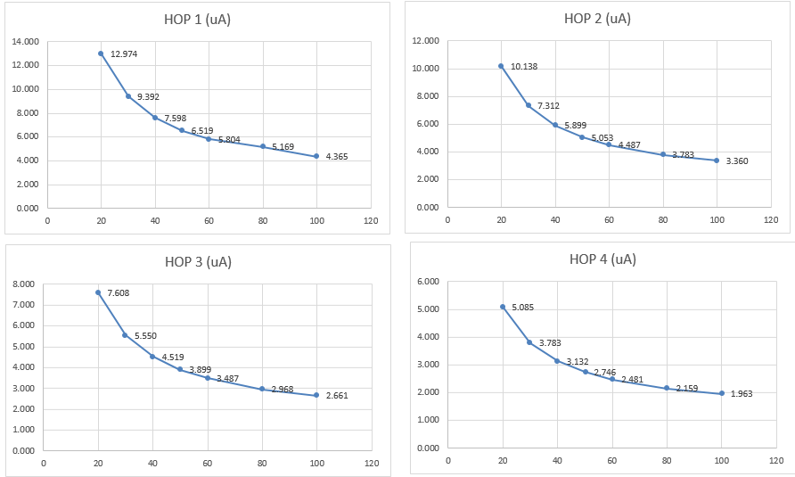
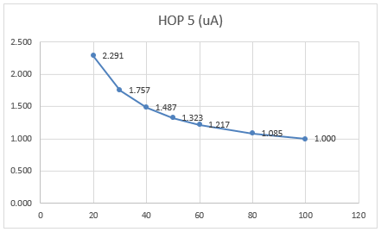

Figure.6. No of Loggers per Hop Vs Current consumption with 50 loggers
The current utilization of the loggers with respect to number of motes available in the mesh with change in stability (due to increase of distance or interferences) can be seen in the graph. Battery lifetime will be affected by the total number of loggers in the network. If there are hundreds of loggers competing with each other to communicate with the Base Station, there will be a significant number of collisions and retries depending upon the frequency of communication. Even if there is sufficient bandwidth to carry all of the data these nodes have to transmit, the wasted power expended upon retries can exceed the power required to send the data itself.
To achieve sufficient space coverage, a logger must be able to transmit with more RF stability. For larger locations such as warehouses and campuses, low RF stability will be insufficient to reach across the entire target site. As a result, more loggers will be required to achieve complete coverage. In addition, multiple base stations may be needed throughout the site, significantly increasing system complexity and requiring expensive manual configuration during installation.
The power consumption also depends on the payload (number of bytes transmitted) per packet. The observation with 50 loggers in the mesh can be observed below.
Table 7. No of Bytes in payload Vs Current consumption
 |  |  |  |  |  | Power Consumption (uA)
S# | Hops | Loggers / Hop | Total Loggers | RF Stability | Payload Size (Bytes) | 1st HOP | 5th HOP
1 | 5 | 10 | 50 | 80 | 90 | 4.156951 | 1.143498
2 | 5 | 10 | 50 | 80 | 80 | 4.040359 | 1.125561
3 | 5 | 10 | 50 | 80 | 60 | 3.798206 | 1.089686
4 | 5 | 10 | 50 | 80 | 50 | 3.681614 | 1.071749
5 | 5 | 10 | 50 | 80 | 30 | 3.443946 | 1.035874
6 | 5 | 10 | 50 | 80 | 20 | 3.32287 | 1.017937
7 | 5 | 10 | 50 | 80 | 10 | 3.206278 | 1

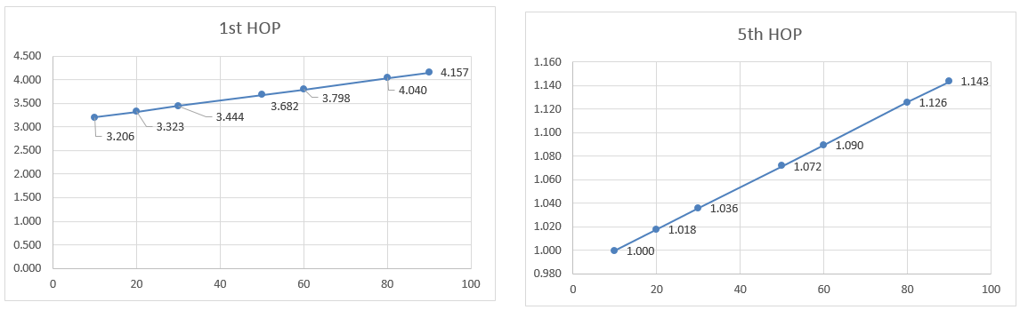
Figure.7. No of Bytes in payload Vs Current consumption

- CONCLUSION
The wireless Mesh network is a complex system with a huge dependency on robustness on the environment in which it is commissioned. The control parameters are the stability of the transceivers, range defined by the distance between the transceivers, number of loggers and the data packets. This also has an effect on the battery life. The battery characteristics and the design of the application embedded firmware, the wireless protocol implemented all have a bearing on the selection of the appropriate batteries.
The barriers for the mesh to efficiently work, data integrity in terms of availability of the data collected, redundancy in the network are critical aspects of a successful wireless monitoring system.
The experiments conducted clearly indicate that the battery power consumption is directly proportional to the data packet size, barriers the mesh path, stability of the network defined in terms of RF strength and distance and number of loggers in the system.
REFERENCES
- Medic Batteries, alkaline-batteries-vs-lithium-batteries-compare-alkaline-lithium-alkaline-compared-to- lithium
- SAFT LS14500 battery datasheet by SAFT Batteries, from http://www.saftbatteries.com/battery-search/ls-lsh; Doc. No 31064-2-0909.
- Data acquired from datasheet of MSP430, Texas Instruments Incorporated.
- Linear Technology Corp. from “SmartMesh WirelessHART Mote Serial API Guide”.
- Linear Technology Corp. from “Dust Networks SmartMesh Power and Performance Estimator”
- Measured observations at Amphenol Advanced Sensors.

