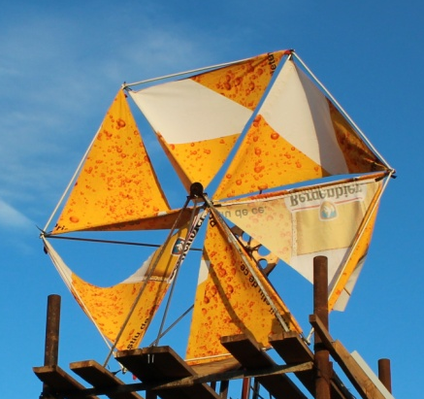

Study of sail type wind turbines aerodynamics
S.E. Sakipova¹, K.E. Sakipov², Tanasheva N.K.¹

¹E.A. Buketov Karagandy State University, Karaganda, Kazakhstan
²L.N. Gumilyov Eurasian National University, Astana, Kazakhstan

The study of aerodynamics characteristics and the choice of sail-type wind turbines are due to the fact that they are able to transform the wind energy at speeds less than 3 m/s, at which vane-type turbines usually aren't rotate. Furthermore, a sail-type wind turbine is easily adjusted on the direction of the wind, and practically doesn't make noise and vibration.
In paper are the results of experiments on the study of aerodynamic characteristics of three various models of sail-type wind turbines under different flow conditions are present. The description of procedure of testing and measurement of aerodynamic forces is shown. The thrust and drag forces graphs at different rates and angles of attack of the air flow were obtained. We defined the dependence of head drag and thrust forces coefficients when Reynolds number changed. It was established experimentally that the model of a doble sail type wind turbine with two wind wheels more effectively converts the energy of the incoming airflow while changing its direction.
The obtained patterns of drag and thrust force change are obtained for these models under conditions in the experimental tests. In practice it is necessary to consider the influence of other parameters, such as temperature, degree of atmospheric humidity. Nevertheless, these results can be used in engineering analysis in the development of multiblade sail type wind-driven power plants, adapted to the specific climatic conditions, operating at low wind speeds.

Biographies

Sakipova Saule - candidate of physical and mathematical sciences, Professor, supervisor and executor of scientific projects, invited researcher of ESF project (Riga, Latvia), published more than 75 papers, 1 monograph and 7 patents

Sakipov Kamalkhan - candidate of technical sciences, Professor, Head of the Department "Heat Power Engineering", supervisor and responsible executor of projects, has articles in reputed journals and patents

Tanasheva Nazgul – doctor PhD, Senior Lecturer of Chair of Engineering Thermophysics named after Professor Zh.S. Akylbaev, has articles in reputed journals and 3 patents

