A conceptual design of sustainable hospital in NEOM

Dhaifallah Muways Alotaibi¹, Akbar A. Javadi¹, Mohammad Akrami^{1*}
¹ Department of Engineering, College of Engineering, Mathematics, and Physical Sciences,
University of Exeter, Exeter, United Kingdom

Abstract
NEOM, a £370 billion Megacity in Saudi Arabia is planned to be constructed in the border between this country and Egypt [1], to host a large population. This Mega-city is going to be built to embrace new technologies and lifestyle for the young population of this country. One of the main aims of proposing this green city is to fully supply its energy from the renewable sources such as solar power [2]. Therefore, recently the 200 GW solar power plant has been signed off [3] for supplying the energy requirements for the country. But one of the main users of the electrical energy is the hospitals, for which these solar plants need to have sustainable supply of electricity.
The main purpose of this research is to analyse the technical possibilities of using fully green technologies for a conceptual hospital framework. In order to achieve this framework, different disciplines including the power supply, waste disposal [5] and energy wastage are going to be evaluated for the purpose of constructing a conceptual sustainable hospital in the new city of NEOM by considering its geographical location, climate conditions, transport facilities and the demand analyses based on the population demographic data. In this study, a combination of three renewable energy sources; solar, biomass, and wind turbine energy are evaluated by using the HOMER PRO software [6], to fully supply the required power of this modern city.
Keywords: Sustainable hospital, Green energy, NEOM

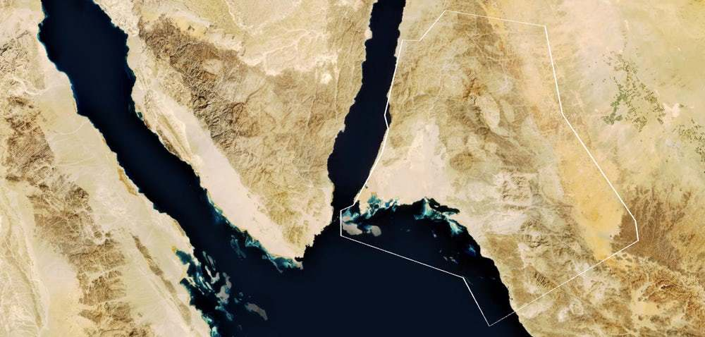
Figure 1: The geographical location of the city of NEOM in SA [2]
References
[1] http://discoverneom.com/ [Accessed on 24/04/2018]. [2] http://neomsaudicity.net/where-is-neom-location/ [Accessed on 24/04/2018]. [3] https://qz.com/1240862/what-saudi-arabias-200-gw-solar-power-plant-would-look-like-from-space/ [Accessed on 24/04/2018]. [5] Azmal, M., Kalhor, R., Dehcheshmeh, N.F., Goharinezhad, S., Heidari, Z.A. and Farzianpour, F., 2014. Going toward green hospital by sustainable healthcare waste management: segregation, treatment and safe disposal. Health, 6(19), p.2632. [6]http://www.nrel.gov/analysis/models_tools/HOMER/homer.html. consulted 21-Jan-2015 [Accessed on 24/04/2018].


Biography: Engineer Dhaifallah has been Graduated from National University of Science and Technology(NUST), as a Mechanical engineer. Recently, he has been studying MSc Mechanical engineering with management at Exeter University and he has continued his research in renewable energy.
Email: Dhaif90@yahoo.com
Desired Presentation: Poster
Topic: A conceptual design of sustainable hospital in NEOM
*Corresponding Author Details:
Dhaifallah Muways Alotaibi, Department of Engineering, College of Engineering, Mathematics, and Physical Sciences, University of Exeter, Exeter, United Kingdom
Email: DA344@EXETER.AC.UK Tel: +44(0)78539222

