Production of Biofuels by Conversion of Biomasses: Proposal of a General Index of Assessment.

Francesco Patania*, Salvatore Cannavò**

* Full Professor, Chemical Engineering for Industrial Sustainability, Dep. DIEEI, Catania University.
** Engineering Ph Doctor, Catania

Abstract
EU Directives 2003/30/CE and 2009/28/CE established many regulatory interventions concerning renewable energies in favor of environment to limit pollution of greenhouses gasses (GHG). Particularly, Directives recommended to EU nations to introduce in domestic market a percentage of biofuels to mix with fossil fuels yearly traded. Italian Statutory Legislation, in compliance with EU-Directives, establish year by year percentage of biofuels to introduce in Italian market of fossil fuels.
On the other hand partial replacement of fossil fuels with biofuels could be certainly advantageous for environment if the amount of polluting substances originated by combustion of biofuels added to pollutions caused by processes of production of biofuels are at lover rate of polluting matters originated by combustion of fuels having equal output of energy achievable throught the combustion of biofuels. Since there are many kinds of biomass and various processes of conversion, people consider appropriate to shape an available assessment index able to verify energy and environmental efficacy of operational technique of conversion independently from kind of conversion, kind of biomass and used technologies. To this aim paper gives details about the way to develop such assessment index which takes in account only energy and environmental real parameters caused by processes of biomasses conversion.

Introduction
EU established objectives to increase market share of renewable energies on the total amount of energies consumed to the aim to reduce GHG emissions, to decrease dependence from import of fossil fuels and to promote rural development and agricultural sector (Bense et al, 2010).
Italian Legislation Decree n. 128/2005 established to specify year by year the smallest percentage of biofuels to introduce in domestic market in function of entire amount of fossil fuels traded in Italy. Percentage is valued on the basis of contents in gigacalories of diesel and gasoline sold one year before. Tab. 1 shows the percentages adopted yearly by Italy from 2006 to 2012.

Reference year | Lowest share | Legislative reference
2006 | 1.0 % | Law 03.11.2000 n.281
2007 | 1.0 % | Law 12.27.2006 n.229
2008 | 2.0 % | Law 12.27.2006 n.229
2009 | 3.0 % | Law 12.24.2007 n.244
2010 | 3.5 % | MISE Decree  01.25.2010
2011 | 4.0 % | MISE Decree  01.25.2010
2012 | 4.5 % | MISE Decree  01.25.2010
Tab. 1

Always more frequently processes of conversion require advanced technical knowledge and expensive plants of processing which waste various kinds of energy (heat, power etc. etc.) and precisely for these reasons biofuels show higher selling prices in comparison with fossil fuels. Moreover, in industrial countries public burning debates take place about the way to use biomass cultivated land for production of biofuels [1]. This way involves decline of biodiversity, reduction of carbon storage and reduction of plots of land destined to food purposes (Helmann and Verburg, 2010). Other theme of public debate insists on the overstated claim of reduction of greenhouse effect contested all over the world by many scientists called “skeptics”. On the basis of previous criticisms people believe strictly necessary that evaluation of vantages coming from use of biofuels is based on “technical-pragmatic” data rather than on “political-ideological” judgments and believe that is advantageous to have an index of evaluation built on real measures of energy and environmental parameters rather than on theoretical conjectures or subjective penchants.
Almost all types of biomass are available to be processed as summarized in Fig. 1 [2].

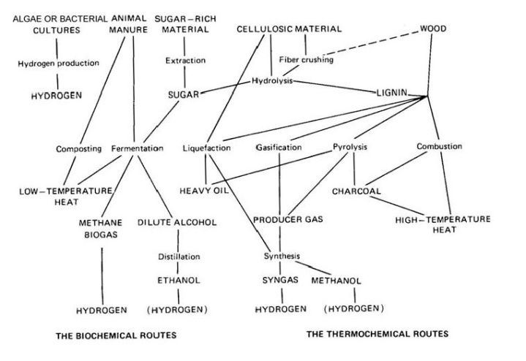
Fig. 1

Nowadays processes of conversion to produce heat power and biofuels from biomasses are based mainly on six technologies (Tab 2) and market state of processes is shown in Tab. 3 [3].
Technologies | Energy and Fuels
Technologies | Heat Power | Gas | Liquid | Solid
Direct Combustion | ●
Anaerobic Digestion |  | ●
Fermentation |  |  | ●
Oil Extraction |  |  | ●
Pyrolysis |  | ● | ● | ●
Gasification |  | ● | ●
Process | Possible Scale | Feedstock Flexibility | Conversion Efficiency | Output Flexibility | Market Value of Product | Development Status
Direct Combustion | Large | High | Low | Low | Low | Established
Anaerobic Digestion | Small | Low | Medium | Low | Medium | Established
Fermentation | Medium | Low | Medium | Low | High | Established
Oil Extraction | Small | Low | High | Low | High | Established
Pyrolysis | Large | High | Medium | High | Medium | Early Commercial
Gasification | Large | Medium | Medium | Medium | Medium | Early Commercial

Tab. 2 Tab. 3

At present indexes mainly used to appreciate economical and environmental affordability of conversion processes are the “Life Cycle Assessment” (LCA) and the “Energy Return on Energy Investment” (EROEI).
- LCA is principal index as regard environmental affordability and it is based on a compilation of inventories of wasted resources and connected polluting emissions during each phase of life cycle of products. Environmental balance therefore becomes merely an account of flows of resources and polluting releases between human activities and biosphere. In sequence, environmental effects of impacts are collected inside same large categories. LCA, however, is a relative method structured around a functional unit called “quality performance of one system of product to utilize as a reference in a study normalized at international level” (UNI EN ISO 14040, 2006). LCA envisages four activities following one another such as:
- definition of objectives and fields of application
- compilation of inventories of all that relevant goes in and comes out from system product (Life Cycle Inventory)
- subsequent phase of estimating of life cycle (Life Cycle Impact Assessment)
- explanatory phase of life cycle
Fig. 2 gives an elementary scheme of relevant environment components involved, activities, wasted resources and polluting emissions to consider during assessment phase.

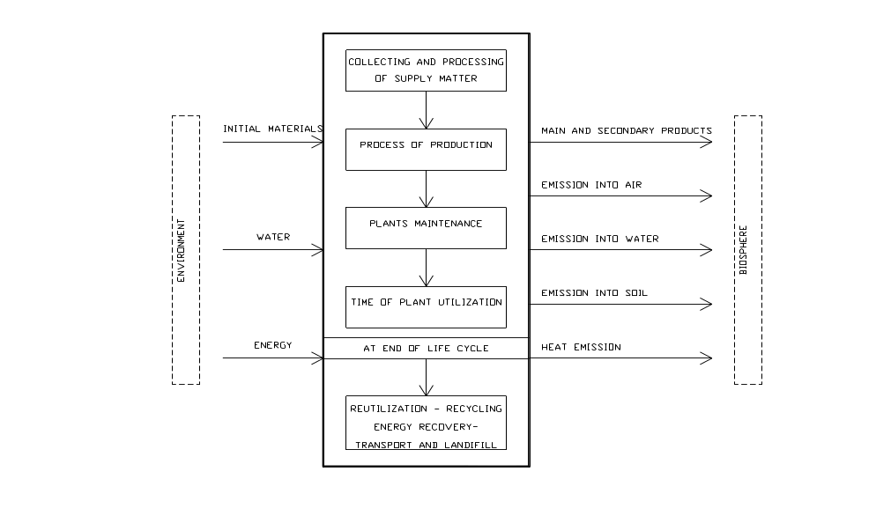 FIG. 2

LCA truthfully includes real limits as index involves during evaluation such many interconnected parameters all of them coming from subjective estimates of “Specialists”. Often “Specialists” in the same matter do not give identical value to a certain parameter obtaining therefore different value of LCA. Moreover, value of parameters is estimated and not coming from real measurement. Main reasons that make evaluation undefined are summarized as follows:
- Certain lacking in input data based on subjective hypotheses
- Methodology of calculation and interpretation of results are not scientifically and technically tested
- Index do not takes in account geographically dispersion or deterioration of pollutants in case of significant distance between the place of production and the place of utilization of products
- The evaluation involves a large amount of speculative problems regarding scenario and dynamics less or more future.
- EROEI is principal index as regard economic convenience of energy conversions and it is based on “energy repayment on energy investment” (Cleveland, F. 2005). Synthetic concept at the basis of index is well clear : people takes in account initial costs to calculate necessary time to recover money invested at the beginning. Time of repayment starts when economic profit begins that is after amortization of initial expenses. Index monetizes energy therefore EROEI seems efficient on economic basis but it does not believable on energy basis for evident lacunae such as:
- Long operational time of conversion plants (frequently much more than ten years) makes extremely aleatory economic parameters of appraisal like inflation, discount rate, cost of fuels and power, market demand, etc. etc.
- Very often input data about technologies and machinery are not well-explained
Previous lacunae clarify because value of EROI is significantly variable for each energy source as shown in Tab. 4 (Ridh, H. and Biars, J., 2005)

Energy Source | EROEI Value
Hydroelectric | 50-250
Crude Oil | 5-100
Aeolian | 5-80
Nuclear | 5-100
Photovoltaic | 0.5-80
Charcoal | 2-17
Natural Gas | 5-6
Biomass | 0.6-27

Tab. 4

The suggested “Energy and Environmental Index” (EEI)
People devise formation of index by means of balances of energies and environment pollutants caused by combustion of fuels and biofuels all of them involved in conversion processes.
EEI therefore is not an economic index even if people believe that significant value of index involves surely economic advantages too. EEI must be used specifically to evaluate energy and environmental efficiency of processes of conversion from biomasses to biofuels.
To have a general effectiveness index must be independent from:
- typology of process of conversion
- kind of plant and connected machinery
- kind of biomass feeding plants
- potentiality of production of biofuels
People consider Index composed by interaction of two factors: Energy Factor (EF) and Environmental Factor (EnvF) as reported in formula n. 1

$EEI=EF∙EnvF$ (1)

Energy Factor (EF)
To appraise EF people propose to take into consideration all kinds of energies in any case connected to conversion process, such as:
- $E_{cb}=$ potential thermal energy yearly achievable by combustion of biofuels produced by process [J · year]
- $E_{ck}=$ potential thermal energy yearly achievable by direct combustion of biomasses fed in process but not more available after conversion process [J · year]
- $E_{T}=$ thermal operational energy yearly wasted during conversion process [J · year]
- $E_{e}=$ electrical energy yearly wasted during conversion process [J · year].
People adopt following symbolism:
${\dot{M}}_{{gb}_{i}}=$ amount of “i” gaseous biofuel like biomethan, syngas, etc. etc. yearly produced [Nm³·year]
${\dot{M}}_{{lb}_{j}}=$ amount of “j” liquid biofuel like bio-ethanol, bio-diesel, etc. etc yearly produced [kg · year]
${\dot{M}}_{{sb}_{k}}=$ amount of “k” solid biofuel like bio-char, coal-powder, etc. etc. yearly produced [kg · year]
${LHV}_{g_{i}}=$ low calorific value of “i” gaseous biofuel [J/Nm³]
${LHV}_{l_{j}}=$ low calorific value of “j” liquid biofuel [J/kg]
${LHV}_{s_{k}}=$ low calorific value of “k” solid biofuel [J/kg]
${\overline{η}}_{g_{i}}=$ average efficiency of combustion of “i” gaseous biofuel
${\overline{η}}_{l_{j}}=$ average efficiency of combustion of “j” liquid biofuel
${\overline{η}}_{s_{k}}=$ average efficiency of combustion of “k” solid biofuel
then formula n.2 gives achievable $E_{cb}$:

$E_{cb}=[\sum_{i}{({\dot{M}}_{{gb}_{i}}}·{LHV}_{g_{i}}·{\overline{η}}_{g_{i}})+\sum_{j}{({\dot{M}}_{{lb}_{j}}}·{LHV}_{l_{j}}·{\overline{η}}_{l_{j}})+\sum_{k}{({\dot{M}}_{{sb}_{k}}}·{LHV}_{s_{k}}·{\overline{η}}_{s_{k}})$ [J · year] (2)

Adopting the following symbolism:
${\dot{M}}_{b_{i}}=$ yearly ammount of “i” biomass feeding conversion process [kg · year]
${LHV}_{b_{i}}=$ low calorific value of “i” biomass [J/kg]
then formula n.3 gives potential thermal energy $E_{ck}$ achievable by direct combustion of biomasses yearly fed in process but not more available after conversion process:

$E_{ck}=\sum_{i}{({\dot{M}}_{b_{i}}}·{LHV}_{b_{i}}·{\overline{η}}_{b_{i}})$ [J · year] (3)

Adopting the following symbolism:
$E_{T_{j}}=$ Thermal energy yearly wasted by “j” plant of conversion process
${\overline{η}}_{T_{j}}=$ average efficiency of “j” plant producing $E_{T_{j}}$
then formula n.4 gives thermal operational energy wasted yearly by plants to produce $E_{T}$:

$E_{T}=\sum_{j}{E_{T_{j}}}·{\overline{η}}_{T_{j}}$ [J · year] (4)

Adopting the following symbolism:
$E_{ek}=$ electric energy yearly wasted in “k” plant of conversion
${\overline{η}}_{e_{k}}=$ average efficiency of “k” plant producing $E_{ek}$
then formula n.5 gives electrical operational energy wasted yearly by plants to produce $E_{e}$:

$E_{e}=\sum_{k}{E_{e_{k}}}·{\overline{η}}_{k}$ [J · year] (5)

People consider all operative plants of conversion process from biomass to biofuel as an open system OS. Fig. 2 shows all energy entering and coming out from open boundary line of OS.

$$E_{c_{k}}$$

$$E_{T}$$
$$E_{c_{b}}$$
OS
system

Fig. 2

$$E_{e}$$
OS open boundary

People, on the basis of formulae from n. 2 to n. 5, define Energy Factor (EF) by means of relationship shown in formula n.6 between all energies yearly wasted and potential energy yearly achievable in process of conversion:

$EF={E_{cb}∙{(E}_{ck}+E_{T}+E_{e})}^{-1}$ (6)

Environmental Factor (EnvF)
People define Environmental Factor (EnvF) by comparison between potential pollution capable to be produced yearly by combustion of biofuels coming from conversion of biomass and the sum of pollutions coming from $E_{T}$, $E_{e}$ as well as not more usable energy $E_{cb}$. Well founded and verified technical and scientific bibliography makes available all types of polluting matters coming from combustion of various fossil fuels, biofuels and biomasses.
Adopting the following symbolism:
- ${\dot{w}}_{g_{i}}$, ${\dot{w}}_{l_{i}}$ and ${\dot{w}}_{s_{i}}$ types and amount of pollutants yearly coming from combustion respectively of “i” gaseous, “i” liquid and “i” solid biofuels
- ${\overline{η}}_{b_{z}}=$ average efficiency of process of combustion depending on burnt biofuel “z”
then formula n.7 expresses potential pollution $P_{cb}$ yearly producible by potential combustion of biofuels originated by process:

$P_{cb}=\sum_{i}{\sum_{z}{[(}}{\dot{w}}_{gi}·{\overline{η}}_{bz})+\left({\dot{w}}_{li}·{\overline{η}}_{bz}\right)+\left({\dot{w}}_{si}·{\overline{η}}_{bz}\right)]$ (7)

Adopting the following symbolism:
- ${\dot{w}}_{f_{i}}=$ types and amount of pollutants yearly coming from combustion of “i” fossil fuel to produce $E_{T}$
- ${\overline{η}}_{f_{z}}=$ average efficiency of process of combustion depending on burnt fuel “z”
then formula n.8 expresses pollution $P_{cT}$ produced yearly by combustion of fossil fuels to obtain $E_{T}$:

$P_{cT}=\sum_{i}{\sum_{z}{[(}}{\dot{w}}_{fi}·{\overline{η}}_{fz})$ (8)

Adopting the following symbolism:
- ${\dot{w}}_{e_{i}}=$ types and amount of pollutants yearly coming from “i” operational thermo-electrical plant producing $E_{e}$
- ${\overline{η}}_{e_{z}}=$ average efficiency of electrical production depending on thermodynamic cycle of plant as well as by used combustible “z”
then formula n.9 expresses pollution $P_{e}$ coming from production of electrical energy $E_{e}$ yearly wasted:

$P_{e}=\sum_{i}{\sum_{z}{[(}}{\dot{w}}_{ei}·{\overline{η}}_{ez})$ (9)

Adopting the following symbolism:
- ${\dot{w}}_{b_{i}}=$ types and amount of “i” pollutant that could be produced by potential direct combustion of biomasses yearly wasted in conversion process to achieve potential energy $E_{ck}$ not more producible after conversion process
- ${\overline{η}}_{bk}=$average efficiency of direct combustion of biomass depending on type of biomass burnt “k”
then formula n. 10 expresses pollution $P_{ck}$ saved since it is not possible to burn the biomass for energy purpose since already used for conversion process:

$P_{ck}=\sum_{i}{\sum_{k}{[(}}{\dot{w}}_{bi}·{\overline{η}}_{bz})$ (10)

From all previously reported, fig. 3 shows balance of pollution on biosphere and formula n.11 expresses total pollution $P_{T}$ on conversion process from biomass to biofuel:

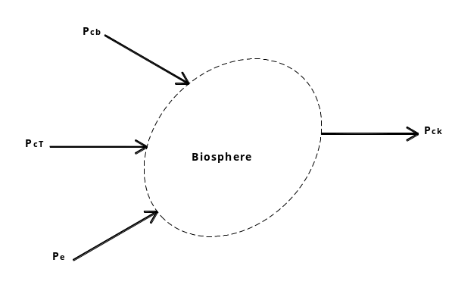
$P_{T}=P_{cb}+P_{cT}+P_{cb}-P_{ck}$ (11)
Fig. 3

People define environmental factor EnvF by means of relationship reported in formula n. 12 between yearly pollution producible by use of biofuels ($P_{cb}$) and total pollution ($P_{T})$ produced yearly by process of conversion:

$EnvF=P_{cb}∙{{(P}_{T})}^{-1}=P_{cb}∙{{(P}_{cb}+P_{cT}+P_{cb}-P_{ck})}^{-1}$ (12)

People esteem that Energy and Environmental Index (EEI) depends from unavoidable interaction between Energy Factor (EF) (formula n. 6) and Environmental Factor (EnvF) (formula n.12) and propose to use formula n. 13 to calculate EEI:

${EEI=EF∙EnvF=[E}_{cp}∙{(E_{ck}+E_{T}+E_{c})}^{-1}]∙{[P}_{cp}∙{(P_{e}+P_{T}+P_{ck})}^{-1}]$ (13)

Conclusions
Formula n.13 gives us the general approach to assessment since formula includes all possible forms of energy and pollution interacting inside conversion processes.
Pragmatically, in operational applications formula shrinks significantly since in real processes some of terms of formula are or can be considered negligible.
EEI can be used for a global energy and environmental evaluation of a determinate conversion process or to evaluate through EnvF only environmental effects on site or to evaluate through EF energy efficiency of chosen process of conversion and executive design of connect plants.
EEI is not calculated trough subjective judgments of “Experts” but on the basis of objective physical quantities all of them able to be obtained by previous reported formulae. Furthermore, Energy Factor (EF) allows to appraise in not long-lasting period of time also economic effects of conversion through comparison between economic potential value of energy produced by biofuels and economic costs of operational energy and biomass wasted during conversion.
Moreover, Environmental Factor (EnvF) allows to choice among possible conversion processes that one must be adopted in function of site where process will become operational: in case of ecologically fragile site people can opt for conversion owning the biggest value of EnvF even if option could take to a lover value of EF. In case of not fragile site choice of conversion must be addressed to biggest value of EEI.

Reference

[1] Ravindranath N.H., Manuvie R., Fargione J., Canadell J.G., Berndes G., Woods J., Watson H., Sathaye J. (2009), Greenhouse gas implications of land-use and land conversion to biofuel crops, in: R.W. Howarth. and S. Bringezu (eds) Biofuels: Environmental Consequences and Interactions with Changing Land-use, Chapter 6, pp. 111-125.

[2] Schematizing from: Brown T.L., Le May jr. H.L. et al, “Chemistry the Central Science”, 2009

[3] European Biomass Association, “A Biogas Road Map for Europe (AEBIOM), Brussels, 2009”

