Maxine Outerbridge
Abstract Title: A Survivor’s Self-Love Recipe for Understanding and Recovering from Anxiety and Depression
Abstract

Experiencing domestic violence and sexual abuse is commonplace within black and brown communities, especially when committed against women of color, while acknowledging and collectively addressing the residual mental health effects of trauma are not. This keynote presentation will provide a powerful testimony of the inevitable succumbence of post-traumatic stress syndrome (PTSD), anxiety and depression following the rampant ailes of physical and sexual abuse, teen pregnancy and familial isolation. A completely holistic treatment approach saturated with the principles of Self-Love and coupled with psychological counselling debunks the often misconceived notion by untreated parties that acknowledgement or identification of mental health disorders is also acceptance and submission to narcotic intervention. Fundamental self-love practices can improve mental illness related symptoms due to increased interest and accountability over one’s own mental health, establishment of realistic expectations, adequate management of adversity and prioritization of acceptance, compassion, forgiveness and care of oneself among others. This keynote presentation will also highlight a personal attestation to psych level limitations that result from sexual abuse including obsessive attachment, co-dependency and intimacy deficiencies. As a call to action, there is an opportunity within the Psychiatry industry to increase targeting of vulnerable communities, such as communities of color and to mitigate the cultural hesitancy and cynicism that often exist.

Keywords— Anxiety, Domestic Violence, PTSD, Self-Love, Sexual Abuse,

Professional Biography

Maxine Outerbridge is a New York City native, hardworking and passionate mother of two (including a special needs child) and mental health and healing advocate. Maxine’s testimony of surviving domestic violence and sexual abuse, teen pregnancy and financial distress during her pursuit of her undergraduate degree landed her a role as surrogate to Hillary Clinton during the 2016 Presidential Campaign. Maxine was the youngest delegate to represent the state of New York at the 2016 Democratic National Convention. Maxine studied Finance and Accounting in her undergraduate and graduate studies and is a Certified Public Accountant (CPA) working in the financial services industry (including holding positions at PwC, AIG and Bank of America.)

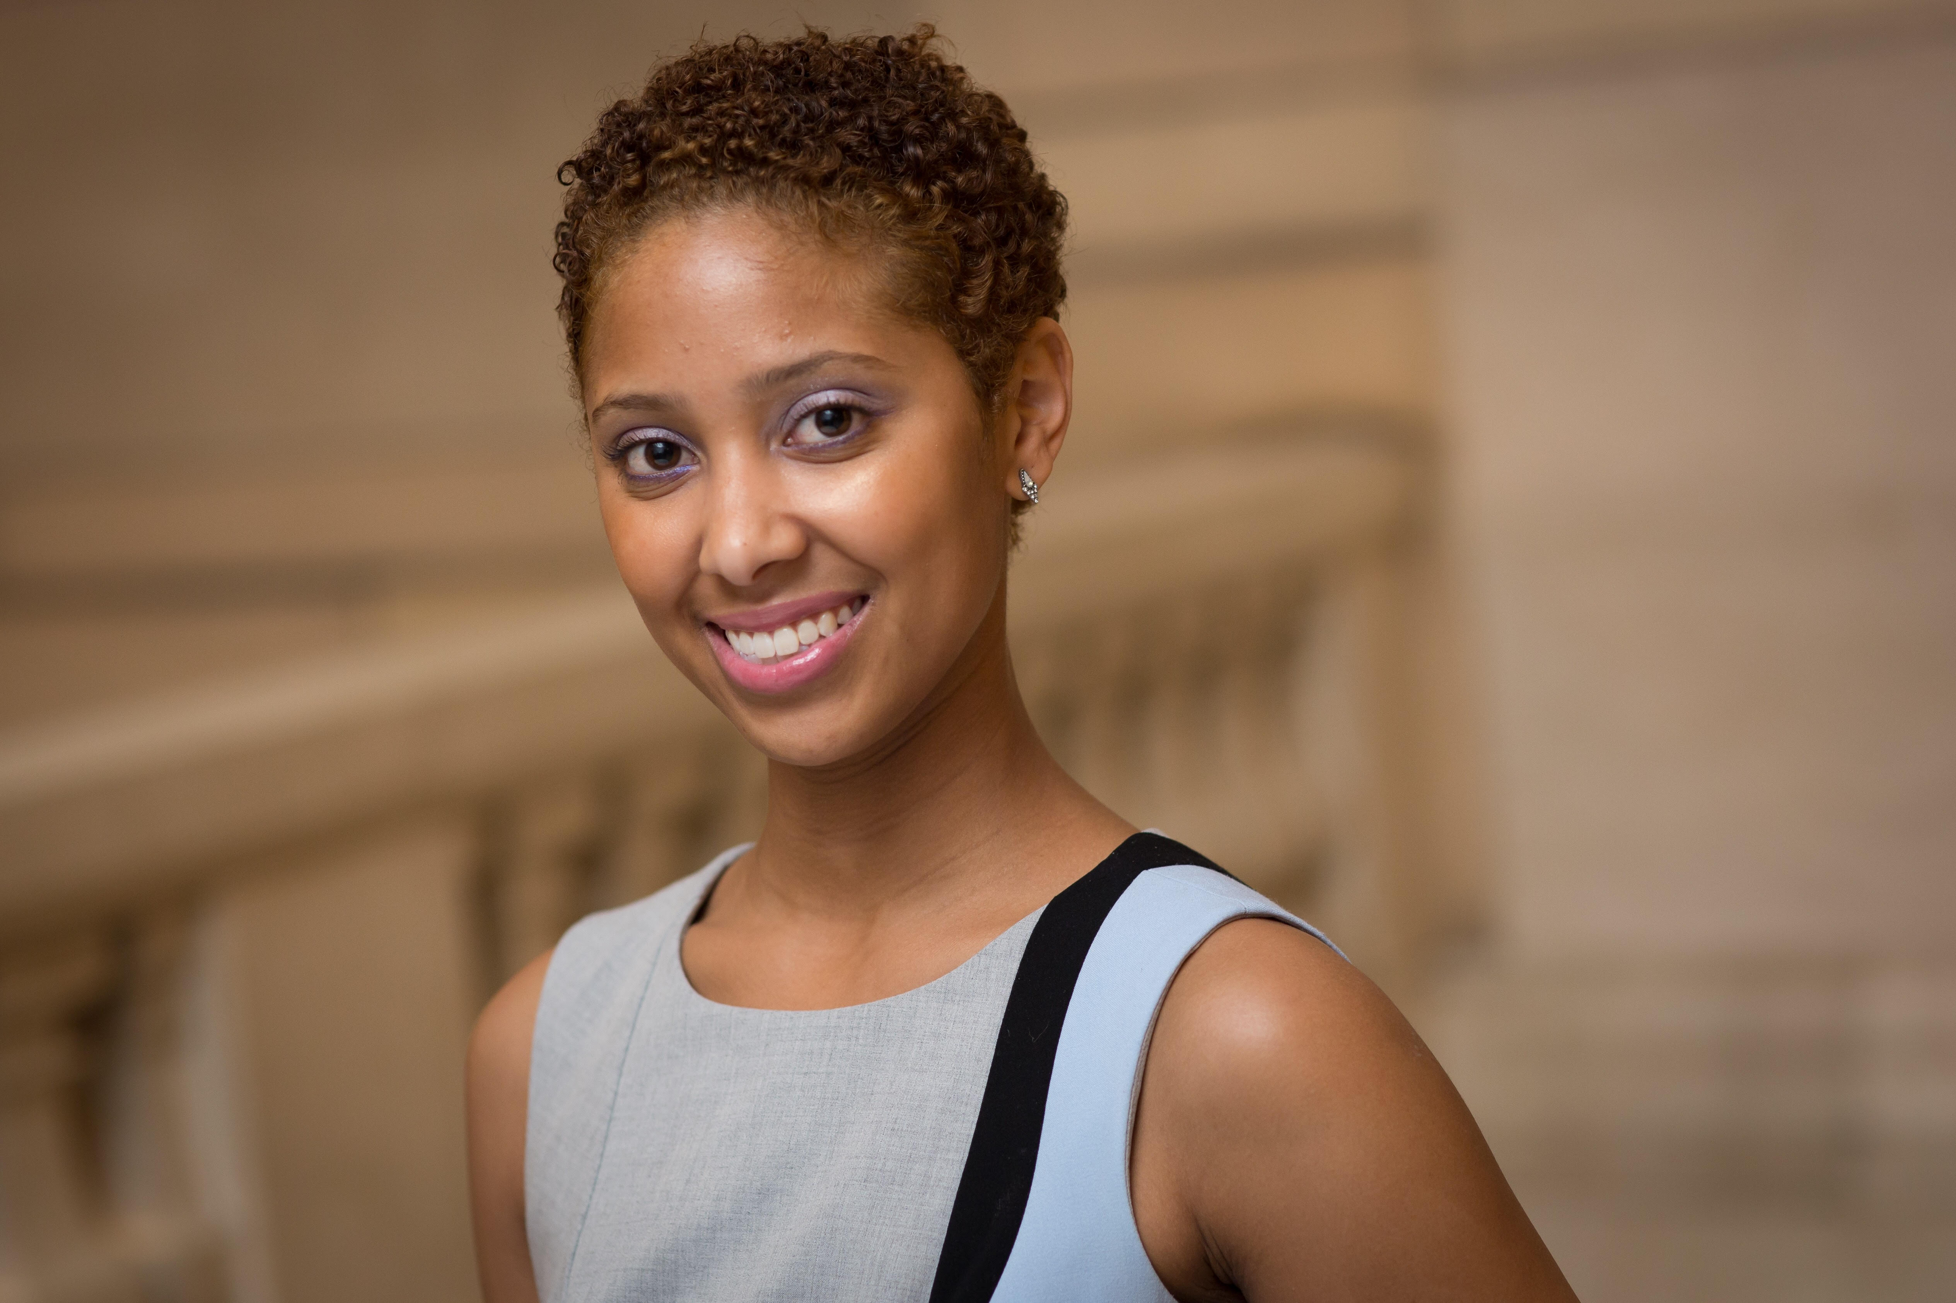
Headshot

Email Id: maxineouterbridge@gmail.com

Any Comments:

