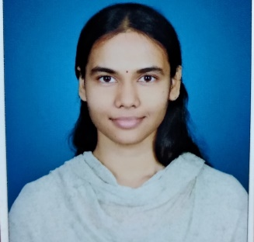
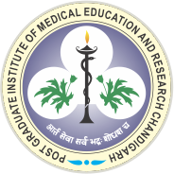

Paste y our Logo here
Paste your Photograph Here

Title : Endoscopic coblation assisted transpterygoid approach for sphenoid lateral recess defects: Our experience

Name: Dr. Ramya Rathod

Post Graduate Institute of medical education and research , Chandigarh, India.

Sphenoid lateral recess leak is one of the most common sites of spontaneous CSF rhinorrhoea. A lateral recess is a lateral extension of the sphenoid pneumatisation into the pterygoid and this extensive pneumatisation gives thin bony borders to the sinus separating it from intracranial space and in a setting of raised intracranial pressure(ICP) leads to an acquired, non-traumatic sphenoid leak. We performed a retrospective case series of 7 diagnosed cases of CSF rhinorrhoea with defect in the lateral recess of sphenoid sinus who underwent endoscopic defect repair by transpterygoid approach at our institution between 2009 and 2018 . All 7 patients had the defects localised to the lateral recess of the sphenoid and 6 (85.7%) had intrasphenoidal meningoencephalocoele on imaging as well as intra-operatively. Out of 7, 3 (42.8%) patients had previously undergone transnasal approach to defect repair which were unsuccessful and 1 patient underwent a neurosurgical procedure prior to csf leak. Out of 7, 6 (85.7%) patients underwent defect repair by coblation assisted endoscopic transpterygoid approach where coblation was used to achieve better access, visualisation, preserving the mucosa and to reduce the encephalocoele followed by multilayer defect repair. One patient developed dry eye as a long term complication. All patients were followed up for a minimum of 3 months and no recurrence till date have been reported. In this study, we layout our experience in delineating the sphenoid lateral recess defects, a robust approach to access the defect and practising novel methods of achieving adequate healing.

Biography

Dr. Ramya Rathod has completed her graduation in Bachelor of medicine and Bachelor of surgery from Gandhi Medical college, NTR University of health sciences, Andhra Pradesh , India in 2013 and is pursuing her post graduation in Otorhinolaryngology, Head and neck surgery at Postgraduate institute of medical education and research, chandigarh, India .

