Trench weir: An innovative structure for diverting water from high gradient rivers
Zulfequar Ahmad, PhD, IIT Roorkee, India
Sanjeev Kumar, PhD, Graphic Era University, India

Abstract (300 word limit)
Conventional types of raised-crest weirs for diverting water from the high gradient rivers for its use in generation of hydropower, irrigation, water supply schemes etc. are not well suited as the afflux brings a remarkable changes in morphological of the river. The sediments are deposited upstream of the crest as a result, the intake gets easily choked up. Moreover, any structural component that protrudes out of the river-bed gets damaged easily by the force of large sediments rolling down during floods.
The most suitable weir adopted in such scenario is trench weir, which is simply a trench built across the river below its bed level. The top of the trench is covered with bottom rack bars. Water while flowing over it, passes through the bottom racks and enters into the trench and being collected in an intake well located at either of the banks at the end of the weir. This type of weir has a definite advantage as it does not affect the morphology of the river. However, due to being below the bed of the river, the bed sediment load of size less than the clear spacing of the rack bars enters into the trench which necessitates post-monsoon clearance of the trench. A photograph of a trench weir showing its various components is shown in Fig. 1.
Hydraulics of the trench weir covering its discharging capacity under free and submerged conditions, water surface profile, ingestion of the sediment into trench etc. have been studied. Tracking of sediment over the bottom racks has also been carried out to investigate the mechanics of movement of sediment and its ingestion into the trench. Shape and size of the trench has also been optimized for maximum withdrawal of discharge from the river. Discharging efficiency of various shape of bars like circular, flat, T-shape of bottom racks has also been investigated.
Relationships have been developed for the discharging capacity of the weir, quantification of sediment ingestion into the trench, water surface profiles etc. Based on the investigations, design norms for the trench weir have been developed and such norms are successfully adopted in the design of trench weirs. Satisfactory performance of the constructed trench weir, designed on the basis of the developed norms, has been noticed.

Image

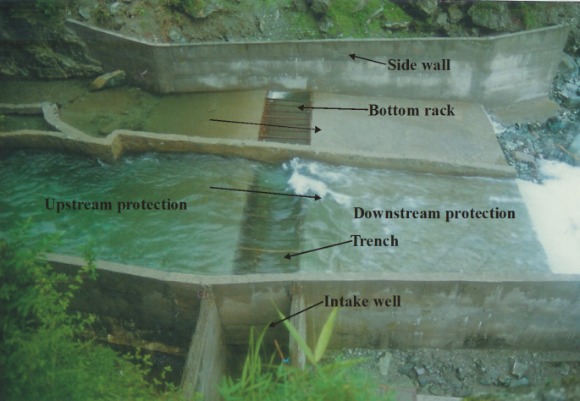
Figure 1: View of a trench weir
Recent Publications (minimum 5)
- Ahmad, Z., Mittal M.K., (2006). Recent advances in the design of trench weir, Himalayan small hydropower summit, Oct. 12-13, Dehradun, India. pp. 72-84
- Ghosh, S. and Ahmad Z. (2006), “Characteristics of flow over bottom racks”, Water and Energy International, Water and Energy International, CBIP, Vol. 63 No. 2, pp. 47-55.
- Ahmad, Z., and Kumar S., (2010). Estimation of trapped sediment load into a trench weir, 11th International Symposium on River Sedimentation (ISRS), University of Stellenbosch, South Africa, Sept. 6-9, 2010, pp.1-9.
- Kumar S., Ahmad Z., Kothyari U.C. and Mittal M.K. (2010) “Discharge characteristics of a Trench Weir”. J. flow measurement and instrumentation, Elsevier, 21(2010); 80-87. (Scopus Indexed).
- Kumar S. and Ahmad Z. (2015) “Experimental Investigation on Ingestion of Sediment into Trench Weirs”. ISH Journal of Hydraulic Engineering, DOI 10.1080/09715010.2015.1043595, Vol. 21, No. 3, pp. 343-352. (Taylor & Francis Pub).
- Kumar S. and Ahmad Z. (2016) “Experimental Study of Flow over Trench Weir with Flat Bars”. ISH Journal of Hydraulic Engineering, DOI 10.1080/09715010.2016.1241722, (Taylor & Francis Pub).

Biography (150 word limit)
Dr. Z. Ahmad is currently Professor of Civil Engineering at Indian Institute of Technology Roorkee, Roorkee, Uttarakhand, India. He has over twenty years experience of teaching at various levels & has published more than 140 research papers in referred journals and conference proceedings. He has carried out more than 100 research & consultancy projects of practical relevance. He has been recipient of various national and international awards. His area of interest is hydraulic structures, fluvial hydraulics, River Engineering etc. and carried out innovative works in these areas for sustainable development of water resources. His innovative work on diversion of water by trench weir from hilly streams for use in hydro power generation, irrigation, water supply etc. has successfully been implemented in the field.
Email: zulfifce@gmail.com

Notes/Comments:

