Impact of Urban Development on Water Quality through Modelling
Ganesh Babu O, Anna University, Chennai, India
Saravanan R, Anna University, Chennai, India
Sashikkumar M C, Anna University, Chennai, India

Abstract (300 word limit)
Rapid urbanisation and urban migration not only pollute the water, but also make the water resource allocation very complex. Landfills have been identified as one of the major threats to groundwater. More than 90% of municipal solid waste (MSW) generated in India is directly dumped on land in an unsatisfactory manner. Solid waste placed in landfills or open dumps are subjected to leachate and contaminate the groundwater. One such situation is prevailing in Erode district of south india. The study area is in erode district, which is now facing a major problem of environment pollution due to dyeing units. One of the most significant challenges for the erode textile industry today is water. Textile production, particularly dyeing and bleaching, can be water intensive and can generate large quantities of effluents. Therefore, there is a need to study the impact of leachate percolation on groundwater. However, the specific study locations are the unlined landfill sites at Vendipalayam, Semur and Vairapalayam of Erode district, Tamil Nadu.

Modflow-mt3d was used in this study to predict the flow and transport of the groundwater flow taking into consideration the external stress like discharge from wells and groundwater recharge. Then the model was simulated for steady state flow at the beginning and transient state from the year 2002 to 2012. The output shows that the groundwater flow is towards the Cauvery river and the magnitude of groundwater is also high near the river. The contaminant transport is simulated using a module MT3D, which indicates the contaminant concentration in three layers varies from 25000 mg/l near the dumpsite to 4000 mg/l near the concentration boundaries. The migration of leachate is observed, which moves towards Cauvery river in the northeast direction.
In-order to mitigate the plume migration entering in the settlement region as well as irrigation field, recovery wells were installed based on the flow direction. Three scenarios have been simulated, which are: Scenario – i: Present condition; Scenario – ii: Effect of recharge and Scenario – iii: Effect of sub-surface dyke with same quantity of recharge and pumping. Scenario-iii was considered to be more efficient in containing the plume
and not allowing mixing plume concentration with the river. From this study, it is concluded that the proposed Scenario – iii is a promising method to contain and remediate the contaminated plume without disturbing the present disposal practices.
Significant reduction of contamination concentration was observed in all the layers of the dump sites. However, the installation of dyke with recharge and recovery wells helps to protect river from the contaminated plume. It is concluded that the groundwater system developed using Visual MODFLOW, MT3D for the dump sites of Erode, will be very helpful for the planners and decision makers to contain and remediate the contaminated plume without disturbing the present disposal practices.

Image

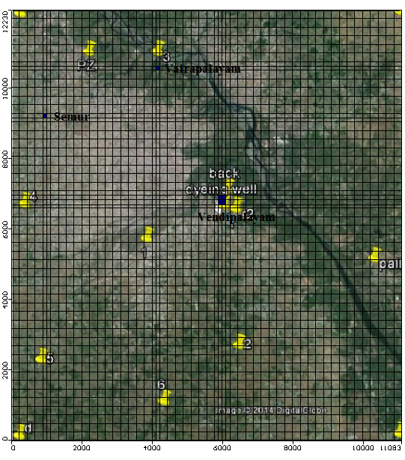

Recent Publications
- GaneshBabuO, SashikkumarMC, VijayarajM, GokulakrishnanK, SakthieswaranN (2016) ‘Assessment of groundwater quality in the District of Erode, Tamil Nadu, India’, International Journal of Advanced Engineering Technology, 7:1248-1252.
- GaneshBabuO, SaravananR, SashikkumarMC, PitchaikaniS (2015) ‘Assessment of groundwater vulnerability to pollution using Modflow’ The Asian Review of Civil Engineering, 4:20-27.

Biography

Ganesh Babu O is working as an Assistant Professor in Civil Engineering, Anna University Regional Campus,Tirunelveli.
Email: oganeshbabu@gmail.com

