Flow and Transport Through Randomly Heterogeneous Soils: Numerical Experiments and Upscaling
Veena S. Soraganvi, Basaveshwar Engineering College, Bagalkot, India
Rachid Ababou, IMFT., France
M.S. Mohan Kumar, IISC., Bangalore, India

Abstract
Modelling of groundwater flow and transport plays a major role in predicting the movement of water and pollutant underground. Performance of the mathematical models in prediction of movement of water and contaminant depend upon the input of the right values of flow properties of the media. Assuming a constant value of flow parameter over a large stretch of lands does not represent the actual situation and this homogeneity assumption leads to error in predictive modeling. Spatial variability of soil hydraulic properties has to be considered in order to provide realistic predictions of unsaturated flow and transport at field scale. This heterogeneity can be included in the modelling by various approaches, depending on the problem of interest. The natural heterogeneous porous media is represented by a statistically homogeneous realization. As the parameters are considered to be statistically homogeneous, the conventional deterministic solutions can be applied assuming these parameters as random variables. Thus the local hydraulic properties are reduced to a few statistical parameters, e.g. mean, variance and correlation length. The field soils in general exhibit various kinds of heterogeneities like random heterogeneity, layered heterogeneity etc. and there is a possibility of random heterogeneity within each layer. Although there is a vast body of literature for modeling the infiltration into layered soils, all these studies neglected the heterogeneities within the layers. But in general analysis of flow domain under various different kinds of heterogeneities has not been performed, which is planned to address in this paper. Effective hydraulic conductivities are defined by averaging out the flow field over several numerical simulations with respect to mean suction.
In the first part of this study, one and two-dimensional analysis of flow in heterogeneous medium in general with different standard deviation and heterogeneity within layers are considered. We are interested in illustrating some of the field scale effects, which we believe will occur in the heterogeneous environments encountered in the field. These effects include vertical movement and lateral spreading of the moisture, which cannot be explained by conventional stochastic analytic solutions. Also the combined effect of capillary dispersion length and correlation length of log-conductivity field on the distribution of moisture and tension profile is illustrated. In the second part transport simulations are also performed and solute plume movement with respect to time is analyzed. Variance of suction and moment analysis of solute plume are performed

Image
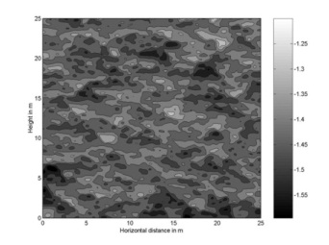 | 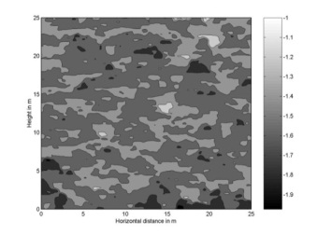
Steady state pressure fields for log Ks field of σ = 1.0 and σ = 2.3

Recent Publications
- Veena S. Soraganvi, Rachid Ababou and M.S. Mohan Kumar “ Analysis and upscaling of unsaturated flow through randomly heterogeneous soil, ASCE journal of Hydrologic Engineering , Issue No. 040160631,2016 pp 1-13
- Naveen Desai , Veena Soraganvi and Anuradha Tanksali, “Vermicomposting: Solution for milk sludge , Proceedia Environmental Sciences vol. 35: 2016
- Anuradha Tanksali, Veena S. Soraganvi “ Groundwater quality analysis of Hungund Taluk with Emphasis on Fluoride”, International journal of research in engineering and technology , vol 4 spl issue 11, pp 55-60, 2015
- Guruprasad M. Hugar and Veena. S. Soraganvi , Impact of soil organic carbon on bulk density and plasticity index of arid soils of Raichur district, India”, International research journal of environment sciences vol 3(2), pp48-58; 2014
- Soraganvi Veena. S. and M. S. Mohan Kumar, “ Modeling of flow and advection dominant solute transport in variably saturated porous media” ASCE Journal of hydrologic engineering, vol 14 issue 1, pp1-14, 2009.
- Veena S Soraganvi “ A study of reservoir induced land use / land cover changes using GIS ; A case study of submergence due to Alamatti Dam in Karnataka, India” International journal of remote sensing and GIS , vol 2, Issue 3, pp 92-103. 2013

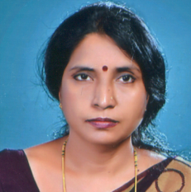
Biography
Dr.Veena Soraganvi works on Water Resources and Environmental Engineering. Her expertise spreads over surface water, groundwater, unsaturated flow and transport modeling, waste water treatment and remote sensing and GIS applications. This article focuses on unsaturated flow and transport modeling in soil media with spatial heterogeneity. She has a vast experience of teaching, administration and research. This article illustrates how the spatial variability can be considered in numerical modeling and helps in real time flow and transport predictions in groundwater.
Email: veena.snv@gmail.com, veena_snv@yahoo.co.in
Cell: +919845585878 Fax: +918354234204

