Quantification of effect of Linear Anionic Polyacrylamide (LA-PAM) on Seepage in irrigation Channels in Maule catchment
Hamil Uribe, Dr, Agricultural Research Institute, INIA Chile
Cristian Arancibia, Agricultural Research Institute, INIA Chile

Abstract (300 word limit)
In Chile, the water for irrigation and hydroelectricity is delivery through unlined channels on earth, which have high seepage loses. Traditional seepage-abatement technologies are very expensive.
The goals of this work was to quantify water loss in unlined channels and select reaches to evaluate the use of Linear Anionic Polyacrylamide (LA-PAM) to reduce seepage losses. The study was carried out in Maule region, central area of Chile. Water users indicated 36 reaches with potential seepage losses, 91 km of channels in total, whose flow varied between 0.66 and 23.6 m3 s-1. According to flow measurements, 9 reaches of channels, 13.43 km in total, were selected for LA-PAM application. 1 to 3 LA-PAM applications were performed at rates of 11 kg ha-1, considering wet perimeter area as basis of calculation. Large channels were used to allow motorboat moving against the current to carry-out LA-PAM application. For applications a seeder machine (Lhaura model 10502) was used to evenly distribute granulated polymer on water surface. Water flow was measured (StreamPro ADCP) at both ends of selected reaches, before and after LA-PAM application. Weekly measurements were made to quantify treatment effect duration. In each case water turbidity and temperature were measured (multi-parameter water quality checker Horiba U-50). Channels showed variable losses up 12.5%. Channels showing water gains was not treated with PAM. In more than 87% cases LA-PAM effect was positive, achieving loss reductions of 7 to 3% in average. Water loss was confirmed and it was possible to reduce seepage through LA-PAM applications provided that losses were known and correctly determined when applying the polymer. This could allow increasing irrigation security in critical periods, especially under drought conditions.

Image

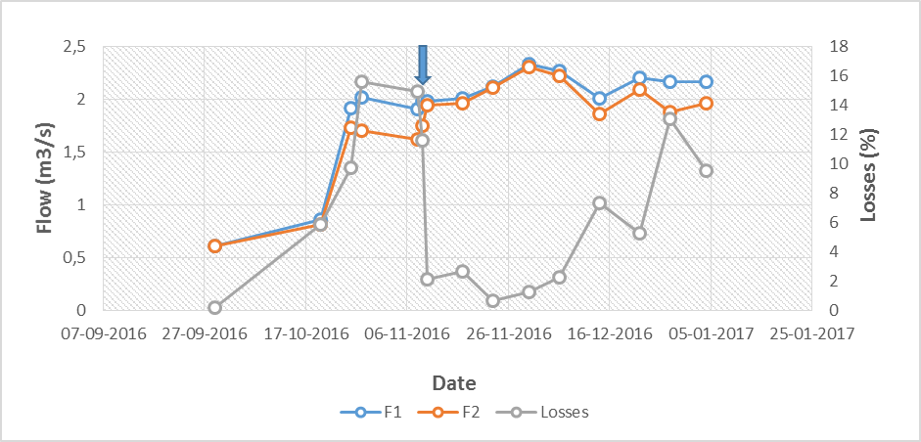

Figure 1: Temporal flow comparison between upstream and downstream points, 480 m separated. The arrow indicates LA-PAM application that produce the losses reduction.

Recent Publications (minimum 5)
- Hamil Uribe, David E. Rupp, José Luis Arumí, Ryan D. Stewart and John S. Selker (2014) “Assessment of current and potential yield of hand-dug wells in a semi-arid zone in south-central Chile using an analytical methodology”. Chilean J. Agric. Res 74(2).
- Uribe, H., R. Figueroa, L. Llanos. (2013) “Assessment of linear anionic polyacrylamide application to irrigation canals for seepage control”. Journal of Agricultural Engineering XLIV(s1):e155 p. 773-778.
- Uribe, H, T. Arnold, J. Arumí, T. Berger y D. Rivera (2009) “Modificación del modelo hidrológico WaSiM -ETH para mejorar su aplicación en áreas regadas”. Ingeniería Hidráulica en México, vol. XXIV, num. 2. pp. 23-36.
- Ryan D. Stewart, Majdi R. Abou Najm, David E. Rupp, John W. Lane, Hamil C. Uribe, José Luis Arumí and John S. Selker (2014) “Hillslope run-off thresholds with shrink–swell clay soils”. Hydrological Processes. doi:10.1002/hyp.10165.
- Martínez, I., C. Ovalle, A. De Pozo, H. Uribe, N. Valderrama, C. Prat, M. Sandoval, F. Fernández Y E. Zagal (2011) “Influence of Conservation Tillage and Soil Water Content on Crop Yield in Dryland Compacted Alfisol of Central Chile”. Chilean J. Agric. Res. vol.71 no.4.

Biography (150 word limit)
Hamil Uribe, Agricultural Engineer, MgS and Doctor in Agricultural Engineering has his expertise in water resources and irrigation. His works in water and soil management at catchment level had been a contribution for the central zone in Chile. The last year he include the new topic in his researches, the polymers use for reduce the seepage in irrigation channels. He has experience in others research subjects, hydrology modeling, especially in small catchment, irrigation water demand, water footprint. Also he teaches in Universities, direct doctor and master thesis and develop some software in irrigation and water footprint. In the Agricultural Research Institute (INIA), he work in research and technology transference.

Email: huribe@inia.cl

Notes/Comments:

