WATER INFRASTRUCTURE DEVELOPMENT IN A DEVELOPING COUNTRIES AND KEY DRIVERS IN ADAPTING STRATEGIES FOR LEADING CHANGE TOWARD ENVIRONMENTAL SUSTAINABILITY

ABSTRACT:
Water resources are becoming increasingly scarce in many part of the world due to the development increased demand because of the population growth. Increase economic activities and increase in pollution, the world fresh water resources are under increasing pressure (Funke et al, 2007).Turton et al, (2007) claimed the current water crisis facing the world was primarily attributed to poor or in effective governmenance and water resources management. For many years people have been looking for an effective approach to deal with the scarcity of water supply and basic sanitation in developing countries. The philosophy and principle for integrated water resource management have been widely accepted and adapted as offering the most suitable solution to this problem ,as well as those derivative and closely related one(Adriaens et al., 2003).
When water first rose to international importance in the 1970s, it was identified as one of the ‘basic needs’ common to all humanity – alongside food, water, shelter, means of livelihood - whose fulfilment had become a stated goal of international development policy. The fulfilment of population’s basic needs for access to a supply of safe drinking water and a safe disposal of human waste, remain important parts of today’s social and economic challenges. There has been some progress towards satisfying these two basic needs, but the challenge still remains today, with 900 million persons not having access to safe water and 2.6 billion people who do not have access to adequate sanitation facilities (WHO, 2011).There are large regional and intra-regional disparities gap in water supply and sanitation access; SUB-SAHARA AFRICA: 56% access to water supply, 37% access to sanitation; heavy bias towards urban areas. In South Asia: 85%access to water supply, 38% access to sanitation.
In East Asia: 78% access to water supply, 45% access to sanitation past 20 years more than 2.4 billion people gained access to water supply and 600 million to sanitation. (MCCS, 2012). Management must be devolved to the lowest appropriate level and enhance the roles for NGOs, the private sector and community groups. Women must play a central part in the provision, management and care of the resource. General approach to water resources management and climate change Address governance and political economy issues Scaling-up support to reach the MDGs Enhance coordination of donors Improve quality of financial spending Develop technical capacity to absorb incremental resources

KEYWORD: sustainability, infrastructure, water, developing country

INTRODUCTION.
Water is the most important and valuable natural resources in this world.it are a basic necessity of life for both plan and animals. Mankind cannot survive without water as human body is made up of about 70% contains water alkali et al, (2014). The world available water is about 97% of the water are salt water while only 2.5% frozen and 5% are fresh accessible (Dr suresh lecture note).Access to fresh water cannot be taken for granted by many people around the world today.it is estimated that 15,000 people die every day due to the lack of water mainly in developing countries by 2025. 3 billion people 40% of the world population live in water scarces conditions and the proportion is expected to increase to at least 60%.(WHO, 2012).African is a continent ,which has one of the lowest water supply and sanitation coverage of any region I global terms Africa contains 28% of the world population without access to water and 13% of the people without access to improved sanitation worldwide (sida, 2000).access to drinking water for domestic use connection is as low as 16% in sub-Saharan Africa ,20% in southern Asia and 28% in south east Asia (united nations,2010).it is not surprising therefore, that access to clean water is now officially recognised as a human right. According to united nation water is very important for all socio-economic development and for ecosystem maintainances.as population increase and development call for increase domestic water ,ground water allocaton,surface water, agriculture and industrial sectors, the pressure on water resources intensifies, conflict among the use which lead to tensions and excessive pressure on the environment (Pedersen, 2013).in many developing countries the infrastructure that supply the population with drinking water and waste water are badly rundown .koundouri ,etal (2003) noted that water scarcity originated more from use inefficiency from the physical constraint of it supply and poor management. Other infrastructures sector is the gap between the demand and investment requirement (weber and Alfen 2010). It is therefore major investment required to upgrade the system to the standard particularly sewer system and water main.
Sound strategies for community water supply and sanitation programmes in developing countries should be based on , a clear understanding of the existing problems, the beneficial impacts achievable, and the factors which determine sustainability. (Smith and zhank 2004).
The impacts of many water and sanitation programmes are limited, and many systems break down and are abandoned prematurely; only limited impacts are achievable in the short term without greatly increased investment. Sustain- ability, in the sense of continued delivery and uptake of services, is threatened by numerous attitudinal, institutional and economic factors, and community partici- pation approaches alone are no guarantee of success in developing countries. The key to sustainability is that all stakeholders involved in consumption/use, maintenance, cost recovery, and continuing support, perceive it in their best interests to deliver high-quality services. (CIWEM, 1999).expanding water infrastructure in developing area is greatly challenged, especially in urban areas. Pressure in fresh water resources and aquatic environment increases dramatically friendly solutions of water systems tools for measuring and assessing progress toward sustainability development are necessary (zinn, 2000).one method that gain a lot of interest recently is the use of sustainable developing indicators (SDI).with aim at making the concept of sustainable development measurable by quantify trends in society and determining toward sustainability development or not (Hager then Meyer 1996). Lund in etal have revealed a number of proposed environmental sustainability indicators (ESI) for urban water system, and also evaluated these in case of studies in urban area of Sweden and South Africa. The indicators were proven to be useful for assessing temporal variation of the urban water system and for identification of change in environment activities in both the countries .a separate study that evaluate different scenario us of urban makers at various level to alternative solution for different water system can be apply in this ways in a developing countries like Ghana in Africa does not have to build the water system in the future a big advantage compare to majority of industrial countries. (Smith and thank 2004).

PILLARS OF SUSTAINABLE WATER INFRASTRUCTURE.
- Waste water utilities and good water management
- Watershed approach to protection
- Efficient water use
- Full cost pricing
These pillars provide the starting point for development of approaches design construction and maintenance more sustainable infrastructure.(Pedersen,2011).

RESEARCH AIMS AND OBJECTIVES:
The aim of this research work is to discuss the various environmental issues with related to sustainable water infrastructure development in a developing countries and key drivers in adapting strategies for leading change toward environmental sustainability. The management of fresh water resources and related services is of critical importance to healthy social, economic and political well-being of a society. Stresses exerted on the world's water resources by the increasing demand from growing populations with changing consumption patterns and the destruction of water quality from pollution as a result of poor environmental management, are placing water increasingly higher on the international agenda, including that of climate change. Effective water resource management and developments impacting on water resources are recognised as key components of environmentally sustainable development (Hubbard et al., 2011). The negative consequences of poor water resource management on socio-economic development are more frequently arising especially in developing countries. This is clearly apparent in the agricultural and other water-sensitive industries. However industries where water is less evident in the supply chain, and even other sectors such as energy, are becoming increasingly aware of the risks and consequences associated with a potentially unreliable. Objective related to sustainability issues include
- Sustainable water infrastructure-sustaining the collection and distribution systems, treatment plants and other infrastructure that collect, treats and delivers water related services.
- Sustainable water sector systems-sustaining all aspects of utilities and systems that provide water related services.
- Sustainability communities-promoting the role of water services in furthering the broader goals of the community. (USEPA, 2012).

PROJECT KEY DRIVERS/ISSUES/CHALLENGES/IMPLEMENTATION.

According to American society of civil engineers “sustainable water resources system are those design and managed to fully contribute to the objective of the society now and in the future. While sustainable water infrastructure comprises energy management limited adaption and urban planning (Pedersen, 2011).the urban land institutehas identified the number of keys point to consider when designing sustainable water infrastructure project these includes;
- Intergrade land use into water management
- Reduce agricultural demand
- Moderate house hold consumption
- Think comprehensively
- Encourage conservation and raise rates
- Protect ecosystem
- Embrace collaboration among agency, region and communities
- Fix leaks and make necessary upgrade first
- Face the reality of added cost to ratepayers
Sustainable water infrastructure can only be achieved when conceived, designed constructed, operated, and maintained within the frame work of urban planning. (Pedersen, 2011).Water in developing countries, over one million people are without access to safe water, while twice as many lack access to improve sanitation services making these two of the worlds the most pressing issues .the sustainability of critical infrastructural system such as water and sanitation is necessary though not sufficient especially in a developing countries criterion for achieving sustainable human settlement since the lack of adequate service affects literally all aspect of the community daily existence including health education family surroundings, and employment(Jones and Silver 2008).
It is widely recognized that modern sanitation (with proper sewer systems and wastewater treatment plants) has greatly contributed to the improvement of public health and increased life expectancy. However, again for economic reasons, the percentage of world population using improved sanitation is very low in the poorest countries as a result, half of the urban population in Africa, Asia. Demetri’s Koutsoyiannis (2011)
And Latin America suffers from diseases associated with inadequate water and sanitation (Vorosmarty et al., 2005). Recognizing the poor economic situation and the lack of technological infrastructure as the real reasons for water scarcity and health problems, we can expect that economic progress, wherever and when- ever it is made possible, will lead to improved water availability and sanitation in developing countries.
THE KEY ENVIROMENTAL ISSUES.
Generally environmental resources water is probably the one that is most abused through human activities. For instance the emission of organic pollutant as a result of industrial activities is responsible for rapid deterioration of water quality assessment with define health consequence for human population. the total effect deterioration of water quality includes industrial recreational and fishing diseconomies (knees and bower, 1979).scarcity of water particularly in urban centre complicate the problem of sanitation ,thereby posing a threat to public health. in rural communities without access to safe water and where drinking water is sourced from polluted streams and stagnant water bodies ,there has been marked incidence of water related diseases such as cholera ,river blindness, guinea worm infestation ,all of which impose substantial welfare loss on society(Orubu, 2006).

WATER RESOURCES MANAGEMENT: THE CHALLENGES
Environmental stresses imposed by population growth, urbanisation, industrialisation and climate change have become a prominent theme of international concern, especially since the 1992 Earth Summit in Rio de Janeiro Designing. (MCC’s, 2012). One of the most affected of the natural resources is that of freshwater. Demands upon the world’s supply of freshwater resources are increasing the threats and risk to both the quantity and quality of a natural resource essential to human life, health, social and economic activities. (Letmathe, 2013). These risks to water resources have raised political attention which has been translated into political commitment, within and between countries, for the protection of this vital resource. Growing concerns related to climate change highlight the urgency of the freshwater situation. Climate change impacts are expected to affect populations directly by more frequent extreme events such as floods and droughts, rising sea levels, changes in the seasonal distribution and amount and type of precipitation such as snow and rain, Climate change is also expected to impact on the storage components of the Water Life Cycle such as glaciers, snow pack and groundwater via recharge. (Letmathe, 2013).
PRIORITIES FOR WORLD BANK ASSISTANCE IN DEVELOPING COUNTRIES
- Water Supply, Sanitation, Hygiene
- Integrated Water Resources Management
- Agriculture Water Management
- Floods and Droughts
- Hydropower
- Ecosystem Management
- Groundwater
- Adaptation to Climate Change in Water
GOALS FOR WATER INFRASTRUCTURE IN DEVELOPING COUNTRIES
- Safe drinking water for all by 2025 at the latest, with a parallel focus on quality, moving from an “improved” water perspective to “truly safe drinking water”.
- Accelerate the provision of access to improved sanitation to at least 120 million additional people per year, aiming for universal access before 2050. Analysis of achievements so far show that this is realistically possible, and with further increased efforts political leaders might aim for even more ambitious targets.(Letmathe 2013).

- Adequate treatment of all municipal and industrial wastewater prior to discharge by 2030. Best practice initiatives to reduce groundwater pollution by agricultural production (traditional, organic, etc.).(Letmathe 2013).
CLIMATE CHANGE.
Is a major risk factor that infrastructure development needs to address long term? Climate changes are both direct and indirect and the rate of the climate change is likely to increase significantly. There is need of infrastructure project to adapting the changing climate with development it serves to reduce or mitigate the effect of climate change through the reduction of carbon emission. (John, 2014).
ADAPTING TO CLIMATE CHANGE.
- Increase Supply:
  - Expand alternatives of water supply and storage
  - Increase efficiency of water supply services
  - Control water balance at basin level
  - Sustainable aquifer management (recharge)
  - Desalination
- Pollution Management:
  - Foster water quality management at basin level
  - Phased approach to investments and standards
  - Support priority investments in wastewater treatment
  - Support reuse
- Water Consumption
  - Economic incentives to reduce consumption and waste
  - Support water technologies and reuse
  - Increase productivity of water in irrigation systems
Impact on water cycle, water availability, and water allocation at the global, regional, basin, and even local levels
Smaller stocks of existing water infrastructure in developing countries
Impact supply and demand of water resources and associated infrastructure

CONSIDERATIONS OF CLIMATE CHANGE IN DEVELOPING COUNTRIES
- Challenges for developing countries
- Needs for additional water infrastructure and nonstructural investments
- Adaptive management to address uncertainty about implications of climate variability and long term impacts on the water balance.(Letmathe 2013).
WATER INFRASTRUCTURE INVESTMENT.
According to Underhill (2010) water supply will become an increasing problem for the developing countries in the twenty-first century. Improving water delivery, minimising costs, and increasing effectiveness of water recycling necessitates water infrastructure investment moving forward as a challenging task for developing countries. Furthermore, spending requirements for maintaining aging and building new physical water infrastructure are too heavy for the developing countries to absorb which presents an economic challenge to the water sector. It is not surprising therefore that there is an increasing calls for the private sector participation in developing and delivering water infrastructure in developing countries. (DR Suresh lecture note).
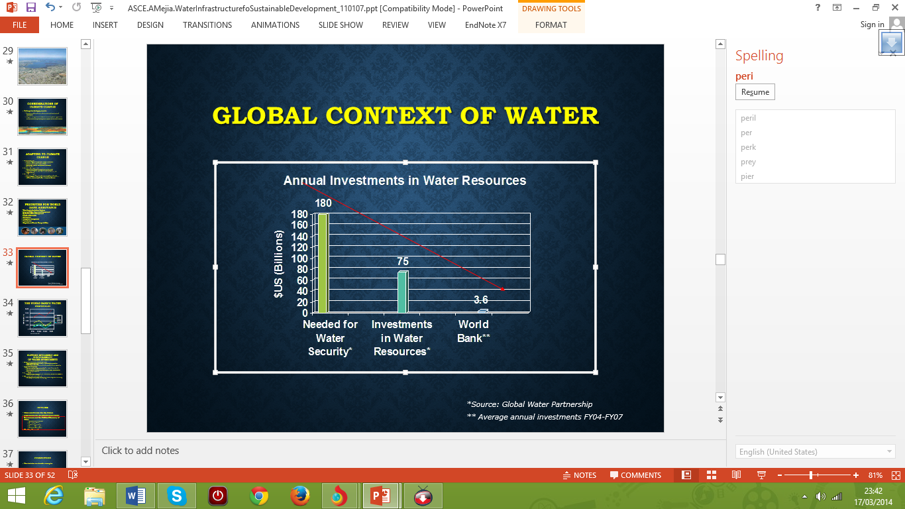
Adapted from global water partnership.

SUPPORT EFFICIENCY AND SUSTAINABILITY OF WATER INVESTMENT
It would appear that most of the investments in infrastructure in developing countries have been publicly funded, at about 70% of current total spending. The private sector contributes roughly about 20%, while international development assistance finances only around 10%. It is therefore important to improve the quality of fiscal spending so as to target sector investments appropriately.
- Charge the well-to-do, subsidize the poor
  - From (regressive) consumption subsidies to connection subsidies for the poor
  - Public Expenditure Reviews to inform public financing policy
- Apply smart technology
  - Focus on system improvement before expanding capacity
  - Flexible standards decrease cost
  - New irrigation and drainage techniques, reuse, desalination
  - Better designs of dams
- Secure
  - Revenues from consumers, as a minimum, should cover to reinforce sustainability
- ‘Climate proof’ new investment
  - The infrastructure that is built now, will be subject to increasing variability and climatic uncertainty
IMPLICATION FOR WATER POLICY
Contained within the international consensus on principles that should govern the response to global water problems, is the recognition that problems must be identified within the local context, and solutions developed which take local specificities into account. Louis, (2013) However, the implications of putting into effect some of the most important features of the international consensus - given the particularities of water realities in the developing world - have not always been given due recognition by donors. The growth of international unanimity of view demands more flexibility concerning the practical application of policy principles. Global programming and models need to be viewed more critically, or the international consensus principles themselves will be seen to be less relevant. A series of policy principles applicable at the programming and project level. These include
- institutional and management principles
- social principles
- economic and financial principles
- environmental principles
- information, education and communications principles
- Technological principles.
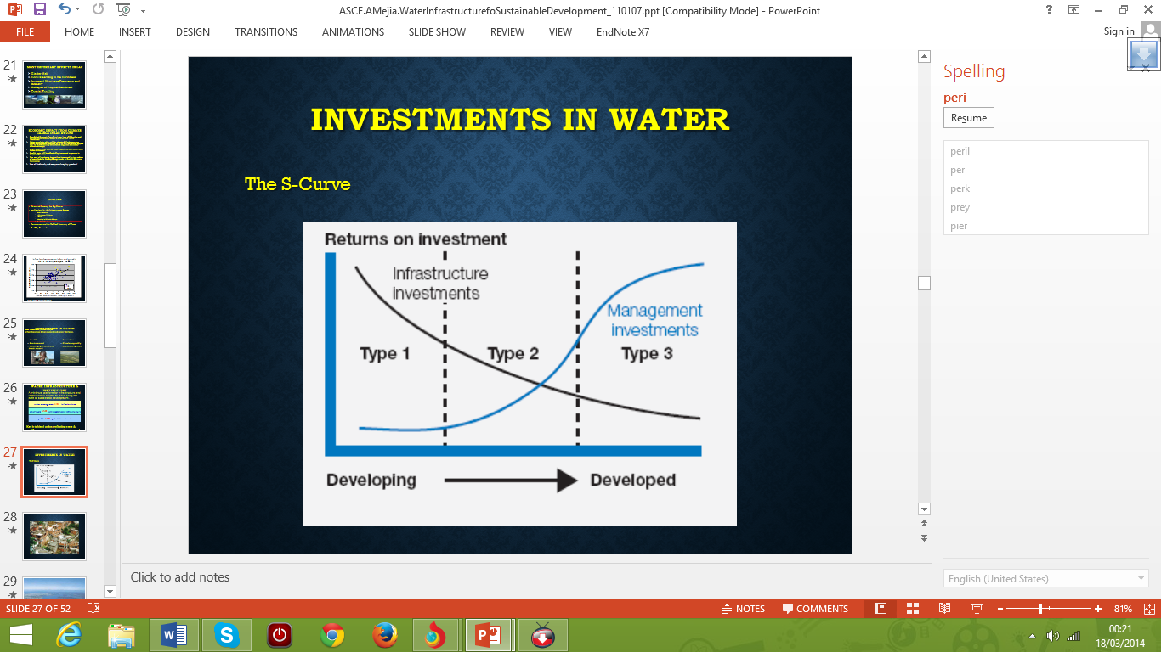
CORRUPTION
Water institution are vulnerable to corruption A focus on “clean” projects may not address the wider context of a “corrupt” sector—that is, while one project may have legitimate cash flows, these may then be illegitimately channeled elsewhere in a utility, government department, or other entity in the sector. Accordingly, thought needs to be focused on how the sector functions as a whole, where it is most vulnerable to corruption, and how it could be better organized to improve probity throughout.Where to look? Corruptible financial flows, discretionary decisions affecting value. (Jowitt, 2009).
DRIVERS OF CORRUPTION IN PUBLIC WORK
- Unclear procurement and tendering
- Lack of compliance monitoring and enforcement sanctions
- Low salaries of utility staff
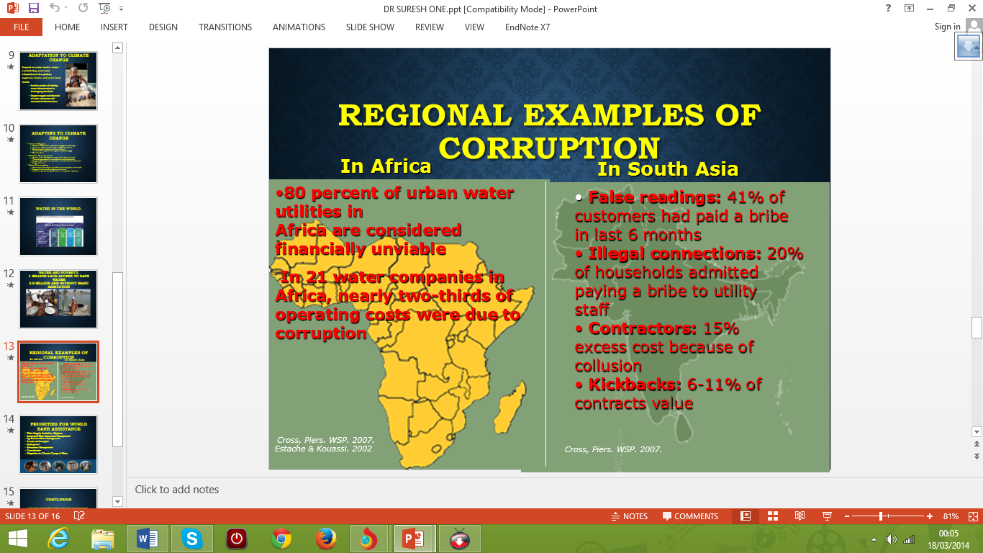
RATIONALE FOR PRIVATE SECTOR PARTICIPATION IN THE WATER INFRASTRUCTURE IN DEVELOPING COUNTRIES
There are many rationales proposed for private sector participation in water sector. One of them is that a private operator would operate more efficiently because of its profit motive and the fact that its contract contained clear, consistent objectives and means rather than the multiple and often conflicting goals assigned to state-owned water utilities (Harris, 2003 Cited from Dr. Suresh lecture note). Developing countries tend to be more concerned with increasing supplies through new infrastructure rather than with water efficiency or managing water demand within existing services. However, with promotion from the international consensus, government officials are becoming more aware of the need to manage resources efficiently, and that the construction of new infrastructure has to take into account environmental and social impacts, and the fundamental need for systems to be economically viable for maintenance purposes.
There are differences of view concerning the involvement of the private sector.(CIWEM, (1999). A perception has been developed that the turning over of state-run water-related functions to the private sector is a panacea for efficiency gains, but still many developing country governments are wary of doing so, reflecting a sometimes necessary degree of prudence on their part. In parts of Asia and in Latin America, the private sector is relatively developed; elsewhere, it is weak and poorly regulated and thus, it may genuinely be the case that transfers to the private sector is either not viable or is undesirable. Where regulation is limited or unenforceable, an uncontrolled private sector can be predatory, exploiting the vulnerability of the poor (Bakker et al. 2008).
While there is clear evidence that, under regulation, some kind of private sector involvement is beneficial to users, local circumstances have to be taken into account. This also applies to the involvement of community-based organisations in management of services. (Hubbard et al., 2011).The ability of small-scale farmer associations and village groups to manage complex water schemes without expert help is normally limited. Their capacity is usually confined to the management of low-level technologies, such as small catchment dams, gravity-flow schemes, rainwater harvesting, hand pumps and simple sewerage systems. Through the mediation of NGOs and motivated water authorities, such approaches have been successfully implemented in many parts of the developing world. However, they are very difficult to integrate into a systematic area-wide or nation-wide framework.
For many reasons, therefore, developing country governments consider water resources planning and management to be a central part of government responsibility. This view is consistent with the international consensus that promotes the concept of government as facilitator and regulator. The challenge is to reach mutual agreement about the level at which, in any specific instance, government responsibility can be delegated or be partnered by autonomous water services management bodies and/or community-based organisations.
STRATEGIES LEADING CHANGE.
- Good governance & ethics
- Compliance
- Transparency
- Environmental stewardship, resource efficiency
- Diversity, respect for human rights
- Strategic cost/benefit improvements & performance management
- Developing technologies to support current & future stakeholder needs
- Water should be managed as an economic, as well as social, good.
- Management of the water resource should be at the lowest appropriate level.
- A holistic approach to the utilization of water should be employed.
- Women should play a key role in the management of water.(Virjee and Vaskin, 2004).
KEY PERFORMANCE INDICATORS.
- Clear governance
- Count the signs of credibility
- Measure the result
- Allowing for individual growth and development
- Count leadership signals send throughout the organization
- Measure organizational distractions.
- Evolving regulation
- Shear holder expectation
- Stakeholder demand
Adapted from (CIWEM, (1999)

LEADING CHANGE TOWARDS SUSTAINABILITY LEWIN’S PLANNED CHANGE MODEL
Although, move includes empowering and participation of employees, supporting the change by support groups, new incentives and bonuses, intensive training according to the business strategy and values, and management tools to support the change. Refreeze consists of continuous monitoring and feedback, promoting the new values, new performance appraisal system, and use of task forcesAmong the first ones published and also the most renowned and referred model of planned change is Lewin’s (1951) three-stage process: unfreezing the old; moving to new; and refreezing the new behaviour or situation. Unfreeze includes top management changes, reduction of the levels of hierarchy, redefinition of the business, top management commitment and involvement. (DR Suresh lecture note).
THE KEY FACTORS TO SUCCESS WHEN IMPLEMENTING CHANGE.
- Pressure for change-demonstrated senior management commitment is essential.
- A clear shear vision-you must take everyone with you this is a shear agenda that benefit the whole organization.
- Ability for change-you need to provide the resource; time and finance.
- Action and performance-keep communication channel open. (DR Suresh lecture note).

INFRASTRUCTURE WATER RESOURCES MANAGEMENT PLANNING.
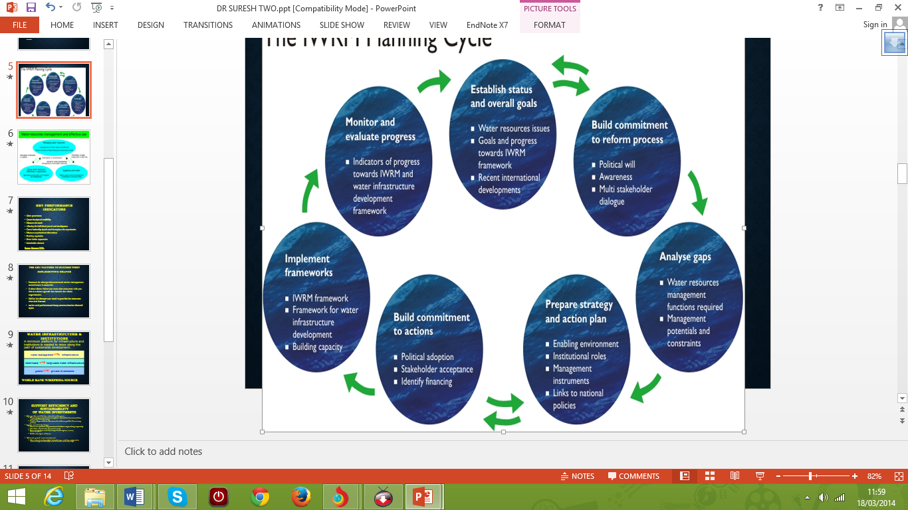

(MCCS, 2012).

CONCLUSION
Many developing countries lack sufficient data on the hydrology of their surface water resources, the groundwater resources and overall water quality. Without a full range of scientific information concerning climate and the ecosystem, it is not possible to evaluate the resource, balance its availability against demand, or reach scientifically-informed management decisions in key areas of water policy. Thus, the development of a water resources knowledge foundation and information data base is a precondition for any effective water policy.
Government authorities and agencies involved in water-related activities need proper information in order to function effectively. This information includes data on technologies, strategies, approaches, organisational models, and management information of all kinds. Data collection systems need to be established, and integrated with one another, so that activities can be continuously monitored, impacts be assessed and adjustments made
Should be valued as an economic good and managed as a resource necessary to meet basic human rights. Institutional arrangements must be reformed so that stakeholder carefully involved with Water must be managed in a complete way, taking into account interaction among users and environmental impacts. Water all aspects of policy formulation and implementation.
Management must be devolved to the lowest appropriate level and enhance the roles for NGOs, the private sector and community groups. Women must play a central part in the provision, management and care of the resource.
General approach to water resources management and climate change
- Address governance and political economy issues
- Scaling-up support to reach the MDGs
- Enhance coordination of donors
- Improve quality of financial spending
- Develop technical capacity to absorb incremental resources

REFERENCES.
Adriaens, P., Goovaerts, P., Skerlos, S., Edwards, E. and Egli, T. (2003) Intelligent infrastructure for sustainable potable water: a roundtable for emerging transnational research and technology development needs. Biotechnology Advances [online], 22(1-2), pp. 119-134 Available at:<http://wlv.summon.serialssolutions.com/2.0.0/link/0/eLvHCXMwVV25DQIxELTISU6s-cPajdGdKAAK2De8iP6FjQiggslmJpgnhIu3QsjCCQxzVTPCVIgNhnfAjvK3tP_D5tsSDrafwnNbH7d7_J4BRCntmiN7E1JX0FSkN4QqKJS7DgVMzlInRHHUToN_kYbPSTbnzUEZulM-hyPN0Pj--pTL9A1Z8yse>.
Alkali, D.M., Iorhemen, O. T., Otun J.A. and Alfa M.I. (2014).provision of sustainable water Supply system in Nigeria a case study of wannune-benue state: world journal of environmental engineering vol.2, No 1, 1-5
Demetris K. (2011) Scale of water resources development and sustainability: small is beautiful, large is great, Hydrological Sciences Journal, 56:4, 553-575, DOI: http://dx.doi.org/10.1080/02626667.2011.57907610.1080/02626667.2011.579076Demetris Koutsoyiannis (2011) Scale of water resources development and sustainability: small is beautiful, large is great, Hydrological Sciences Journal, 56:4, 553-575, DOI: 10.1080/02626667.2011.579076
EPA United state environmental protection agency (2012).water infrastructure moving toward sustainability.
EPAS draft national water programme (2012). Strategy response to climate change.
Frone Sir, S. and Frone, D.F. (2011) Prospects of investment in water infrastructure standing for sustainable development. Quality - Access to Success [online], 12(2), pp. 398-405 Available at :<http://wlv.summon.serialssolutions.com/2.0.0/link/0/eLvHCXMwY2BQSDMxSrRMSk4ysEi1NDROSU1NtDQwSkxKtQC2HSzNLJNRTtpHKs3dhBiYUvNEGRTcXEOcPXRhdUM8aH9GaXG8sZmpuYmpETAVijHwJoLWf-eVgPeJpQAAT_Ed4g>.
Guidelines for drinking water quality". World health organization. Retrieved 26 march 2012.
Hubbard, B., Sarisky, J., Gelting, R., Baffigo, V., Seminario, R. and Centurion, C. (2011) A community demand-driven approach toward sustainable water and sanitation infrastructure development. International journal of hygiene and environmental health [online], 214(4), pp. 326-334 Available at:<http://wlv.summon.serialssolutions.com/2.0.0/link/0/eLvHCXMwVZ09DkIhEISJvY2J1l6AhAVZ2Nr44gH0AMyylK96949oLPQSM18xP86dxyU2gSJUE0rdrEmIDVYnOwiL_i3t_6j5cnA7W4_uudwe17v_ngF4nQjCXhkRxFwIpFULlKTn6ebB0oBwR89ATUmtIBmPAEotU9FQpDHRye3bOzS-bp9yWX8BQkoq5A>.
J.CIWEM, (1999) .the impact and sustainability of community water supply and sanitation programmes in developing countries
John, R. (2013). Climate change and infrastructure National energy foundation, UK. Pp. 11-19
Jones, A.S. and Silver, C. (2008).A practical method to evaluate the sustainability of rural water and sanitation infrastructure system in developing countries .248 pp. 500-509.
Jowitt, P.W. (2009) Water infrastructure, the UN MDGs and sustainable development. Desalination [online], 248(1), pp. 510-516 Available at:<http://wlv.summon.serialssolutions.com/2.0.0/link/0/eLvHCXMwVV05DgIxDIzoaZCg5gMrZZM4xDVixQPgAT7Lrfi_8CIKqPwAWzNTjGdSOnsrhCych-Fc1YwwF2IboR2wo_wl7f-g-XJIO1uP6bncHtf79C0DmCTOLrY5ijXQqg5EErSyUY8CD9faJXQxZ4bsMdkbVejNkRWkFrxkaTqf0p420_j6-jyX6Rs3OirM>.
Knees, A V. and Bower (1979).environmental quality and residual management. John Hopkins university press, Baltimore (1979).
Letmathe p. b. (2013) water-the number one global sustainability development challenge pp.1-6
Louis, G. (2013) Small infrastructure and development: Sustainable water and sanitation services for rural developing communities. ABSTRACTS OF PAPERS OF THE AMERICAN CHEMICAL SOCIETY [online], 246Available at :<http://wlv.summon.serialssolutions.com/2.0.0/link/0/eLvHCXMwY2BQSDMxSrRMSk4ysEi1NDROSU1NtDQwSkxKtQC2HSzNLJNRTtpHKs3dhBiYUvNEGbTdXEOcPXSR64H4AsjZC6C5UmMj8C0lwKIXWDuJMfAmgpaC55WAt4ylAACufiES>.
Millenniums challenging corporation MCC. (2012).
Orubu, O. O. (2006).water resources environmental and sustainable development in Nigeria: department of economics delta state universities abraka nigeria.19 (3); 169-181.
Pedersen, T. A. (2012).Water infrastructure and sustainability .lecture note of environment engineering.
Smith, e. t, and zhang H. X. (2004).development key water quality indicators for sustainable water resources management. Coordinator, sustainable water resources roundtable c/o u.s geological survey Reston, VA 20192.
Smith, T. E. and Zhang, H. X. (2004) Developing water quality indicators sustainable water resources management: coordinator sustainable water resources roundtable/o us geology survey, reton, VA 20192. Water environment federation.
UNICEF. Water quality assessment and monitoring .technical bulletin no.6.united nations children fund (UNICEF), supply division.
Virjee, K. and Gaskin, S (2004).Fussy cost recovery in planning for sustainable water supply system in developing countries.pp. 1329-1341
Water infrastructure (2013).moving toward sustainability United state environmental protection agency pp 2-1.
Weber, W.J. (2002).Distributed optimal technology networks: a concept and strategy for portable water sustainability .water science and technology vol 46 No 6-7 pp 241-246.

