Glacial environment vulnerability and response to changing climate in the high Himalayan region

Arshad Ashraf, PhD, PARC, Pakistan
Bashir Ahmad, PhD, PARC, Pakistan
Muhammad Bilal Iqbal, PARC, Pakistan
Naveed Mustafa, PARC, Pakistan

Abstract (300 word limit)
Global warming has impacted the overall agro-environment and hydrological system of the high Asia. The glacial environment of Himalayan region is facing the spontaneous effects of climate change in the forms of changing glacier behavior, creation of new lakes and expansion in the previously existed ones and increase in frequency of extreme flood/drought hazards. The region forms the single most concentrated source of runoff for the whole Indus basin irrigation system as it supplies approximately 80 % flows to the Indus River during summer and contributes more than 50 % to the total annual runoff in the Indus River system in Pakistan. In the present study, a stepwise holistic approach has been adopted to investigate climate change variability, implications and risk involved in the glacial environment of Himalayan region in Pakistan using multi-sensor remote sensing data complemented by field observations. Temporal analysis of mean maximum temperature data of two decades (1990-2009) indicated an increase in the seasonal (summer and winter) temperatures in the valleys (below 3,500m) whereas decrease over high mountainous regions. Over 95% of the glaciers in HKH were categorized in the less than 10 km² area class. Minimum number of large sized glaciers (>100 km² area) were identified in the Hindukush and Himalaya ranges likely due to lower altitudinal coverage and higher glacial ice melting than Karakoram range. The sudden increase in the frequency of floods in recent years demanded a pressing need of investigating the prevailing situation of the glacial lakes in the country. Overall increase of about 26% in the lakes number and 7% in the lakes area had been observed during 2001-2013 period. The glacier-fed lakes like supraglacial and end-moraine dammed, contribute significantly in changing the lakes number and area. These lakes might have been formed/expanded due to faster rate of ice and snow melting under increased warming conditions in the recent decades. A thorough investigation of the critical expanding lakes is necessary keeping in view reducing high risk of any future flood disaster in the HKH region. An effective long-term programme for monitoring glacial ecosystem and associated hazards is essential to manage high risk of climate change implications in the Himalayan cryosphere.

Image
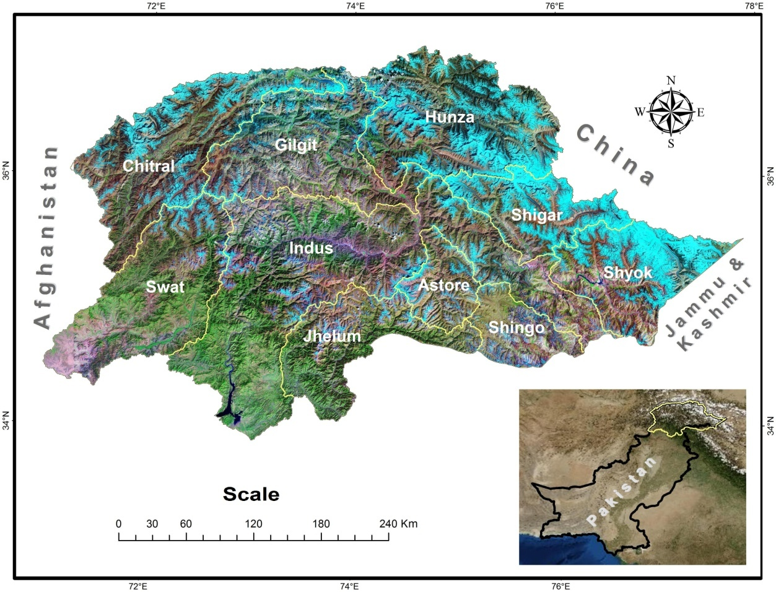
Recent Publications (minimum 5)
- Ashraf, A.; Naz, R.; Iqbal, M.B. 2017. Altitudinal dynamics of glacial lakes under changing climate in the Hindu Kush, Karakoram, and Himalaya ranges. Geomorphology 283: 72–79.
- Ashraf, A.; Naz, R.; Iqbal, M.B. 2015. Heterogeneous expansion of end-moraine dammed lakes in the Hindukush-Karakoram-Himalaya ranges of Pakistan during 2001-2013. Journal of Mountain Science 12(5). DOI: 10.1007/s11629-014-3245-4
- Ashraf, A; Roohi, R.; Naz, R. and Mustafa, N. 2014. Monitoring cryosphere and associated flood hazards in high mountain ranges of Pakistan using remote sensing technique. Natural Hazards, 73:933–949. DOI 10.1007/s11069-014-1126-3
- Ashraf, A; Naz, R. and Roohi, R. 2012. Glacial lake outburst flood hazards in Hindukush, Karakoram and Himalayan Ranges of Pakistan: implications and risk analysis. Geomatics, Natural Hazards and Risk 3:2: 113–132.
- Ashraf, A; R. Roohi; R. Naz and N. Mustafa 2011. Identification of Glacial Flood Hazards in Karakoram Range Using Remote Sensing Technique and Risk Analysis. Jour of COMSATS- Science Vision, Vol.16-17: 71–80.

 Biography (150 word limit)
Arshad Ashraf possesses Ph.D degree in Geophysics with specialization in hydrology and hydrogeology. He is currently working in Pakistan Agricultural Research Council (PARC), as Principal scientifist. He has worked on various projects related to water management of spate irrigation region, runoff water harvesting in arid region, climate change implications for water resource management, risk analysis of flood/drought hazards and preparation of glaciers and glacial lakes inventories for Indus basin of Pakistan.
Email: mashr22@yahoo.com

Notes/Comments:

