Monitoring and modelling high salinity variations in a deltaic tidal river for best water resources planning and management practice
Ali D. Abdullah, PhD, Ministry of Water Resources, Baghdad, Iraq
Usama F.A. Karim, PhD, University of Twente,
Enschede, the Netherlands

Abstract (300 word limit)

This paper provides a summary of the findings from over four years of a research involving monitoring and modelling a deltaic river characterized by high spatiotemporal-salinity variability (0.2 and 40 ppt). The region under study (Fig. 1) is facing a serious problems of increased water salinity and declining water availability. The researchers successfully conducted a full year monitoring campaign in a data scarce and highly dynamic estuary under very tight border and local security conditions. The research novelty is the scientific rigor with which the methodic monitoring system and processing of varied data groups were integrated with statistical, analytical and optimization tools in the same envelope. Geostatistical analysis of data reveal important features for salinity risk management. Detailed zoning for proactive (rather than reactive) risk management requires the use of a comprehensive water quality management system based on monitoring coupled to simulation capabilities in real time. Studies of present or other future and worst-case scenarios in the area under investigation offer best engineering practice in understanding, planning and management of water resources quality and quantity.

The analysis of spatiotemporal variability of salinity and water resources with this approach identifies the critical variables individually and in combination that could provide conditions for maximum seawater intrusion and high-low salinity in the river stream. Integrated datasets and modelling has shown that salinity dynamics is mainly governed by upstream, local, and downstream conditions, and that the distance of seawater intrusion being most sensitive to river discharge when the flow is low. Irrigation and other withdrawals and drainage at discharge locations along the estuary were found to play a central role in the extent of seawater intrusion further upstream. Discharging drainage water into the river, though with relatively high salinity, could be used to counteract seawater intrusion with the location of the outfall point influencing both the distribution and extent of seawater intrusion. More work is planned for extending the monitoring to test remedial measures include cross-border and stakeholders collaborative mitigation taking into account climatic and geo-environmental changes.

Image
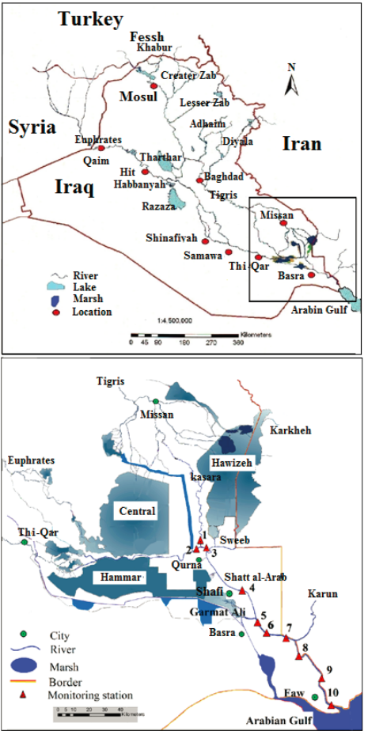
Figure 1. Location of the Shatt al-Arab river, its
tributaries and 10 measurement locations.
Recent Publications (minimum 5)

1. Abdullah, A.D., I. Masih, P. van der Zaag, U.F.A. Karim, I. Popescu and Q. Al-Suhail, 2015. Shatt al Arab River system under escalating pressure: a preliminary exploration of the issues and options for mitigation. International Journal for River Basin Management 13(2), 215-227 [doi:10.1080/15715124.2015.1007870]
2. Abdullah, A.D., U.F.A. Karim, I. Masih, I. Popescu, P. van der Zaag, 2016. Anthropogenic and tidal influences on salinity levels and variability of the Shatt al-Arab River. International Journal of River Basin Management, 14(3):357-366 [doi:10.1080/15715124.2016.1193509]
3. Abdullah, A.D., J. Gisen, P. van der Zaag, H. Savenije, U.F.A. Karim, I. Masih, and I. Popescu, 2016. Predicting the salt water intrusion in the Shatt al Arab estuary using an analytical approach. Hydrology and Earth System Sciences, 20 : 4031-4042 [doi: 10.5194/hess-20-4031-2016]
4. Abdullah A.D., I. Popescu, A. Dastgheib; P. van der Zaag; I. Masih, U.F.A. Karim, 2017. Analysis of possible actions to manage the longitudinal changes of water salinity in a tidal river. Water Resources Management [ doi: 10.1007/s11269-017-1634-5].
5. Abdullah A.D., 2016. Modelling approaches to understand salinity variation in a highly dynamic tidal river: the case of the Shatt al-Arab River. PhD theses, UNESCO-IHE institute for water education, Delft, the Netherlands.
6. Abdullah A.D., Castro-Gama M.E., Popescu I., van der Zaag P., Karim U., Al-Suhail Q., (submitted 2017). Optimization of water allocation in the Shatt al-Arab River when taking into account salinity variations under tidal influence.

Biography (150 word limit)
Ali Dinar Abdullah was awarded a BSc in Civil Engineering from Basra University in 2001, and an MSc in Water Resources Management from UNESCO-IHE Institute for Water Education in 2007. Returning to the Ministry of Water Resources Iraq, he became head of maintenance of water resource projects in 2008. With four more years of experience on flood protection, irrigation and drainage networks, Ali came back to UNESCO-IHE in 2012, researching water availability and salinity changes for improved water resources management in the Shatt al-Arab River, which is formed where the Euphrates and Tigris merge. In 2016 he successfully defended his PhD thesis in Delft in 2016, and is now back in Iraq at the Ministry, developing ideas and operation capacity to support the further restoration of the Mesopotamian Marshes.
Email: alidinar77@yahoo.com

Notes/Comments: The paper could be placed in one of the following sessions
• Water resource planning and management
• Water quality modelling
• Hydrology

