An analysis of Variation in Electrical Conductivity of Groundwater Using Fuzzy Clustering and Neural Network (A Case Study in Drainage Basin of Sefid Rood River)

Abstract:
In this study, the groundwater quality drainage basin of Sefid Rood River has been assessed using chemical analysis of 25 samples. As well as electrical conductivity, other parameters such as total dissolved solid (TDS) and chlorine were measured in the samples.The effectsof these parameters on the electrical conductivity were determined using fuzzy clustering. Then a relation between the parameters and the electrical conductivity was established by neural network.The obtained results indicated that the proposed method is quick, simple and reliable.The average error of relation and nearest-neighbor interpolation method were …. and …. , respectively.

Key words:

Fuzzy clustering, Neural network, Electrical Conductivity, Relation for determination of electrical conductivity

- Introduction

Population growth and consequently the increase in water demand for urban, industrial and agricultural purposesfrom one hand and increasing trend of direct and indirect pollutions of future water resources from the other handhave added a new level of complexity to water supply.Water quality and quantityhave been the focus of a significant amount of studies related to this topic.Among these resources, groundwater has received noticeable attentiondue to its importantrole in the optimal management of water resources. For example, Jalali[1] assessed the chemical components of Famenin groundwater at east of Iran. Johnston [2] studied the distribution of environmental chloride in relation to subsurface hydrology. Safarai [3]determined the filtration network of groundwater using geostatistic method.
Several approaches are found within the literature. Among these, the most powerful method to examine the quality and quantity of aquifer is mathematical and computer model; however, this is costly and time-consuming[4], [5].Other researches indicated that most of the aquifer parameters such aswater level have spatial and temporal variations which require geostatistical analysis[6], [7].The tool is geographic information system (GIS) that includes different software like PC-ILIWIS and PC-ArcView and has a critical role to analyze different factorsof groundwater such as pollution and to present the required maps [8], [9].

Quality and quantity of groundwater are two factors that affect the decision making process [10].It is evident that the quality plays essential roles in water resources management decision making process [11]. As such, many researchers devoted their efforts to the quality of groundwater [12], [13].Several methods and models have been developed in which the collected data from the study area are being used [14].However, this data is approximate and can not be applied to traditional models.Therefore it is inevitable to employ fuzzy logicwhich enables analysis of approximate data [15], [16].This logic based on the fuzzy theorypresents the bestrelation between criteria and variables. Hence, in recent years the use of fuzzy theory has dramatically increased to examine the chemical and hydrologic characteristics of groundwater.For example, Guler et al., [17], studied the impacts of anthropogenic activities on the groundwater hydrology and chemistry.
Among the quality variables of groundwater, electrical conductivity can be characterized as the most important factor which is easy to be measured accurately and does not require complicated tools. Besides, it can be determined by different approaches like neutral network [18], [20]. It also can be related to other quality variables such as nitrate concentration [19]. However, it is expected to apply a method which is simple, quick, accurate and capable to consider the approximation of collected data and importance of effective parameters on the electrical conductivity and to distinguish improper data. This research is aimed at investigating these parameters at drainage basin of Sefid Rood River using fuzzy theory and neural network. Two main reasons to select north of Iran are high population density and agricultural potentialof the region.
The organization of this paper is as follows. In section 2, clustering fuzzy is reviewed using c-means method and neutral network. Case study and obtained results are presented in Section 3. The application of fuzzy clustering and neutral network to derive a relation to determine electrical conductivity is explained in Section 4. In Section 5, the proposed relation was used to find the electrical conductivity at some points within the case study and the obtained resultsare presented.Finally, conclusions and recommendations are stated in Section 6.

- Fuzzy Clustering and Neutral Network
2.1 Fuzzy Clustering
In the deterministic clustering, adjacent data are placed in one cluster; howeverin the fuzzy clustering, each data belongs to all clusters with different degrees of membership. A centre is assigned for each cluster and the degree of membership will increaseas the distance between data and center decreases, and vice-versa.A number of methods have been proposed for fuzzy clustering. In this study, fuzzy c-mean method has been employed.This method has been applied successfully to analyze aquifers [17]. In this method, the degree of membership of each data (x_{k}) to each cluster (u_{ik}) is determined using cluster centers (v_{i}) and Equation 1 [21].

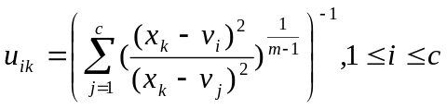 (1)

Then, cluster centers are calculated using degrees of membership and Equation.2.

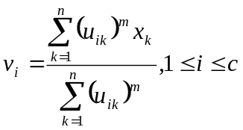 (2)
In the above equations, n,c and m are number of data, number of clusters and fuzzy coefficient, respectively. The fuzzy coefficient ranges between 1.5 and 2.5 and usually is assumed to be equal to 2.Figure 1 shows a fuzzy cluster and its related parameters.

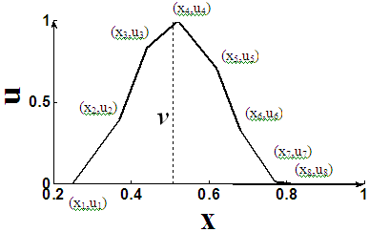
Figure1. Fuzzy cluster and its related parameters

Based on the proposed method, there is not any specific equation to determinethe initial centers of clusters and accordingly they are picked randomly. Different researchers have adopted different criteria for the optimal number of clusters. The current study employs criterion presented by Zhang et al., [22] which is a combinationof variance [22] and separation of the clusters [23]. Equations 3, 4, 5and 6correspond to variance criterion and Equations 7 and 8 are associated with separation criterion.

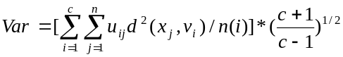 (3)
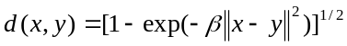 (4)
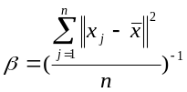 (5)
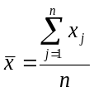 (6)

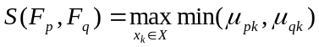 (7)

(8)

In the optimal clustering, the first and second criteria should be minimum and maximum, respectively. Therefore in order to find the optimal number of clusters, the above mentioned criteria should be first determined. Then, they are normalized based on the Equations 9 and 10 andfinally the ultimate criterion is calculated on the basis of Equation 11.The optimal number of clusteringcorresponds to minimumultimate criterion.
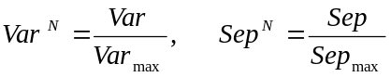 (9)

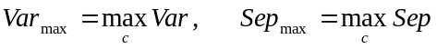 (10)
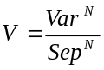 (11)

  - Artificial neural network

In a manner similar to human brain, artificial neural network is capable to process information. In the other words, it can compute the output from the input using a function. This function includescoefficients (a₁, a₂, …, a_{m}) and inputs (x₁, x₂, …, x_{n}).Some data including input(s) and output(s) are given to the network to match themselves with these data [24] so as to compute the coefficients of polynomial
The most currenttype of neural network is recurrent neural network (RNN)that has been employed in this study. This means the coefficients are calculated through spreading the difference in network output and target output (y) between polynomial coefficients. To do this, some values are first assigned to the coefficients and then the network output is determined using input(s). The difference between the network output and the target output is calculated and the change in each coefficient is determined by relation of network output. For this purpose, the relation of network output should be taken the derivative with respect to the coefficient. Then, the difference in network output and target output is divided into the obtained derivative and finally the result is multiplied by a number ranging between zero and one. This coefficient is shown as eta and thus the change of coefficient will be identified [25].
error=(y-output) (12)
Δa_{i}=(error/(df/da_{i}))×eta (13)

where, y is the target output,Δa_{i}is the i-th variable, df/da_{i}is derivative with respect to i-th variable and eta is a defined coefficient.
Similarly, the change of all coefficients is computed. Then the same procedure is repeated with new data, with the only difference that the coefficients have changed. The new coefficients are sum of old coefficients plus changes .This process is repeated for all data. Then in the next step again all data are utilized to train the network variables .The training sequence is continued until reaching one of these endpoints: 1. to reach the maximum number of training cycles. 2. the average difference between the network output and the target value for all data to be less than the threshold. The above-mentioned algorithm is illustrated in Figure 2.
YES
NO
NO
Optimal result
Set the first data as the training data

Use the next data
Is NTC greater than the limit or the error rate is acceptable?
YES
NTC=NTC+1
Is this the last dat?
a₁=a₁+Δa₁
a₂=a₂+Δa₂
a₃=a₃+Δa₃
.
.
.
a_{m}=a_{m}+Δa_{m}

error=(y-output)
Δa₁=(error/(df/da₁))×eta
Δa₂=(error/(df/da₂))×eta
Δa₃=(error/(df/da₃))×eta
.
.
.
Δa_{m}=(error/(df/da_{m}))×eta

Neural Network to determine the optimal values of parameters

A value is assigned to each coefficient.
Set the number of training cycle (NTC) to one and the first data as training data.

Determine the network output using inputs and coefficients.

Figure 2. Neural network algorithm

3. Case Study
3.1. Location

The study area is Sefid Rood alluvial fan located in drainage basin of Sefid Rood River, the largest river in the southern part of Caspian Sea, and is extended from Emam zadeh Hashem to Sefid Rood River Delta.The area which covers an area of 1412 km2is located in the east of Rasht City.Astaneh Ashrafieh is the largest city in the study area. The subject area is located in UTM zone 39N with a Northing between 409900 and 4150000 meters and an Easting between 370000 and 430000 meters. The aquifer is made of delta and alluvial deposits of Sefid Rood River. In the southern part, the aquifer deposit is coarser grained. In order to evaluate the quality of groundwaterof the study area, 25 observation wells were tested within 11 periods. The location of the wells is shown in Figure 3.
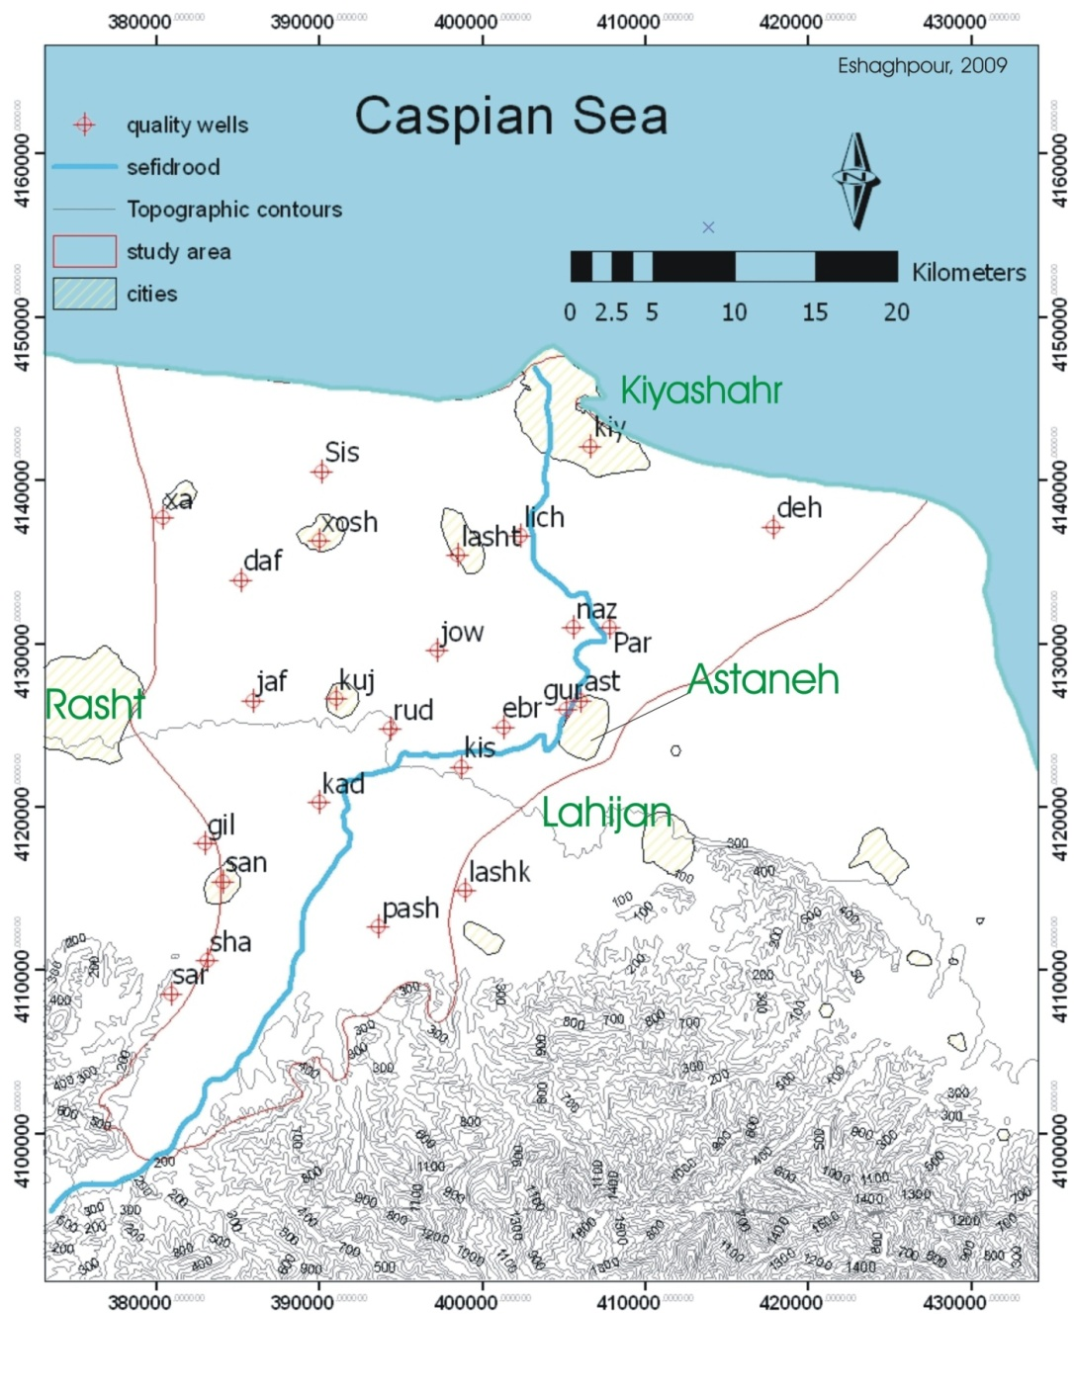
Figure 3. Location of observation wells within the study area

3.2. Obtained information from observation wells

The obtained information within 11 periods aretotal dissolved solid (TDS), electric conductivity (EC), total hardness (TH), anions CO₃, HCO₃, SO4, and Cl and cations Mg, Ca, Na and K. The information from one of the wells is summarized in Table 1.

Table 1. Measured Parameters in one of the observation e wells
EC*10^6  (µs/cm) | TH  (CaCO3) | TDS  (mg/l) | Cl  (meq/l) | HCO3  (meq/l) | k  (meq/l) | Mg  (meq/l) | Ca  (meq/l) | Na  (meq/l) | SO4  (meq/l)
1549 | 474.50 | 975.87 | 5.00 | 7.45 | 0.46 | 3.19 | 6.3 | 4.89 | 2.69

4. Determination of electrical conductivity using affective parameters

4.1. Parameters influencing electrical conductivity

Among the mentioned parameters in section 2-3, the most effective parameterson the electrical conductivity of groundwater should be recognized. The methodology used in this section is based on the determination of the relation between inputs and outputs of fuzzy system. In this system, the obtained data is used to categorize the output (electrical conductivity) to different clusters such as very low, low, average, high and very high. This clustering in which each member belongs to more than one cluster is performed through c-means method. The membership is shown as a number between zero and one.
برای هر یک از دسته های خروجی، دسته (های) هر یک از ورودی ها تعیین می شوند. برای این منظور میزان عضویت هر کدام از مقادیر خروجی به هر کدام از دسته ها، به مقادیر ورودی نظیر تعلق می گیرد.

In each cluster, the membership degree is initially low and gradually increases and then decreases. Therefore as shown in Figure 4, more than one input cluster might be generated for each output cluster. It can be seen that based on the degrees of membership, two input clusters are obtained. In this figure, the horizontal axis is output and input values and the vertical axis is degree of membership.
(y₂,u₂)
(y₁,u₁)
(y₅,u₅)
(y₆,u₆)
(y₈,u₈)
(y₇,u₇)
(y₉,u₉)
(y₄,u₄)
(y₃,u₃)
(x₁,u₁)
(x₃,u₃)
(x₅,u₅)
(x₇,u₇)
(x₈,u₈)
(x₆,u₈)
(x₂,u₂)
(x₉,u₉)

Figure 4. Two input fuzzy cluster per one output fuzzy cluster
هرچه میزان تاثیر یک ورودی بر خروجی بیشتر باشد، با تغییر میزان آن به مقدار مشخص، مقدار خروجی به میزان بیشتری تغییر می کند.

Therefore, obtaining lower number of input clusters per one output cluster means higher impact of the input to the output. This is used to determine the impact of inputs. To do this, first output values are clustered and then the corresponding input clusters to each output cluster are calculated. This process is repeated for all output clusters.After that, the corresponding clusters are added up and divided by the number of clusters. As the input value decrease, the impact of input to output will increase.
According to what mentioned in sections 1-3 and 2-3, the number of existing data is 275 (25*11). Among these, 20 data were utilized to evaluation the proposed method in section 4 and the remaining data were employed the above-mentioned method. It should be noted that the proposed method is valid for normalized output and input values within the range of 0 to 1. For this purpose, first all values are normalized based on their maximum and minimum values and then output values are clustered through using Equation 1 to 11. The optimal number of cluster is 12. Table 2 shows the average number of clusters and impact factor of different input values. The impact factor of each input is the inverse ratio of average number of clustersof that input to the total number of clusters of all inputs.

Table 2. Impact factor of affecting factors to electrical conductivity
Input | TH | TDS | Cl | HCO3 | K | Mg | Ca | Na | SO4
Average number of clusters | 7 | 7 | 8 | 6 | 49 | 10 | 20 | 18 | 5
Impact factor | 0.142 | 0.134 | 0.127 | 0.173 | 0.02 | 0.099 | 0.049 | 0.056 | 0.200

4.2. Determination of electrical conductivity
Equation 14 can be utilized to compute electrical conductivity in terms of affective parameters.
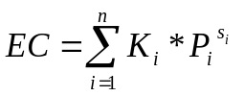 (14)

Where, n is number of affective parameters, P_{i}is the value of i-thparameter and K_{i} is the impact of factor of i-thparameter. S_{i} exhibits the relation between electrical conductivity and i-thparameter and is calculated based on the distance between the centers of output clusters and corresponding input clusters. For each output cluster, a vector is drawn from the centre of output cluster to the center of input cluster.R_{j} (j=1,2,…,c) is equal to the length of this vector and its sign is determined on the basis of vector direction. If the vector is directed towardright (left), the sign would be positive (negative). In the event of having more than one input clusters per output cluster, it is required to make an average between r_{j} values to determine m_{i}. Determination of r_{j}is illustrated in Figure 5. Also, Equation 16 is used to calculate S.

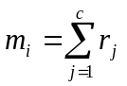 (15)

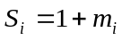 (16)

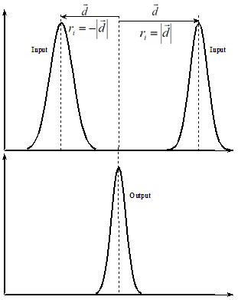
Figure 5. Determination of distance between two fuzzy clusters

The methodology is that if the vector is directed rightward (leftward), the output value is lower (higher) than input value.Hence, the exponent of input value should be greater (lower) than one. It should be noted that all values range between zero and one and in order to decrease them, the exponent should be greater than one and vice versa.
K_{i} and S_{i} are approximated based on the fuzzy clustering and the proposed relations and accordingly they should be optimized using the presented neural network in Section 2.2.
Four relations are developed to determine electrical conductivity. Cations, anions, stiffness and total dissolved solid are inputs to the first, second, third and fourth relation, respectively. Table 3 shows the values of K_{i} and S_{i} after optimization
Table 3. Coefficients and exponents of effective parameters (after optimization)
total dissolved solid | Hardness | Anions |  |  | Cations |  |  |  | Relation
TDS | TH | SO₄ | Cl | HCO₃ | K | Na | Mg | Ca | Inputs
1.081 | 1.2347 | 1.594 | 0.954 | 1.41 | 0.163 | 0.444 | 0.742 | 0.399 | K_{i}
2.44 | 0.2151 | 0.433 | 0.384 | 0.322 | 1.54 | 1.04 | 1.41 | 1.4 | S_{i}

5. Assessment of relation to determine electrical conductivity

In order to assess the proposed relation, the obtained results have been compared with the measured data from the well to determine error. Also, the same process was repeated using nearest-neighbor interpolation method. The results are presented in Table 4.
Electrical conductivity should be measured in the field and environmental conditions. This is because as the time passes in the laboratory, it will differ from its actual value in the field due to the temperature changes, dissolved gases and precipitation of some minerals. In this research, the electrical conductivity was measured in the laboratory, the all values were approximate and some of them were not within the acceptable range.

Table 4. Comparison of the proposed relation and nearest-neighbor interpolation method
 | داده1 | داده2 | داده3 | داده4 | داده5 | داده6 | داده7 | داده8 | داده9 | داده10 | داده11 | داده12 | داده13 | داده14 | داده15 | داده16 | داده17 | داده18 | داده19 | داده20
K | 0.089 | 0.219 | 0.079 | 0.089 | 0.04 | 0.079 | 0.271 | 0.05 | 0.18 | 0.32 | 0.03 | 0.059 | 0.069 | 0.05 | 0.069 | 0.089 | 0.101 | 0.079 | 0.069 | 0.079
Na | 3.981 | 6.742 | 2.848 | 3.190 | 3.025 | 4.441 | 2.176 | 1.715 | 2.872 | 4.465 | 1.833 | 4.465 | 3.367 | 3.521 | 4.347 | 3.981 | 4.064 | 5.09 | 4.087 | 4.677
Mg | 1.455 | 3.946 | 3.364 | 2.453 | 1.523 | 2.482 | 2.405 | 3.655 | 1.601 | 2.347 | 1.504 | 3.703 | 2.453 | 2.405 | 3.153 | 2.405 | 2.608 | 2.822 | 1.901 | 2.192
Ca | 5.4 | 2.817 | 5.868 | 9.375 | 5.248 | 4.290 | 3.997 | 4.395 | 4.605 | 5.845 | 4.395 | 4.851 | 7.703 | 7.703 | 2.852 | 7.306 | 8.159 | 7.633 | 2.595 | 4.874
2.61obtained relation | 1049 | 1220 | 1229 | 1562 | 1008 | 1137 | 924 | 999 | 982 | 1299 | 730 | 1331 | 1436 | 1388 | 941 | 1377 | 1499 | 1589 | 902 | 1131
Interpolation | 1031 | 1472 | 1220 | 1519 | 1119 | 1144 | 931 | 1018 | 993 | 1278 | 715 | 1330 | 1407 | 1396 | 439 | 1381 | 1452 | 1337 | 911 | 1122
Actual value | 1087 | 1430 | 1265 | 1548 | 986 | 1154 | 915 | 1025 | 974 | 1345 | 751 | 1301 | 1430 | 1361 | 956 | 1394 | 1484 | 1559 | 878 | 1163
Relation error (%) | 4+ | 15+ | 3+ | 1- | 2- | 1+ | 1- | 3+ | 1- | 3+ | 3+ | 2- | 0 | 2- | 2+ | 1+ | 1- | 2- | 3- | 3+
6.36  Interpolation error | 5+ | 3- | 4+ | 2+ | 13- | 1+ | 2- | 1+ | 2- | 5+ | 5+ | 2- | 2+ | 3- | 54+ | 1+ | 2+ | 14+ | 4- | 4+
So₄ | 1.2 | 0.55 | 1.66 | 2.29 | 1.22 | 0.77 | 0.82 | 1.12 | 0.77 | 1.72 | 0.67 | 1.85 | 1.6 | 2.66 | 1.32 | 2.47 | 2.21 | 3 | 1.86 | 0.73
Cl | 2.6 | 5.999 | 3.6 | 5.306 | 2.952 | 3.498 | 1.201 | 2.747 | 3.452 | 3.202 | 0.701 | 3.998 | 3.555 | 3.805 | 2.395 | 4.146 | 3.808 | 5.499 | 3.896 | 3.202
Hco₃ | 7.3 | 7.75 | 7.15 | 7.55 | 5.8 | 7.4 | 6.7 | 6 | 4.9 | 8 | 6.15 | 7.9 | 8.3 | 7.3 | 5.85 | 6.9 | 8.7 | 7.25 | 2.97 | 7.8
Proposed relation | 1069 | 1428 | 1225 | 1565 | 988 | 1226 | 937 | 1020 | 1003 | 1340 | 766 | 1299 | 1400 | 1366 | 958 | 1255 | 1353 | 1572 | 861 | 1236
Interpolation | 1096 | 1445 | 1438 | 1564 | 1012 | 1234 | 791 | 1012 | 948 | 1335 | 791 | 1399 | 1393 | 1331 | 1012 | 1550 | 1390 | 1510 | 853 | 1103
Actual value | 1087 | 1430 | 1265 | 1548 | 986 | 1154 | 915 | 1025 | 974 | 1345 | 751 | 1301 | 1430 | 1361 | 956 | 1394 | 1484 | 1559 | 878 | 1163
2.57  Relation error (%) | 2+ | 0 | 3+ | 1- | 0 | 6- | 2- | 0 | 3- | 0 | 2- | 0 | 2+ | 0 | 0 | 10+ | 9+ | 1- | 2+ | 7-
4.95  Interpolation error | 1- | 1- | 14- | 1- | 3- | 7- | 14+ | 1+ | 3+ | 1+ | 6- | 8- | 3+ | 2+ | 6- | 11- | 6+ | 3+ | 3+ | 5+
TDS | 684 | 900 | 797 | 975 | 621 | 727 | 577 | 646 | 614 | 848 | 473 | 1300 | 900 | 857 | 602 | 879 | 935 | 983 | 553 | 733
Proposed relation | 1093 | 1420 | 1265 | 1529 | 995 | 1160 | 927 | 1035 | 985 | 1342 | 755 | 1388 | 1420 | 1355 | 965 | 1388 | 1470 | 1541 | 888 | 1168
Interpolation | 1082 | 1429 | 1268 | 1547 | 987 | 1153 | 897 | 1026 | 974 | 1345 | 751 | 1300 | 1429 | 1365 | 953 | 1396 | 1484 | 1504 | 879 | 1160
Actual value | 1087 | 1430 | 1265 | 1548 | 986 | 1154 | 915 | 1025 | 974 | 1345 | 751 | 1301 | 1430 | 1361 | 956 | 1394 | 1484 | 1559 | 878 | 1163
Relation error (%) | 1- | 1+ | 0 | 1+ | 1- | 0 | 1- | 1- | 1- | 0 | 1- | 0 | 1+ | 0 | 1- | 0 | 1+ | 1+ | 1- | 0
Interpolation error | 0 | 0 | 0 | 0 | 0 | 0 | 2+ | 0 | 0 | 0 | 0 | 0 | 0 | 0 | 0 | 0 | 0 | 4+ | 0 | 0
TH | 342.9 | 338.3 | 461.3 | 593 | 340.9 | 340.9 | 323.1 | 405.1 | 312.5 | 412.4 | 297.9 | 429.6 | 509 | 507 | 253 | 487.1 | 540 | 524.2 | 228.5 | 355.5
Proposed relation | 1072 | 1063 | 1293 | 1517 | 1068 | 1068 | 1032 | 1191 | 1010 | 1204 | 980 | 1389 | 1376 | 1372 | 881 | 1338 | 1429 | 1402 | 822 | 1097
Interpolation | 948 | 1033 | 1719 | 1626 | 948 | 948 | 1001 | 1219 | 1420 | 993 | 967 | 1272 | 1382 | 1385 | 1025 | 1239 | 1366 | 1390 | 1094 | 1133
Actual value | 1087 | 1430 | 1265 | 1548 | 986 | 1154 | 915 | 1025 | 974 | 1345 | 751 | 1301 | 1430 | 1361 | 956 | 1394 | 1484 | 1559 | 878 | 1163
Relation error (%) | 1+ | 26+ | 2- | 2+ | 8- | 8+ | 13- | 16- | 4- | 10+ | 31- | 0 | 4+ | 1- | 8+ | 4+ | 4+ | 10+ | 6+ | 6+
Interpolation error | 13+ | 28+ | 36- | 5- | 4+ | 18+ | 9- | 19- | 46- | 26+ | 29- | 2+ | 3+ | 2- | 7- | 11+ | 8+ | 11+ | 25- | 3+

The average error of relation between cations and electricalconductivity and the nearest-neighbor interpolation error for the study area are 2.61% and6.36 %, respectively. Furthermore, the average error of relation between anions and electrical conductivity and the nearest-neighbor interpolation error are 2.57 % and 4.95 %, respectively. The relatively high error in both cases indicates the existing of other ions with low electrical conductivity.However it was found that the error of proposed method is lower than the nearest-neighbor interpolation error in both cases. This issue reveals that in such cases it is required to utilize meta-heuristic methods, like the proposed method in this research, to determine the relation between these parameters and electrical conductivity.
The average error of the relation between total dissolved solid and electrical conductivity and the nearest-neighbor interpolation error are 1.05% and 0.39%, respectively. This implies that the presented method is not effective for total dissolved solid (TDS) because its relation with electrical conductivity is so simple and evident that it does not require to use this method. A linear equation is defined by a variable coefficient which is normally assumed to be 1.56. In the event of using this relation, the average error is 4.29 %. Therefore, it is advised to employ nearest-neighbor interpolation method to determine electrical conductivity on the basis of total dissolved solid value.
The average error of the proposed relation between hardness and electrical conductivity and interpolation of nearest neighbor value are 8.49 % and 15.19 %, respectively. This issue indicates the appropriate performance of the relation. According to the literature review, it has been realized that up to now no equation has been developed to compare it with the presented equation in this study.

6. Conclusion

The water quality demands and its interaction effects on different consumption was the goal of this paper to determine electrical conductivity as a quality indicator of groundwater.For this purpose, powerful tools such as fuzzy clustering and neural network were utilized. The assessment of the proposed method indicated that it could be an appropriate substitute for many traditional equations.This is because there is no limitation in the number and type of inputs and it is be more accurate than even the interpolation methods in some cases.This is due to the employing effective methods for fuzzy clustering of data and optimizing of the parameters.
The unique feature of the proposed method is that it is simple and comprehensible. The values of electrical conductivity are categorized into some clusters which exhibit different statuses using simple relations.The used neural network in this research is the simplified version of the recurrent neural network (RNN).
Regarding the quality of groundwater, the proposed method to determine electrical conductivity can be applied to:
- Determine effective factors and their order of effectiveness on electrical conductivity
- Determine variables such as total dissolved solid (TDS) using electrical conductivity and the simple and approximate relation between them
- Distinguish improper data among existing data
- Determine water quality indicators like salinity using electrical conductivity and consequently to develop an optimization program
- Determine chemical reactions or interference of external water through determination of electrical conductivity at different parts of groundwater flow path
- Model from the presented method to determine other quality and quantity parameters of groundwater

7. References
- Jalali, M. (2007)Assessment of the chemical components of Famenin groundwater, western Iran,Environ Geochem Health, 29:357-374
- Johnston, C.D. (1987) Distribution of environmental chloride in relation to subsurface hydrology. – J. Hydrology 94: 67–88.
- Safarai, M., 2002. Determination filtration network of groundwater using geostatistic method.M.Sc Thesis. Tarbiyat Modares University Agricultural Faculty, Persian Version.
- Rojas,R. and Dassargues.A., (2007). Groundwater flow modeling of the regional aquifer of the Pamp del Tamarugal, northern Chile, Hydrogology Journal, 15, 537-551.
- Pisinaras, V., Petalas C., Tsihrintzis, V.A. and Zagana, E., (2007), A groundwater flow model for water resource management in the Ismarida plain, North Greece, Environmental Modeling and Assessment, 12: 75-89.
- Ahmadi., S,H and Sedghamiz., A. (2007) Geostatistical Analysis of Spatial and Temporal Variations of Groundwater Level, Environ Monit Assess 129:277-294.
- Theodossiou N., and Latinopoulos, P. (2006). Evaluation and optimization of groundwater observation networks using the kriging methodology. Environmental Modeling.
- Alemaw, B. F., Shemang, E. M., and Chaoka, T. R., 2004, Assessment of groundwater pollution vulnerability and modeling of the Kanye Wellfield in SE Botswana- a GIS approach, Physical and Chemistry of the Earth, v. 29, 1125-1128.
- Thapinta, A., and Hudak, p. F., 2003, Use of geographic information systems for assessing groundwater pollution by pesticides in Central Thiland, Environmental International, v.29, 87-93.
- Cheng-Shin Jang, Shih-Kai Chen, Yi-Ming Kuo, Establishing an irrigation management plan of sustainable groundwater based on spatial variability of water quality and quantity, Journal of Hydrology, Volumes 414–415, 11 January 2012, Pages 201-210.
- Cors van den Brink, Willem Jan Zaadnoordijk, Bas van der Grift, Peter C. de Ruiter, Jasper Griffioen , Using a groundwater quality negotiation support system to change land-use management near a drinking-water abstraction in the Netherlands, Journal of Hydrology, Volume 350, Issues 3–4, 28 February 2008, Pages 339-356.
- Yongjun Jiang, Yuexia Wu, Chris Groves, Daoxian Yuan, Pat Kambesis , Natural and anthropogenic factors affecting the groundwater quality in the Nandong karst underground river system in Yunan, Journal of Contaminant Hydrology, Volume 109, Issues 1–4, 13 October 2009, Pages 49-61.
- Sandow Mark Yidana, Bruce Banoeng-Yakubo, Thomas M. Akabzaa ,Analysis of groundwater quality using multivariate and spatial analyses in the Keta basin, Journal of African Earth Sciences, Volume 58, Issue 2, September 2010, Pages 220-234.
- M. Tamer Ayvaz, Application of Harmony Search algorithm to the solution of groundwater management models, Advances in Water Resources, Volume 32, Issue 6, June 2009, Pages 916-924.
- R.C.M. Nobre, O.C. Rotunno Filho, W.J. Mansur, M.M.M. Nobre, C.A.N. Cosenza , Groundwater vulnerability and risk mapping using GIS, modeling and a fuzzy logic tool, Journal of Contaminant Hydrology, Volume 94, Issues 3–4, 7 December 2007, Pages 277-292
- B. Dixon , Groundwater vulnerability mapping: A GIS and fuzzy rule based integrated tool, Applied Geography, Volume 25, Issue 4, October 2005, Pages 327-347.
- Cüneyt Güler, Mehmet Ali Kurt, Musa Alpaslan, Can Akbulut, Assessment of the impact of anthropogenic activities on the groundwater hydrology and chemistry in Tarsus coastal plain (Mersin, SE Turkey) using fuzzy clustering, multivariate statistics and GIS techniques, Journal of Hydrology, Volumes 414–415, 11 January 2012, Pages 435-451.
- Claudia Sainato, Griselda Galindo, Cristina Pomposiello, Horacio Malleville, Diego de Abelleyra, B. Losinno ,Electrical conductivity and depth of groundwater at the Pergamino zone (Buenos Aires Province, Argentina) through vertical electrical soundings and geostatistical analysis, Journal of South American Earth Sciences, Volume 16, Issue 2, June 2003, Pages 177-186.
- Kelin Hu, Yuangfang Huang, Hong Li, Baoguo Li, Deli Chen, Robert Edlin White, Spatial variability of shallow groundwater level, electrical conductivity and nitrate concentration, and risk assessment of nitrate contamination in North China Plain, Environment International, Volume 31, Issue 6, August 2005, Pages 896-903
- B. Tutmez, Z. Hatipoglu, U. Kaymak, Modelling electrical conductivity of groundwater using an adaptive neuro-fuzzy inference system,Computers & Geosciences, Volume 32, Issue 4, May 2006, Pages 421-433.
- Pal,N. R., Bezdek,J. C.(1994).“On cluster validity for the fuzzy c-means model,” IEEE Trans. Fuzzy Syst.
- Yunjie Zhang, Weina Wang, Xiaona Zhang, Yi Li, A cluster validity index for fuzzy clustering, Information Sciences 178 (2008) 1205–1218.
- H.K. Lee, Y.S. Song, K.M. Lee, Similarity measure between fuzzy sets and between elements, Fuzzy Sets Syst. 62 (1994) 291–293.
- Computational Materials Science 41 (2008) 305–311. Prediction of compressive strength of concrete containing fly ash using artificial neural networks and fuzzy logic, İlker Bekir Topçu , Mustafa Sarıdemir
- A. Rashidi, F. Jazebi, I. Brilakis, “A neuro-fuzzy genetic system for selection of construction project managers.” Journal of construction engineering and management, Vol. 137, No. 1, pp. 17-29, 2011.

