Key Factors for Flood Control Operation
Tae Jin Kim, Department of Civil Engineering, Daegu University, Republic of Korea

Abstract (300 word limit)
The monthly time step Water Rights Analysis Package Model (WRAP) is one of the components in the Texas Water Availability Model (WAM) system. Sub-monthly time step capabilities to conventional WRAP based on the monthly time step has been added. In this study, focus was given to key variables for simulating sub-monthly time step WRAP as follows: disaggregation of monthly inflow and routing parameters computation. The daily flow pattern method was utilized for disaggregating Brazos River Authority Condensed (BRAC) monthly inflow and routing parameters based on length are computed. The USACE Southwestern Division Reservoir System Simulation Model (SUPER) model daily unregulated (naturalized) flows from 1939 to 1997 were used to develop daily flow patterns for disaggregating BRAC monthly inflows. The mean values of the daily naturalized flow for 1939 to 1997 were used as the flow pattern for 1900 to 1939 and 1998 to 2007. Also, these daily flow patterns were distributed to the other ungaged control points. The lag times at control points of the BRAC dataset were computed based on the distance of the reaches with consideration of the lag time computed using the SUPER daily naturalized flow. The Muskingum routing parameters K were also computed based on the distance of the reaches. The key variable evaluated in this study provides a sufficient level of accuracy for using the model in flood control operations for a multiple-reservoir system. However, further refinements are possible by expending more time and effort to compile more detailed data.

Image

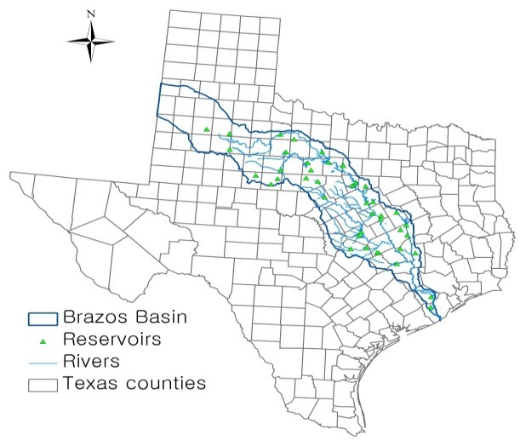
Fig. 1. The Brazos River Basin, Texas, USA
Recent Publications (minimum 5)
- Kim, T.J. 2014. Assessment of Relative Impact of Reservoir Location. J. Water Supply Res. T. 63(4), 248-259.
- Kim, T.J. 2015. Generation of Daily Naturalized Flow at Ungaged Control Points. J. Water Supply Res. T., 64(3), 354-364.
- Wurbs, R.A. and Hoffpauir, R. J. 2013. Water Rights Analysis Package (WRAP) Daily Modeling System, TWRI TR-430, Texas Water Resources Institute, College Station, Texas, USA, 329 pp.
- Wurbs, R.A. 2014. Sustainable Statewide Water Resources Management in Texas. J. Water Resour. Plan. Manage. Doi: http://dx.doi.org/10.1061/(ASCE)WR.1943-5452.0000499)
- Wurbs, R.A. 2015. Institutional and Hydrologic Water Availability in Texas. Water Resour. Manage. 29(2). 217-231.

Biography
Tae Jin Kim has been involved in various aspects of water and environmental fields, including watershed management, water availability, river basin hydrology, and management of river/reservoir system and optimization. His specific fields are as follows: watershed protection plan focused on surface runoff, base flow, and salinity, urban stormwater management focused on flood and water pollutant, multiple reservoir system operation, optimization: decision support system and watershed flood management.

Email:kimtj@daegu.ac.kr

Notes/Comments:

