Strategy for emergent contaminants and nanoparticles behaviors in surface waters

Philippe Le Coustumer, Associate Professor, University of Bordeaux, France
Mohamed Baalousha, Associate Professor, Unniversity of North Carolina, USA
Serge Stöll, Professor, University of Geneva, Swiss
Jessica Villanueva, Consultant, Bordeaux, France
Dirk Schaumlöffel, Professor, University of Pau
Gaëtane Lespes, Professor, University of Pau, France
Bruno Grässl, Professor, University of Pau, France
Stéphanie Reynaud, Associate Professor, University of Pau
Hélène Celle-Jeanton, Professor, University of Besancon, France
Frédéric Huneau, Professor, University of Corsica, France

ABSTRACT (300 words)
Environmental behavior of Emergent Contaminants (ECs) and nanoparticles (NPs) requires integrated approach. Currently, most of field studies are based on sampling which are susceptible to artefacts. It is therefore essential to develop recipe “best” practices to avoid misleading characterization, analytical bias and interpretation regarding simple concept.

This presentation provides some statements about useful concept, sampling methods and analytical tools allowing holistic approach for ECs and NPs presence and evolution in our environment.

1. We introduce the physicochemical speciation for metallic trace elements (MTE) and NPs, based on the topochemistry theory, to face MTE distribution and evolution in surface waters.
2. Samples have to respect many conditions and a brief review will fix the different available options. We take the opportunity to discuss of the interest of in situ sensors. Used from several years they can provide friendly information about labile concentration, fluxes and time integration along short (< 1 day) and long period (> 21 days).
3. Dedicated analytical platform is presented regarding the parameters and data needed for environmental impact of ECs and NPs of surface waters. It is based on coupling dynamic particle separation by Field-Flow Fractionation (A4F) online with DLS, MALLS, UV, FLD, HR-ICPMS, and offline with HR-STEM/X-EDS analysis.

Conclusion is based on our most recent works confirming:
- Physicochemical speciation helps for behavior of ECs & NPs exchanges between particles, colloids, labile fraction.
- In situ sensors bring additional information onto the labile fraction, flux and time evolution in surface waters.
- The dedicated platform is flexible and adapted for extreme low concentration, phase distribution, ECs and NPs impacting mechanisms (aggregation/disaggregation; conservation/evolution trends; intrinsic/extrinsic controlling parameters such pH, IS, etc.).

In term of water management, a global approach allowing reduction or controlling contaminants into surface waters (natural, used, waste) is available for collaboration or implementation.

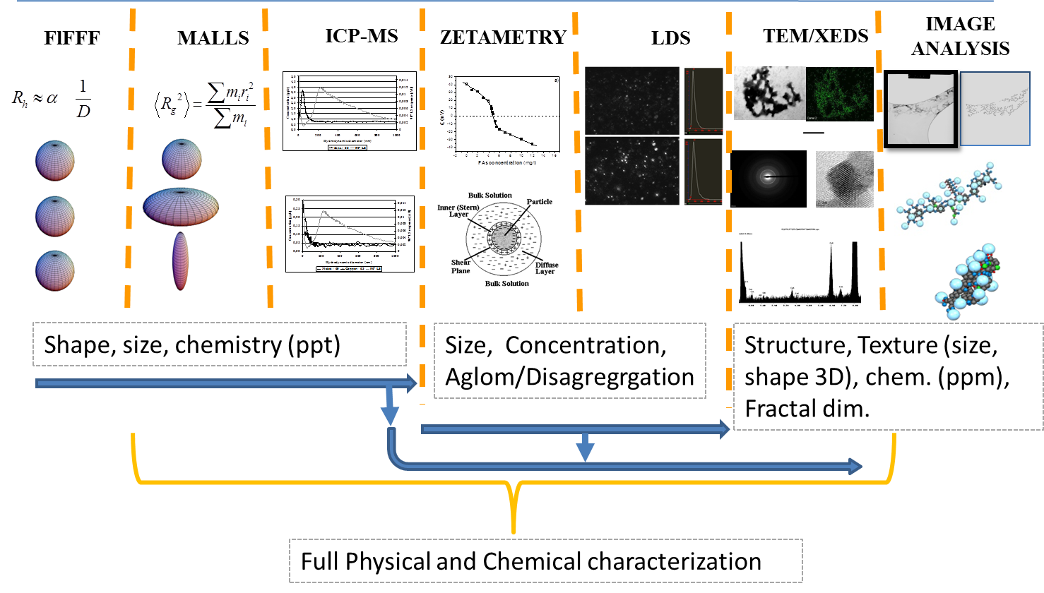
Figure 1: Analytical platform dedicated for emergent contaminants and nanoparticles in surface waters based on physic-chemical speciation concept.

RECENT PUBLICATIONS
Baalousha M, Le Coustumer P, Jones I., Lead J. R. (2010) Characterisation of structural and surface speciation of representative commercially available cerium oxide nanoparticles. Environ. Chem., 7, 377-385
Baalousha M, Kammer v.d. F., Motelica-Heino M., Baborowski M., Hofmeister C., Le Coustumer P (2006) Size-based speciation of natural colloidal particles by Flow Field-Flow Fractionation, ICP-MS and TEM/EDX: colloids-trace element interaction. Environmental Science & Technology, 40, 2156-2162. DOI: 10.1021/es051498d
Baalousha M, Motelica M, Le Coustumer P. (2006) Conformation and size of humic substances : Effects of major cation concentration and type, pH, salinity and residence time. Colloids and Surfaces A: Physicochemical and Engineering aspects, Vol. 272, No. 1, pp 48-55. DOI: 10.1016/j.colsurfa.2005.07.010
Baalousha M, Kammer F. v.d., Motelica-Heino M, Le Coustumer P. (2006) 3D characterization of natural colloids by FFF-MALLS-TEM. Analytical and Bioanalytical Chemistry, 383, 549-556.
Baalousha M, Kammer F. v.d., Motelica-Heino M., Hilal H. M. and Le Coustumer P. (2006) Size fractionation and characterization of natural colloids by FlFFF-MALLS. Journal of Chromatography A, 1104, 272-281
Kohlshutter H. W. (1918) Über Disperses Aluminiumhydroxyd. I. Z. Anorg. Allg. Chem. 105, 121. DOI: 10.1002/zaac.19181050102
Lespes G, Zuliani T, Schaumlöffel D. (2016) Need for revisiting the terminology about speciation. Environ Sci Pollut Res. 23:15767–15770. DOI 10.1007/s11356-016-6922-8
Loosli F, Le Coustumer P. Stoll S. (2015) Effect of electrolyte valency, alginate concentration and pH on engineered TiO2 nanoparticles stability in aqueous solution. Science of the Total Environment, Volume 535, Pages 28-34. DOI: 10.1016/j.scitotenv.2015.02.037
Loosli F., Le Coustumer P., Stoll, S. (2014) Effect of natural organic matter on the disagglomeration of manufactured TiO2nanoparticles. Environmental Science: Nano, Volume 1, Issue 2, 1, Pages 154-160. DOI: 10.1039/c3en00061c
Loosli F., Le Coustumer P. et Stöll S. (2013) TiO2 nanoparticles aggregation and disaggregation in presence of alginate and Suwannee River humic acids. pH and concentration effects on nanoparticle stability., Water Research, Volume 47, Issue 16, 15, Pages 6052-6063. DOI: 10.1016/j.watres.2013.07.021
Perez M. (2015) Développement de capteurs passifs pour le diagnostic et la gestion environnementale du cuivre en zone viticole. PhD 7 December 2015, Université de Pau & ds Pays de l’Adour, France
Perez M, Reynaud S, Lespes G, Potin-Gautier M, Mignard E, Chéry P, Schaumlöffel D, Grassl B. (2015), Development of a new passive sampler based on diffusive milligel beads for copper analysis in water, Anal. Chim. Acta. 890 117–123. DOI:10.1016/j.aca.2015.07.037.
Villanueva J.D., Le Coustumer P., Huneau F., Motelica-Heino M., Perez T.R., Materum R., Espaldon M.V.O., Stoll S. (2013) Assessment of Trace Metals during Episodic Events using DGT Passive Sampler: A Proposal for Water Management Enhancement. Water Resources Management 27 (12) , pp. 4163-4181, DOI: 10.1007/s11269-013-0401-5
Villanueva1 J. D., Le Coustumer P., Denis A., Abuyan R., Huneau F., Motelica-Heino M., Peyraube N., Celle-Jeanton H., Perez T. R., Espaldon M. V. O. (2015) Trends of labile trace metals in tropical urban water under highly contrasted weather conditions., Environ Sci Pollut Res., DOI: 10.1007/s11356-015-4835-6
Villanueva, J.D., Granger, D., Binet, G., Litrico, X., Huneau, F., Peyraube, N., Le Coustumer, P. (2016) Labile trace metal contribution of the runoff collector to a semi-urban river. Environmental Science and Pollution Research, Volume 23, Issue 11, pp 11298-11311. DOI: 10.1007/s11356-016-6322-0
Vystavna, Y., Huneau, F., Motelica-Heino, M., Le Coustumer, P., Vergeles, Y., Stolberg, F. (2012) Monitoring and flux determination of trace metals in rivers of the Seversky Donets basin (Ukraine) using DGT passive samplers. Environmental Earth Sciences 65 (6) , pp. 1715-1725.

Biography
Philippe Le Coustumer starts a scientific career (1987: PhD in Physic–Chemistry of Materials), as associate professor in Geology at the University of Poitiers (1991). In 2000 at Bordeaux University where he obtained his HDR in Earth Sciences (2003); Associate Director of the EA 4592 laboratory (2010-2014); Now he shares his time between 2 CNRS laboratories in Bordeaux and 1 in Pau University. His skills covered solid and soft material analysis, Nanoanalytics of colloids and bio-organic-inorganic materials, water & soil quality management, and waste valorization by dual approach. Involved in normalization (AFNOR, CEN, ISO) he has been nominated for the Audit and Evaluation of French normalization offices. He provides expertise at companies (BRGM, CEA, EDF, Horiba, Italcementi, Renault, Schott, Suez, Sumitomo); head of European INTAS project in Central Asia (1995 – 2001). He is co-authors of 10 ISO norms, 115 publications and 19 PhD directions; more details on: www.researchgate.net/profile/Philippe_Le_Coustumer.
Email: philippe.le-coustumer@u-bordeaux.fr

