Mathematical Modeling ROR to long term applied to precipitations and extremes temperatures in the Villa Clara Province. Cuba
Ricardo Osés Rodríguez. CMP Villa Clara, Cuba
Lomberto Gomez Camacho, CMP Villa Clara, Cuba.
Alfredo Pedraza Martinez, CMP Villa Clara, Cuba.

Abstract

Objective: To model the long term, one year before the extreme temperatures (maximum and minimum) and rainfall of the 5 closest weather stations available to the Provincial Meteorological Center of Villa Clara, and evaluation of the prognosis in an independent sample of 365 days. Methods: Objective Regressive Methodology, (ROR) is used. Results correlation coefficients of actual and predicted values of greater than 45% extreme temperatures and higher precipitation at 11% significant at 99% in both cases with small errors, less than 3 ªC for the temperatures of the stations are presented and minor errors at 12 mm rainfall. Discussion: Our study supports and demonstrates that it is possible to forecast extreme temperatures and daily rainfall a year in advance. Conclusions: The long-term prognosis is a powerful tool in planning the activities of individual companies or entities as both errors are small and the correlation coefficients are highly significant reason why the implementation of this service is recommended in practice.

Keywords: Forecast | Long term | Extremes temperatures | Precipitation | Villa Clara | Cuba

Recent Publications (minimum 5)
- .Impacto del clima en la salud humana y animal..Publicia.ISBN:978-3-8416-8056-3.
- Division by zero, of Cristosols to estimate universe longitude. Futurology and Regressive methodology finding information beyond awhite noise. Lambert Academic Publishing. OmniScriptum GmbH & Co.KG. ISBN: 978-3-659-71469-6.
- Mathematical modeling of malaria in the entomoepidemiológic analysis " (ISBN 978-3-659-02519-8) for the Spanish Academic Publishing is a trademark of LAP LAMBERT Academic Publishing GmbH&Co.KGAcademia.
4. Long Term Forecast of Meteorological Variables in Sancti Spiritus. CUBA. 01/2014; 2(1):37-42. DOI:10.12691/aees-2-1-6

5. Mathematical Modeling (ROR) applied to the forecast of earthquakes in the global level. Revista Electronica de Veterinaria 01/2014; volumen 15(No 08B).
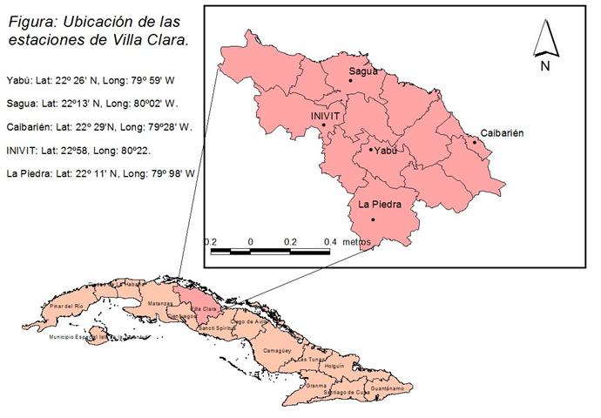
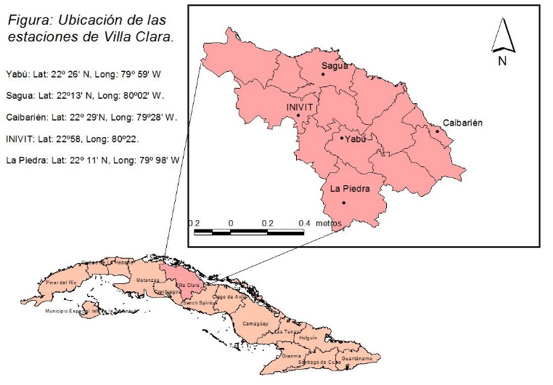


Biography
I direct science projects applied to different branches of the economy, I have developed a bulletin of climatic Surveillance where the rains and the extreme temperatures of the County are predicted besides it is extended to the two seasons in the province. I have imparted conferences of Statistic applied to the Meteorology and the Climatology, I am consultant of the Center in climatic applications and I carry out investigations on the presage and the climatic applications, I manage the software SPSS, as well as other software’s. I advise the technicians in Meteorology in the Provincial Meteorological Center. I have been boss of the department of Applied Meteorology and secretary of the Scientific Council of the Provincial Meteorological Center, I am Treasurer of the ONG Cuba solar in the County of Villa Clara that is devoted to the Promotion of the Sources of Renewable Energy in Cuba. I have published 5 books and more than 30 articles.
Email: ricardo.oses@vcl.insmet.cu

Notes/Comments:
Thanks , to the organizers of the Conference for my participation.

