Physical testing and computational fluid dynamic (CFD) modelling of articulated concrete blocks for application in large scale fishway passages
Sarah M Luu, BEng (Civil), Golder Associates, Australia

Abstract
Rock ramp fishways aim to mimic the natural ramps and pools observed in watercourses which allow the migration of fish. The high hydraulic roughness of rock generates low velocities required for fish migration. The recent design of a large scale (1.5 km long) rock-ramp fishway passage in North Queensland, Australia, required velocities lower than 0.3 m/s to allow migration of weak swimmers. The fishway required an alternative construction material due the cost and community issues associated with importing rock to the remote project site. Articulated concrete blocks (ACB) were selected as an alternative lining material with similar high hydraulic roughness. ACB consists of pre-fabricated concrete blocks connected to a mesh fabric. Aside from the ACB’s ability to reduce velocities, it was adopted due to the reduced labour installation requirements and its ability to modify the surface roughness through manufacturing. However, the use of ACBs to mimic the well-developed principles observed in rock-ramp fishways are largely undocumented. The purpose of this study is to assess the hydraulic performance of ACB lining and its ability to achieve the fishway’s low velocity design criteria. Computational fluid dynamics (CFD) and physical modelling were completed to test the hydraulic performance of ACBs. A longitudinal section of the fishway was modelled using the CFD package FLOW-3D to assess the water level profile and confirm whether the ACBs generate sufficient roughness to reduce velocity and prevent hydraulic jumps from occurring within the fishway. Scaled physical models were subsequently tested to optimise the ACB arrangement by ensuring target velocities were observed between the ACBs. The analysis revealed the ACB lining successfully mimics the hydraulic principles of a rock-lined ramp fishway and achieves the stringent fishway hydraulic design criteria. A continuous band of low velocities was observed for a large range of flow conditions between the ACB along the entire fishway ramp, thereby providing acceptable hydraulic conditions for fish passage.

Image
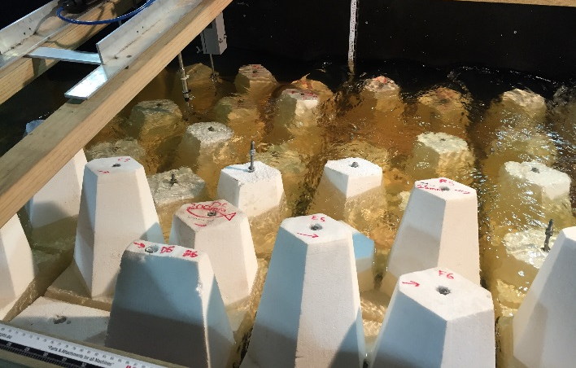
Recent Publications
- Haro A, Franklin A, Castro-Santos T, Noreika J (2008) Design and Evaluation of Nature-Like Fishways for Passage of Northeastern Diadromous Fishes. NOAA National Marine Fisheries Service Office of Habitat Conservation
- Baki A, Zhu D, Rajaratnam N (2014) Turbulence Characteristics in a Rock-Ramp-Type Fish Pass. Journal of Hydraulic Engineering Vol 141, Issue 2
- Baki A, Zhu D, Rajaratnam N (2014) Mean Flow Characteristics in a Rock-Ramp-Type Fish Pass. American Society of Civil Engineers
- E Plymesser (2014) Modeling fish passage and energy expenditure for American shad in a steeppass fishway using a computational fluid dynamics model. Montana State University - Bozeman, College of Engineering
- Acharya M, Kells J, Katopodis C (2000) Some Hydraulic Design Aspects of Nature-Like Fishways. American Society of Civil Engineers

Biography
Sarah Luu is a water resources engineer with Golder Associates in Brisbane, Australia. Her main areas of specialisations are surface water hydrology modelling, hydraulic design, sediment and erosion control planning and design, probabilistic water balance modelling, flood inundation studies, and environmental impact assessments. She has contributed to numerous water resources projects in the mining, oil and gas and infrastructure sectors across Australia, Pacific Islands, and Africa.
Email: sluu@golder.com.au

Notes/Comments:

