Identification of Sampling Locations in Al-Khobar Water Distribution Networks Using Demand Coverage Method

Amin Abo-Monasar, RN PhD, University of Hafr Al-Batin, KSA
Muhammad Al-Zahrani, RN PhD, King Fahd University of petroleum and minerals, KSA

Abstract (300 word limit)
Statement of the Problem: Delivering water in sufficient quantity and acceptable quality is the main objective of water distribution networks (WDN) and at the same time is the main challenge. The deterioration of water quality in the WDN leads to failure at the water quality level, which can be a serious issue since there are virtually no safety barriers before water consumption. Accordingly, developing monitoring (sampling) system which is capable of increasing the level of protection for consumers in case of water quality deterioration is essential. The purpose of this study is to develop a water quality monitoring system for Al-Khobar city WDN. Methodology & Theoretical Orientation: Demand Coverage Method (DCM) and optimization techniques such as Integer Programming were employed to develop an enhanced monitoring system for the WDN. The monitoring system was developed for a real distribution network serving about 300,000 capita, considering the constraints provided by the water authorities. This paper also studies the effect of regional and non-regional constraints for locating optimal monitoring stations and total monitored demand (TMD). Findings: The study shows that it was possible to improve the monitoring system for Al-Khobar WDN using DCM and by dividing the day into four time zones. In addition, the study shows that effect of regional constraints on the TMD decreases as the number of monitoring stations increases.

Image
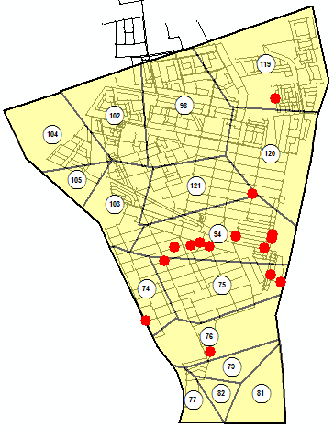
Recent Publications (minimum 5)
- Abo-Monasar, A., and Al-Zahrani, M. A. (2014). Estimation of rainfall distribution for the southwestern region of Saudi Arabia. Hydrological Sciences Journal, 59(2), 420-431.
- Al-Zahrani, M., Chowdhury, S., and Abo-Monasar, A., (2015). Augmentation of surface water sources from spatially distributed rainfall in Saudi Arabia. Journal of Water Reuse and Desalination.
- Al-Zahrani, M. A., and Abo-Monasar, A., (2015). Urban Residential Water Demand Prediction Based on Artificial Neural Networks and Time Series Models. Water Resources Management, 1-12.
- Al-Zahrani A., Abo-Monasar A. and Sadiq R., (2015). Risk-based prioritization of water main failure using fuzzy synthetic evaluation technique. Journal of Water Supply: Research and Technology-Aqua, jws2015051.
- Abo-Monasar A. and Al-Zahrani M., (2016). Framework for water quality monitoring system in water distribution networks based on vulnerability and population sensitivity risks. Water Science and Technology: Water Supply: ws2016174.

Biography (150 word limit)
Amin Abo-Monasar is an Assistant Professor in Civil Engineering dept. at University of Hafr Al-Batin (UOHB). His research interests include Water resources engineering, Hydraulics of water distribution networks, Optimal design and operation of distribution networks and Applications of Operational research, Artificial Intelligence, Decision Support systems and GIS in water engineering. As a member of the Water Research Group in KFUPM, he is trying to develop a real-time and interactive monitoring systems for water distribution networks
Email: abomonasar@hotmail.com monasar@uohb.edu.sa

Notes/Comments:

