Estimation of Maximum Scour Depth near A Spur Dike
Manish Pandey, Research Scholar, IIT Roorkee, India
Dr. P.K. Sharma, Associate Professor, IIT Roorkee, India
Dr. Z. Ahmad, Professor, IIT Roorkee, India
U.K. Singh, Research Scholar, IIT Roorkee, India

Abstract

Scour is a natural phenomenon in river or streams caused by the erosive action of the flowing water on the bed and banks. Abutments undermines due to river bed erosion and scouring, which generally recognized as the main cause of abutment failure. Various equations (Dey and Barbhuiya, 2005; Nagy, 2004; Husain et al. 1998; Lim, 1994 and Frochlich, 1989) have been evolved in the literature for the estimation of maximum scour depth near an abutment. In the present study, controlled experiments around vertical wall abutments have been carried out for estimating maximum scour depth. The collected data in this study along with data of the previous investigators have been carried out on the scour near vertical wall abutment. The collected data in this study along with data of the previous investigators have been used to check the validity of the existing equations of estimation of maximum scour depth. After statistical and graphical analysis, it has been concluded by authors equation proposed by Dey and Barbhuiya (2005) gives good agreements between observed and computed values of maximum scour depth. A new relationship is also proposed to estimate the maximum scour depth around vertical wall abutment and this equation gives better results as compared to the other existing equations.
Eq. (1) was derived for calculating the maximum scour depth around vertical wall abutment. Eq. (1) performs the best result for predicting the maximum scour depth around an abutment. Figure 1 shows the error between present and equation proposed by Dey and Barbhuiya (2005) and almost 90% of the data points are within ±25%.
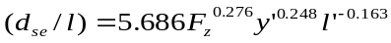 (1)
Where, Fz=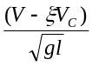, = 0.5 for vertical wall abutment.

Image
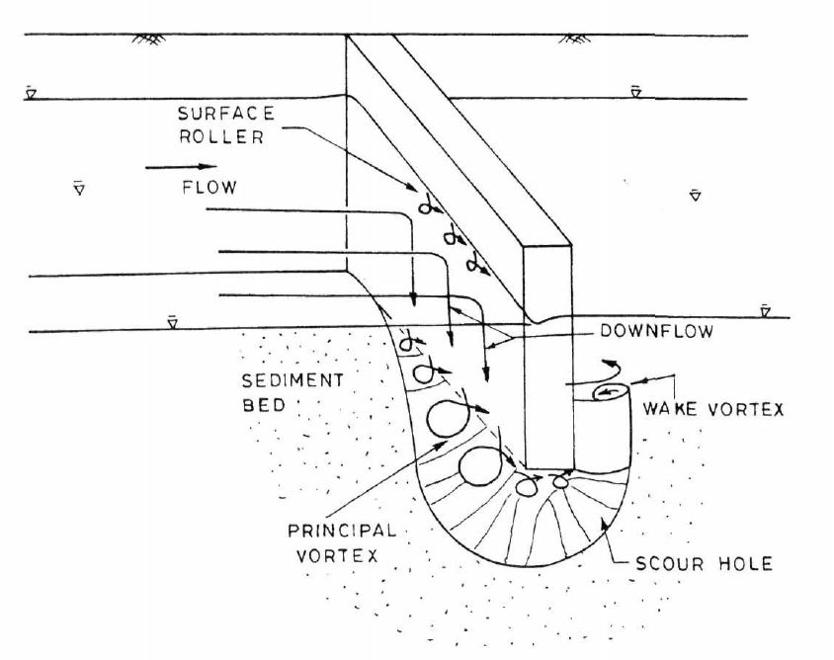
Figure 1: Vortex system around a vertical wall abutment (Kwan, 1984).

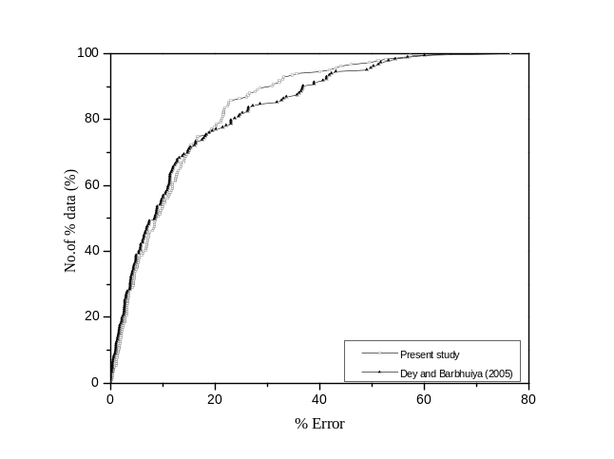
Figure 2: Comparison between equation of Dey and Barbhuiya (2005) and present equation.
Recent Publications
- Baba, Y. et al. (2010), Flow and bed load dynamics around spur dyke in a compound channel. 11th International Symposium on River Sedimentation (ISRS), Stellenbosch, 1-11.
- Dey, S. and Barbhuiya, A. K. (2005), Time variation of scour at abutments. Journal of Hydraulic Engineering, ASCE 131(1): 11-23.
- Marson, C., Fiorotto, V. and Caroni. E. (2006), Clear water scour analysis around groins and bridge abutments. Taylor & Francis Group plc, London, 1749-1775.
- Rajurkar, M. P. et al. (2009), An expert system for predicting longitudinal dispersion coefficient in natural streams by using ANFIS. Expert Systems with Applications. 36: 8589–8596.
- Talaat, A. et al. 2009), Implementation of spur dikes to reduce bank erosion of temporary diversion channels during barrages construction. Australian Journal of Basic and Applied Sciences, 3(4): 3190-3205.


Biography
Manish Pandey was born in Nainital, Uttarakhand, India. He received his B.Techdegree in Civil Engineering from Uttarakhand Technical University Dehradun India in 2012. After that he completed his M.Tech degree from Indian Institute of Technology Roorkee, India in 2014. Presently He is full time Ph.D student at Indian Institute of Technology Roorkee, India. His research area is Fluvial Hydraulics, Sediment Transport, Open Channel Hydraulics and Hydraulic Structure. He has published several papers in reputed journals and conferences. He have membership of ISH, IWRS and IEEE since 2014. He have also a 1one semester teaching experience at Quantum Global Campus Roorkee, India. Presently he has an administrative post of Assistant Warden of Radhakrishnan Bhawan, IIT Roorkee India.
Email: manishpandey3aug@gmail.com

