Utilizing Stormwater Resources in Urban Areas using Geospatial Tools
Shray Pathak, Research Scholar, IIT Roorkee, India C.S.P. Ojha, Professor, IIT Roorkee, India R.D. Garg, Associate Professor, IIT Roorkee, India

Abstract
Growing water scarcity and global climate change call for more effective and efficient alternatives for conservation of water. Among all the water harvesting techniques, Storm Water Harvesting (SWH) is the most sustainable approach to reduce pressure on fresh water resources. However, estimation of SWH potential and the selection of suitable sites by applying various complicated approaches for SWH structures are very challenging. This study represents a fairly robust methodology for evaluating SWH potential and identifying sites for different SWH structures by considering multiple technical and socio-economic factors that influence the site suitability. GIS based screening methodology is adopted for identifying potential suitable SWH sites in urban areas as a first pass, then a detailed study by applying suitability criteria’s is also substantiated with the experience of water planners. Initially potential hotspots are identified by a concept of accumulated catchments and later the sites are screened and ranked under screening parameters namely demand, ratio of runoff to demand and weighted demand distance by taking equal weightages for the screening parameters. Then for finalizing the suitable site for SWH, the top ranking sites are opted with the consultation from the urban water infrastructure planners. Thus, the methodology demonstrates the benefits of such tools for water professionals for reducing the stress on freshwater assets. The rapid identiﬁcation of suitable sites for stormwater harvesting can assist planners in prioritising schemes in areas that will have the most impact on reducing potable water demand.
Image
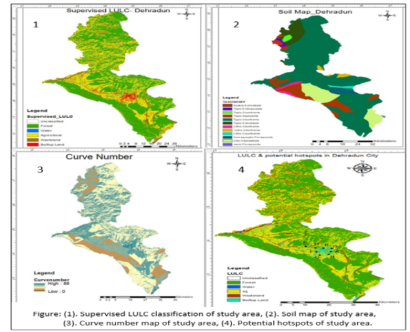
Figure: (1). Supervised LULC classification of study area, (2). Soil map of study area, (3). Curve number map of study area, (4). Potential hotspots of study area.

References
- Fletcher, T., Deletic, A., Mitchell, V., Hatt, B. (2008). “Reuse of urban runoff in Australia: a review of recent advances and remaining challenges.” Journal of Environmental Quality, 37, 116-127.
- Inamdar, P. M., Cook, S., Sharma, A. K., Corby, N., O'Connor, J., and Perera, B. J. C. (2013). “A GIS based screening tool for locating and ranking of suitable stormwater harvesting sites in urban areas.” Journal of environmental management, 128, 363-370.
- Fletcher, T.D., Andrieu, H., and Hamel, P. (2013). “Understanding, management and modelling of urban hydrology and its consequences for receiving waters: A state of the art.” Advances in Water Resources, 51, 261–279.
- McDonald, R. I., Weber, K., Padowski, J., Flörke, M., Schneider, C., Green, P. A., Gleeson, T., Eckman, S., Lehner, B., Balk, D. and Boucher, T. (2014). “Water on an urban planet: Urbanization and the reach of urban water infrastructure.” Global Environmental Change, 27, 96-105.
- Ojha C.S.P., Bhunya P., and Berndtsson R. (2008). Engineering Hydrology, 1st Ed., Oxford University Press, UK, 1-459.

Biography
Shray Pathak was born in Karnal, Haryana, India, in 1990. He received the Bachelor’s degree in Civil Engineering from the National Institute of Technology, Kurukshetra, Haryana, India in 2012 and Master’s degree in Civil Engineering from the Indian Institute of Technology, Roorkee, Uttarakhand, India in 2014. From 2014, he is pursuing the Ph.D. degree in Civil Engineering from the Indian Institute of Technology, Roorkee, Uttarakhand, India. His research interest includes remote sensing, GIS, water resources management, climate change, GPS surveying. This author became a Student Member of IEEE in 2016. He has published papers 1 in international refereed journal, 2 in international/ national book chapters and 2 in international conferences.
Email: shraypathak@gmail.com

