The Oxygenic Photogranule (OPG) process as a novel technology for wastewater treatment
Ahmed Abouhend, UMass Amherst, USA
Chul Park, PhD, UMass Amherst, USA

Abstract (300 word limit)

Wastewater treatment is an energy-intensive industry. About 2.16 MJ of energy is required for the treatment of 1 m3 of wastewater. Since 1912-1914, activated sludge process is the most common technology for wastewater treatment. In activated sludge system, mechanical aeration is required to provide oxygen to the biological flocs (bacteria). Then, the bacterial flocs use this oxygen to oxidize the organic matter and ammonia from wastewater. The process involves oxygen being introduced into the activated sludge system accounts for 25-60% of the overall operational costs. Besides, activated sludge does not settle very well so settling tanks are required to allow the biological flocs to settle. On the other hand, untreated wastewater holds more than 10 times the energy used to treat it. If we can capture this potential energy from wastewater, the wastewater treatment process might become an energy producer rather than a consumer. We propose the oxygenic photogranule (OPG) process for aeration-free wastewater treatment. OPG process is a light-driven wastewater treatment that eliminates the need for mechanical aeration to treat wastewater. These photogranules are enriched with a phototrophic community (cyanobacteria, microalgae) that produces O2 needed for oxidizing organic matter and treating wastewater. Under sunlight, the phototrophs autonomously produce O2 through photosynthesis, which in the activated sludge process should be provided by energy-intensive aeration. In turn, the heterotrophic bacteria within the OPG uses this oxygen to oxidize the organic matter in wastewater and produces CO2 for phototrophs. We evaluated the feasibility of these granules for wastewater treatment in bench and pilot scales. The OPG process can cut the wastewater treatment costs in half through sustaining self-aeration process. Besides, the easily harvested phototrophic biomass could be converted through various pathways to biofuels. This phototrophic biogranule technique would allow wastewater treatment plants to generate most of the energy needed for plant operation.
Image
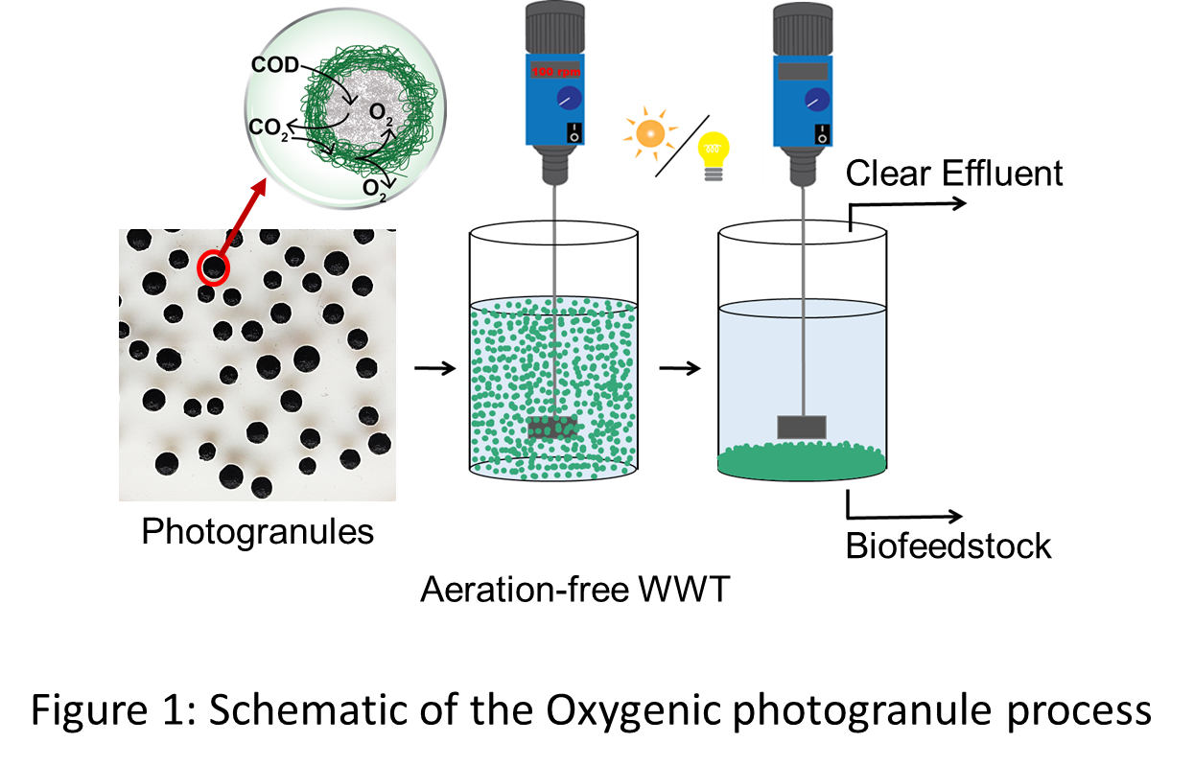
Recent Publications (minimum 5)
1- Milferstedt, K.; Kuo-dahab, W. C.; Butler, C. S.; Hamelin, J.; Abouhend, A. S.; Stauch-White, K.; McNair, A.; Watt, C.; Carbajal-Gonzalez, B. I.; Dolan, S.; et al. The importance of filamentous cyanobacteria in the development of unusual oxygenic photogranules. Sci. Rep. In review.
2- El-Metwally M.E.A., Abouhend A.S., Dar M.A., and El-Moselhy K.M., 2017, Effects of urbanization on the heavy metal concentrations in the Red Sea coastal sediments, Egypt. International Journal of Marine Science, 7(13): 114-124.
3- Abouhend, A.S. and El-Moselhy, K.M (2015) Spatial and Seasonal Variations of Heavy Metals in Water and Sediments at the Northern Red Sea Coast. American Journal of Water Resources, 3(3):73-85.
4- Shaaban, M.T, Ibrahim, H.A.H. Abouhend, A.S. and El-Moselhy, K.M (2015) Removal of Heavy Metals from Aqueous Solutions Using Multi-Metals and Antibiotics Resistant Bacterium Isolated from the Red Sea, Egypt, American Journal of Microbiological Research, 3(3):93-106.
5- Abdelmongy, A.S. and El-Moselhy, K.M. (2015) Seasonal variations of the physical and chemical properties of seawater at the Northern Red Sea, Egypt. Open Journal of Ocean and Coastal Sciences, 2(1):1-17.


Biography (150 word limit)
Ahmed Abouhend is a PhD student in Environmental and Water Resources Engineering (EWRE) Program at UMass Amherst, USA. He used to work at the National Institute of Oceanography and Fisheries, Egypt. He did his Masters in Egypt then traveled to the US to pursue his PhD research. He is interested in water quality assessment, wastewater technologies and reactors operations. His PhD research focuses on the oxygenic photo-granules (OPGs) process as a novel technology for wastewater treatment.
Email: aabouhend@umass.edu

Notes/Comment

