A Hierarchical Approach for Change Detection of Water Areas Using a Multi-scale Tile Map
Yilang Shen, Tinghua Ai and Jing Zhou
Wuhan University, China

Abstract
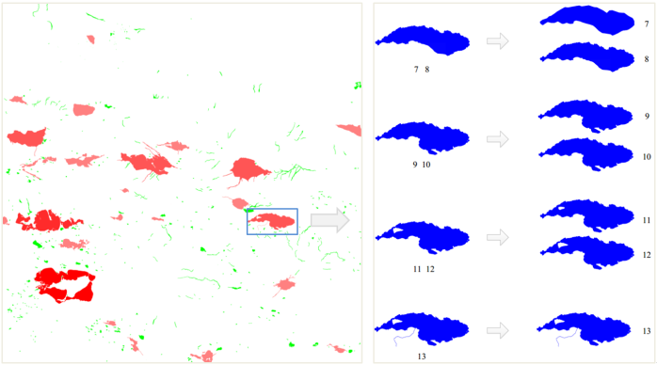
The data source of spatial data for change detection can be divided into raster and vector format. In traditional methods of change detection, remote sensing image is the primary raster data for change detection. In this paper, we describe the use of a new type of raster data, tile maps, to detect the change information of multi-scale water system. From the perspective of spatial cognition, we propose the theory of hierarchical change detection of water areas based on the multi-scale tile map. The detection level of multi-scale water change is divided into three aspects: macro level, medium level, micro level. We also classify the changes of water areas and establish a set of indicators and rules used for the change detection of water areas in the multi-scale tile map. In addition, we solve the key technology in the process of water extraction from a tile map. For evaluation purpose, the proposed method is applied in several test areas from TianDi map in China. After evaluating the accuracy of change detection, our experimental results confirm the efficiency and high accuracy of the proposed methodology.

Image

Figure 1. Hierarchical expression of change information.
Recent Publications
- Rokni K, Ahmad A, Selamat A, Hazini S (2014) Water feature extraction and change detection using multitemporal Landsat imagery. Remote sensing 6:4173-4189.
- Du Z, Linghu B, Ling F, et, al (2012) Estimating surface water area changes using time-series Landsat data in the Qingjiang River Basin, China. Journal of applied remote sensing 6:063609.
- Li X, Damen M C J (2010) Coastline change detection with satellite remote sensing for environmental management of the Pearl River Estuary, China. Journal of marine systems 82:54-61.
- Shi W, Cheung C K (2006) Performance evaluation of line simplification algorithms for vector generalization. The cartographic journal 43: 27-44.
5. Duckham M, Lingham J, Mason K, Worboys, M (2006) Qualitative reasoning about consistency in geographic information. Information sciences 176:601-627.

Biography
Yilang Shen is a PhD candidate in Resources and Environmental Science Institute, Wuhan University. His major specialty contains computer vision, cartographic generalization and spatial data quality.
Email: yilangshen@whu.edu.cn

Notes/Comments:

