Constraining groundwater flow model uncertainty: Workflow and application to deep low-permeable formations
Dirk Mallants, PhD, CSIRO, Australia
Chris Turnadge, CSIRO, Australia
Stan Smith, University of Utah, USA
Luk Peeters, PhD, CSIRO, Australia

Abstract
Large-scale groundwater flow model predictions are generally highly uncertain due to poorly constrained hydrogeologic properties, boundary conditions, and geologic layers. The present study demonstrates a generic workflow to iteratively constrain prediction uncertainty by obtaining improved estimates of the most sensitive model components and incorporating them in updated simulations. A case study was developed in which an initially poorly characterized low-permeable formation, a so-called aquitard, was subject to improved characterization resulting in better constrained estimates of hydrogeologic properties. This study used an existing large-scale groundwater flow model in the Gunnedah Basin, New South Wales, Australia as the basis for the quantification of prediction uncertainty. Predictions generated by the flow model included the magnitude and timing of maximum drawdown in a confined aquifer separated from a stressed groundwater system by a sequence of deep aquitards. A global sensitivity analysis revealed the vertical hydraulic conductivity (K_{V}) as one of the most sensitive groundwater system parameters, which was subsequently subject to improved characterization. Porosity–permeability relationships obtained on core samples were combined with downhole neutron-density logs to generate high-resolution vertical K_{V} profiles. These were then upscaled to the scale of the aquitard formation using analytical and numerical methods. Monte Carlo sampling from hydrogeologic parameter prior distributions was used to estimate the uncertainty of groundwater model predictions before and after improving the characterisation of aquitard K_{V} values. Independent estimates of aquitard-scale K_{V} were derived from a 1D transport model interpretation of a profile of natural tracer. Monte Carlo simulations using a spatially uniform aquitard K_{V} model did not considerably change groundwater model predictions. The groundwater model predictions were best constrained when the spatial correlation structure of K_{V} was explicitly accounted for in the Monte Carlo simulations. The workflow allows for an iterative updating of those uncertain parameters to which the model is most sensitive.

Image
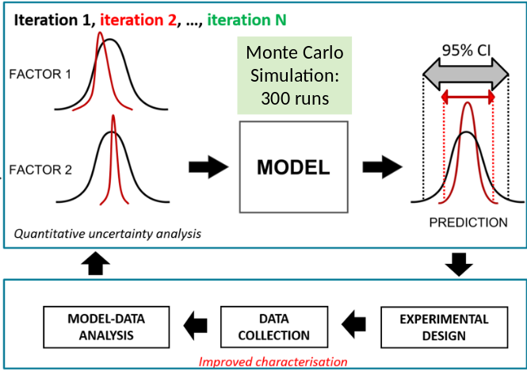
Figure 1 An iterative approach to uncertainty quantification.
Recent Publications (minimum 5)
- Laloy E, Rogiers B, Vrugt J, Mallants D, Jacques D (2013). Efficient posterior exploration of a high-dimensional groundwater model from two-stage MCMC simulation and polynomial chose expansion. Water Resources Research 49(5): 2664-2682.
- Peeters L (2017) Assumption Hunting in Groundwater Modeling: Find Assumptions Before They Find You. Groundwater, 10.1111/gwat.12565
- Peeters L, Podger GM, Smith T, Pickett T, Bark RH, & Cuddy SM (2014) Robust global sensitivity analysis of a river management model to assess nonlinear and interaction effects Hydrol. Earth Syst. Sci., , 18, 3777-3785 doi:10.5194/hess-18-3777-2014
- Rogiers B, Mallants D, Batelaan O, Gedeon M, Huysmans M and Dassargues A (2017) Model-based classification and automated lithostratigraphical mapping of CPT data for high-resolution characterization of a heterogeneous sedimentary aquifer. PLoSONE (https://doi.org/10.1371/journal.pone.0176656)
- Rogiers B, Winters P, Huysmans M, Beerten K, Mallants D, Gedeon M, Batelaan O, Dassargues A (2014) High resolution saturated hydraulic conductivity logging of borehole cores using air permeability measurements. Hydrogeology J. 22(6): 1345-1358.
- Rogiers B, Mallants D, Batelaan O, Gedeon M, Huysmans M, and Dassargues A (2012) Estimation of hydraulic conductivity and its uncertainty from grain-size data using GLUE and artificial neural networks. Mathematical Geosciences 44(6): 739-7635.
- Turnadge C, Mallants D, Peeters L (2016) Aquitard and Fault Simulation Approaches for Use in Regional Scale Assessments of Coal Seam Gas Extraction Impacts. Society of Petroleum Engineers Asia Pacific Oil & Gas Conference and Exhibition. SPE-182460182463-MS. OnePetro.org (http://dx.doi.org/10.2118/182463-MS).

Biography
Dirk Mallants has a background in soil and groundwater hydrology with more than 25 years of experience in characterising and modelling water flow and contaminant transport in complex environments – typically variably-saturated soils, aquifers and low-permeable porous media including deep clay formations and fractured concretes. He contributed to establishing one of the most extensive datasets on hydraulic conductivity of aquitards. Integrating experimental observations and numerical modelling has always been at the centre of his research. His work includes parameterisation of pore-scale and field-scale spatial variability in flow and transport properties, modelling processes of water flow and contaminant transport across a range of spatial scales, and the evaluation by means of process-based models of management options for water-related environmental pollution problems. He has extensive experience of working across a range of scales to understand dynamics of groundwater systems and the impact of resource extraction on the groundwater resource and groundwater dependent ecosystems.
Email: dirk.mallants@csiro.au

