Available Water Resources Index (AWRI) as An Innovation on Water Quantity Environments
Hi-Ryong Byun, Prof. Pukyong National Univ. Rep. of Korea

Abstract
With a new parameter that synthesizes the precipitation amount and it’s time intervals, this study would like to show a new research field of water quantity environment. The dangers of flood, drought and land slide etc. are caused not by the precipitation sum but by the Available Water Resources Index (AWRI) that is the remained water that diminished along time pass by runoff and evapotranspiration etc. after precipitation.
To calculate AWRI, only a simple logic that says ‘the longer the time passes after precipitation, the smaller the AWRI becomes’ is adopted. The differences caused by topography, soil texture and ecosystem etc. can be adjusted using the statistics when necessary.
Originally the summation duration of precipitation in AWRI is 365 days because it is the main periodicity of precipitation on the whole world but it is elongated to 365+n-1 when the anomalies of AWRI is consecutively negative or positive for n days, and it should be recalculated along revised duration.
With the use of AWRI, drought diagnosis became more reasonable by using EDI (Effective Drought Index) and its prediction possible. The big Korean droughts on 2012 and 2015 were predicted at 2008 and it proved true. Every next year’s May drought became predictable in early October when AWRI showed the maximum. It was also found that over 470 mm/day of AWRI at the Dobong observatory make the Eastern Trunk Road of Seoul inundated. This means early warning of flood-like disasters is possible as soon as precipitation is observed or predicted.
Besides, water seasons divided into the little water season and the abundant water season not along the rainy days but along the water quantity, and the big spatial differences of water environments were digitized for agricultural use.

Image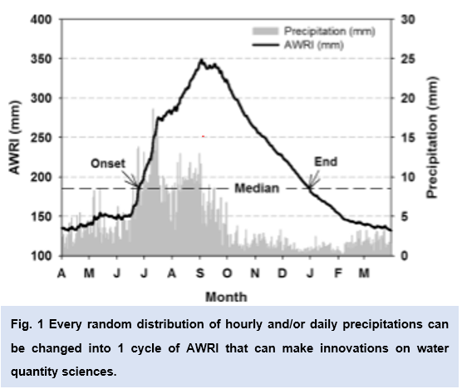

Recent Publications
1. Deo R (2017) Novel Approaches for Hydrometeorological Forecasting Using Artificial Intelligence-Based Algorithms: Theory and Practical Applications. Under review at Envir Moni Ass.
2. Frank A (2017) Inﬂuence of mathematical and physical background of drought indices on their complementarity and drought recognition ability. Atm Res 194:268-280,
3. Kim S (2016) Quantitative Definition and Spatiotemporal Distribution of Little Water Season (LIWAS) in Korea. Asia-Pac J Atmos Sci, 52(4):379-393.
4. Park C (2015) Drought prediction till 2100 under RCP 8.5 climate change scenarios for Korea. J. Hydrol. 526: 221-230.
5. Park S (2015) Definition and characteristics of the water abundant season in Korea. Theo App Clim 120:249–258.


Biography Hi-Ryong Byun had been a weather forecaster in Korean Air force for 19 years. In 1982, he faced and experienced a very hard situation of drought and started to study drought. After separation from Air Force, he became a professor who taught the Synoptic Meteorology. In Pukyong National University, he wrote many articles on natural disasters like thunderstorms, fogs, typhoons, floods, heat waves etc., especially more articles on drought and made the EDI (Effective drought index). The biggest characteristic of his articles is that he considers the time interval very important. Besides, he wrote many scientific columns on newspapers and acquired many patents that mitigate the damages from disasters. Patents against global warming, drought and algae are his masterpieces. Then he has been world ranking 1 in Synoptic Meteorology for 8 years in the Google Schalor site. Some soft wares he developed is free on site http://cafe.naver.com/droughtfloodwater.
Email: hiryongbyun@gmail.com
Notes/Comments:

