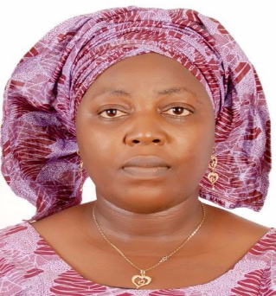

Title: Comparison of Some Physico-Chemical Parameters of Yewa River (Ogun State, Southwest Nigeria) With National and International Standard
Name: RAJI Iyabode Lati
Lagos State University, Ojo, Lagos, Nigeria.

This study assessed the physico-chemical quality of Yewa River, Ogun state, Nigeria. Four locations were chosen spatially along the water course to reflect a consideration of all possible human activities that can influence the quality of river. Water samples were collected monthly for seven months (December 2011 – June 2012. pH, air temperature (℃), water temperature (℃), conductivity (μs/cm) and total dissolved solids (mg/L) were conducted in-situ while dissolved oxygen (mg/L), nitrate (mg/L), phosphate (mg/L), alkalinity (mg/L) and hardness (mg/L) were determined ex-situ using standard methods. Results showed that dissolved oxygen, hydrogen ion concentration, total hardness and nitrate were above the maximum permissible limit of National Administration for Food, Drugs and Control, Standard Organization of Nigeria (SON), other National and International Standards for drinking water during certain months of the study. Results also showed that water temperature and conductivity were within the permissible limits of all the standards excluding FEPA; however, total dissolved solids and alkalinity were within the permissible limits of all the standards. Since most of the parameters measured were above the maximum permissible limits of the national and international standards, it was concluded that the water is unfit for domestic uses and needs to be treated if to be used. The very low dissolved oxygen values for the first four months i.e. < 5 mg/L is most likely caused by the amount of effluents discharged into the river. To prevent mass extinction of aquatic organisms, proper regulations should be implemented to reduce the organic load the river receives.

Biography

Raji Latifat Iyabode completed her undergraduate studies at the age of 26years from Ladoke Akintola University in Oyo State, Nigeria anad she is currently a Masters Student at Lagos State University, Ojo, Lagos State, Nigeria. She is the director of Studies at Megastrides Model College, Sagamu, Ogun State, Nigeria, a premier educational provider in Nigeria.

Presenting author details
Full name: RAJI, Latifat Iyabode
Contact number: +2348035870612
E-Mail: iyaboraji77@gmail.com
Category: Poster presentation

