RECYCLING AND REUSE OF HUMAN EXCRETA
FOR ENERGY GENERATION: A REVIEW
ANIL K. SHRIVASTAVA, Ph.D., MUMBAI, INDIA
akshrivastavaa@yahoo.in

A B S T R A C T

Almost a billion people in developing world have no access to toilet and practice open defecation. But that waste should not go waste. Rather than tainting the environment and transmitting diseases, it could actually be harnessed to heat or power for millions of homes. The review paper will discuss about utilization of human excreta to produce biogas/energy as an alternative renewable energy. Utilization of human waste is considered beneficial in terms of the process because it does not require additional starter (micro organisms seeds) and a supply of micro organisms occurs continuously during the feeding of raw materials. Product gas resulting from typical dry human feces have LHV and energy values of 17.2 MJ/kg and 24 MJ/kg, respectively, at optimum equivalence ratio of 0.31 values that are comparable to wood biomass.
Non- sewered Sanitary Systems (NSS) are emerging as one of the solutions to poor sanitation because of the limitations of the conventional flush toilets. The new sanitary systems are expected to safely treat fecal waste and operate without any external connections to sewer, water supply or energy source. The Nano Membrane Toilets (NMT) is unique domestic –scale sanitary solution to treat human waste on site. The Reinvent The Toilet Challenge (RTTC) is one of the pioneering schemes initiated in 2011 under the Water, Sanitation And Hygiene (WASH) programme of the Bill and Melinda Gates Foundation to increase access to safe, sustainable and affordable sanitation.
In the present communication merits, demerits, advantages, limitations of various engineered technologies employed will be critically reviewed on the basis of their innovations, user friendliness, cost effectiveness, maintenance etc. Also, health aspects of biogas generated, design and R &D aspects of biogas plant fed by human excreta with or without supplementary feed stocks, treatment of slurry and its use, strategy for promotion and integration with other programmes will be thoroughly discussed.

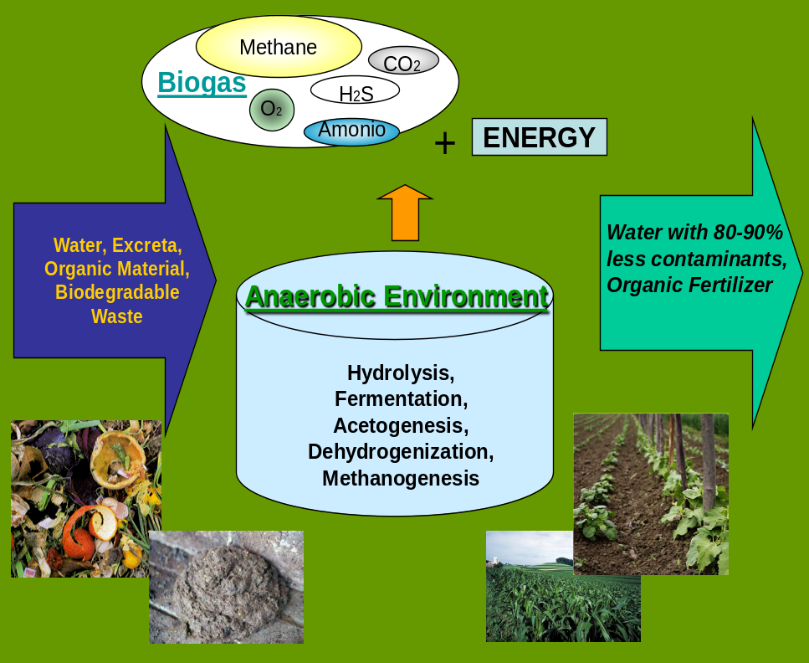

Recent Publications:
- Andriani D, Wresta A. Saepudin A, Prawara B, (2015) A review of recycling of human
excreta to energy through biogas generation : Indonesia case. Energy Procedia 68 : 219-
225.
- Colon J, Aaron A. , Stokes F, Deshusses M A (2015) Anaerobic digestion of undiluted
stimulant human excreta for sanitation and energy recovery In less developed countries.
Energy for Sustainable Develop. 29 : 57-64.
- Liu M , Woudstra T, Promes E J O,. Restrepo S Y G, Aravind P V, (2014) System
development and self sustainability analysis for upgrading human waste to power.
Energy 68: 377-384.
- Monhol F A F, Martins M F (2015) Concurrent combustion of human faeces and polyethylene waste. Waste Biomass Volorization 6 : 425-432.

- MukherjeeS, Chakraborty D (2016) Turning human waste into renewable energy: scope & options for India, National Institute of Public Finance & Policy (NIPFP), New Delhi and Indian Institute of Foreign Trade (IIFT), New Delhi, MPRA Paper No 73669, 13 Sep.

- Onabanjo T, Patchigolla K, Wagland S T, Fidalgo B , Kolios A, McAdam E., Parker A, Williams L, Tyrrel S, Cartmell E. (2016) Energy recovery from human faeces via gasification : A thermodynamic equilibrium modeling approach. Energy Convers. Manage 118 :364-376.

- Speidel M, Kraaij G, Worner A (2015) A new process concept for highly efficient conversion of sewage sludge by combined fermentation and gasification and power generation in a hybrid system consisting of a SOFC and a gas turbine. Energy Convers. Manage 98 :259-267.

- Ward B J, Yacob T W, Montoya L D (2014) Evaluation of solid fuel char briquettes from human waste. Environ. Sci. Technol. 48 : 9852-9858.

- WHO- UNICEF (2014) WHO- UNICEF Progress on drinking water and sanitation, 2014 update. Tech Rep (2014).

Biography: 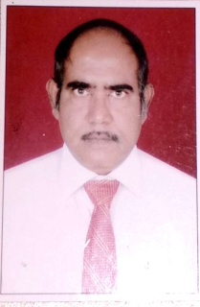

Dr Anil K. Shrivastava obtained the degree of Ph.D. in Chemistry (1983) from Ravishanker University, Raipur, India. Dr Anil has forty years R&D experience in the fields of Analytical Chemistry, Environmental Sciences, Biotechnology, Reliability, Quality & Safety. He had designed, developed, fabricated, tested and installed life supporting system for underwater Naval platforms. In recognition of his meritorious contributions Two National Level Awards, SCIENTIST OF THE YEAR AWARD -2015 and TECHNOLOGY DAY AWARD-2013 were conferred on him.
He worked as Associate Director (Management), Head of Department of Environmental Sciences Group for more than 20 years. Also, he Headed many Technical and Administrative Groups, at Naval Materials Research Laboratory, DRDO, Mumbai. Under his leadership seven R&D Projects of the Lab were successfully completed. He handled ISO 9001:2008 certification of the Lab as Management Representative. He had worked as Chairman of DRTC Assessment Board, DRDO for the year 2017. He had 68 publications in National & International Journals, Seminars.

E-MAIL : akshrivastavaa@yahoo.in

Curriculum Vitae

NAME : Dr ANIL KUMAR SHRIVASTAVA

DATE OF BIRTH : 04 NOV 1956

POSTAL ADDRESS : E-14, RAMESHWAR DARSHAN,
KATRAP, MIDC ROAD,
BADLAPUR (E), DISTT THANE,
421 503
Mobile No. : +91 9890581365
E-mail id : akshrivastavaa@yahoo.in
akshrivastavaa05@gmail.com

E D U C A T I O N A L Q U A L I F I C A T I O N

Degree/ Dip Year University/Institute Subject Div/Class/Grade

M.Sc. 1977 RAVI SHANKAR CHEMISTRY FIRST
UNIVERSITY, RAIPUR

Ph. D. 1983 RAVI SHANKAR CHEMISTRY
UNIVERSITY, RAIPUR

DIPLOMA 1977 RAVI SHANKAR DIPLOMA IN FIRST
UNIVERSITY, RAIPUR RUSSIAN LANGUAGE

DIPLOMA 1999 INSTITUTE OF DIPLOMA IN
ALTERNATIVE MEDICINES ACCUPRESSURE
MUMBAI

DETAILS OF SERVICE

GRADE/POST | FROM | TO | ESTT/LAB/INST/DTE | NATURE OF WORK
SCIENTIST- ‘G’ | 01 Jul 2013 | 30 Nov 2016 | NMRL, DRDO, MUMBAI | Management & R&D ACTIVITIES
SCIENTIST- ‘F’ | 01 Jul 2006 | 30Jun 2013 | NMRL, DRDO | Management & R&D ACTIVITIES
SCIENTIST- ‘E’ | 01 Jul 2000 | 30 Jun 2006 | NMRL,DRDO | Management & R&D ACTIVITIES
SCIENTIST- ‘D’ | 01 Jul 1995 | 30 Jun 2000 | NMRL,DRDO | R&D ACTIVITIES
SCIENTIST- ‘C’ | 01 Jul 1990 | 30 Jun 1995 | NMRL,DRDO | R&D ACTIVITIES
SCIENTIST- ‘B’ | 13 Nov 1984 | 30 Jun 1990 | NCML,DRDO | R&D ACTIVITIES
LECTURER | 23 Oct 1983 | 11 Nov1984 | Govt. College of Engineering & Technology, Raipur | TEACHING

TRAINING COURSES ATTENDED

COURSE TITLE | FROM | TO | INSTITUTION
INNOVATION MANAGEMENT FOR SCIENTISTS & TECHNOLOGISTS | 14-DEC-2009 | 18-DEC-2009 | A.S.C.I., HYDERABAD
TOOLS TO IMPROVE QUALITY AND RELIABLITY OF EQUIPMENT AND SYSTEM | 16-FEB-2011 | 18-FEB-2011 | E.S.C.I., HYDERABAD
TAPPING INNOVATION FOR STRATEGIC ORGANIZATIONS | 28-JAN-2012 | 31-JAN-2012 | I.I.M, AHMEDABAD

Certificates of Excellence : Enclosure No 1
List of Papers/ Publications : Please see Annexure- A

- Forty years experience of R & D in various areas. R &D efforts had resulted into development of various technologies which have been accepted by the Indian Navy and being utilized by the Indian Navy.

- Empanelled Board Member of UPSC, New Delhi.

- Worked as Chairman in Central Assessment Board of DRTC, DRDO, New Delhi.

- Two years teaching experience of Post Graduate Classes of Environmental Sciences at Ravi Shankar University, Raipur (1980-82).

- Joined DRDO as Scientist -“B” (Nov 1984) on the recommendation of UPSC and superannuated in Nov 2016 after completing 32 years meritorious service.
Brief description of important contribution/ Achievements

- PRODUCTS DEVELOPED:

- Compact and Regenerative system for containment of Carbon dioxide during the operational cycles of S/m.

- Air Purifier with Negative ion Generator for submarines.

- Arsenic Removal Kit for water samples.

- Bio sorption system for curtailment of Lead & Cadmium in water samples

- Bio energy plant for domestic applications.

- FACILITY CREATION:

  - Setting up of Integrated Test Facility for environmental
Management in Submarines.

- R & D ACTIVITIES:

- Development of Novel technique for Fluoride Removal from
water samples.

- Innovative Techniques for Determination of Trace Elements in
water Samples.

- Bio-remediation of floating oil.

- FLEET SUPPORT TO INDIAN NAVY:

  - Setting up facility for analysis of breathing air at Port Blair, Andman & Nicobar Command.

  - Evaluation of soda lime samples.
- MANAGEMENT ACTIVITIES:

    - ASSOCIATE DIRECTOR (MANAGEMENT): Overall responsibility of Management of the Laboratory (Jan 14 to Nov 16).

- Worked as Project Leader for 7 DRDO Projects : Guided a team
of Scientists, utilized man power and machines, interacted with
various organizations to achieve the pre defined targets of the
Projects.

    - Group Head Legal Cell (Jan 02 to Nov16).

    - Vice Chairman Official Language Implementation Committee (2013 to 2016)

    - Head of Department, Environmental Sciences & Fleet Support Activities (2014 to 2016)

    - Head of Department, Environmental Sciences & Protective Technology Department (2009 to 2014).

    - Group Head, HRD Cell (2009 - 2012)

    - Group Head Management Services: Overall responsibility of Transport & Accommodation, wet & dry canteen, MI room, Welfare group, Telephone Services etc. (Jan 01 to Dec 09) .

    - Head of Department, Environmental Sciences and Reliability & Quality Assurance Department. (2006 to 2009)

    - Head of Department, Marine Biology & Environmental Sciences (2001 to 2006)

    - Head of Department, Environmental Sciences Group (1996 to 2001).

    - Management Representative for ISO: 9001, 2008 Certification of NMRL (2012-2015).

    - Worked as Chairman , Central Assessment Board, DRTC, DRDO.
Membership of Professional Societies/ Institutions

- Life member of National Environmental Science Academy

- Life member of Indian Society of Analytical Scientists

- Life member of Vigyan Sahithya Parishad

Recognition/Awards/Honours etc.

LAB LEVEL AWARDS:

- Received Laboratory Level TechnologyGroup Award & Citation for the year
2006 as a Team Leader for Design, Development and Fabrication of Carbon Dioxide Control System for Submarine Compartments resulting in User Acceptance for Induction.

2. Received Laboratory Technology Group Award& Citation for the year 2011 as
a Team Leader for Development of State of Art compact Regenerative plant
for curtailment of Carbon Dioxide onboard Naval Platforms.

NATIONAL LEVEL AWARDS:

3. Received Technology Day Award for the year 2013, A Gold Medal & Citation
was given by the Scientific Advisor to Raksha Mantri, Director General &
Secretary DRDO, New Delhi on 11 May13 for Oration on ENVIRONMENTAL
CONTROL TECHNOLOGIES IN SUBMARINES.

4. Received DRDO AWARD ---SCIENTIST OF THE YEAR AWARD - 2015. The
Award and citation was given by Shri Arun Jaitley, honorable Minister of
Defence and Finance, Govt. of India, New Delhi, on 24 Mar 17 for
Outstanding technological contributions with innovative ideas leading to the
development and induction of a compact marine grade , regenerative type
carbon dioxide control system, for rendering living compartments of long
endurance nuclear power based submarines habitable.
ENCLOSURE No. 1.

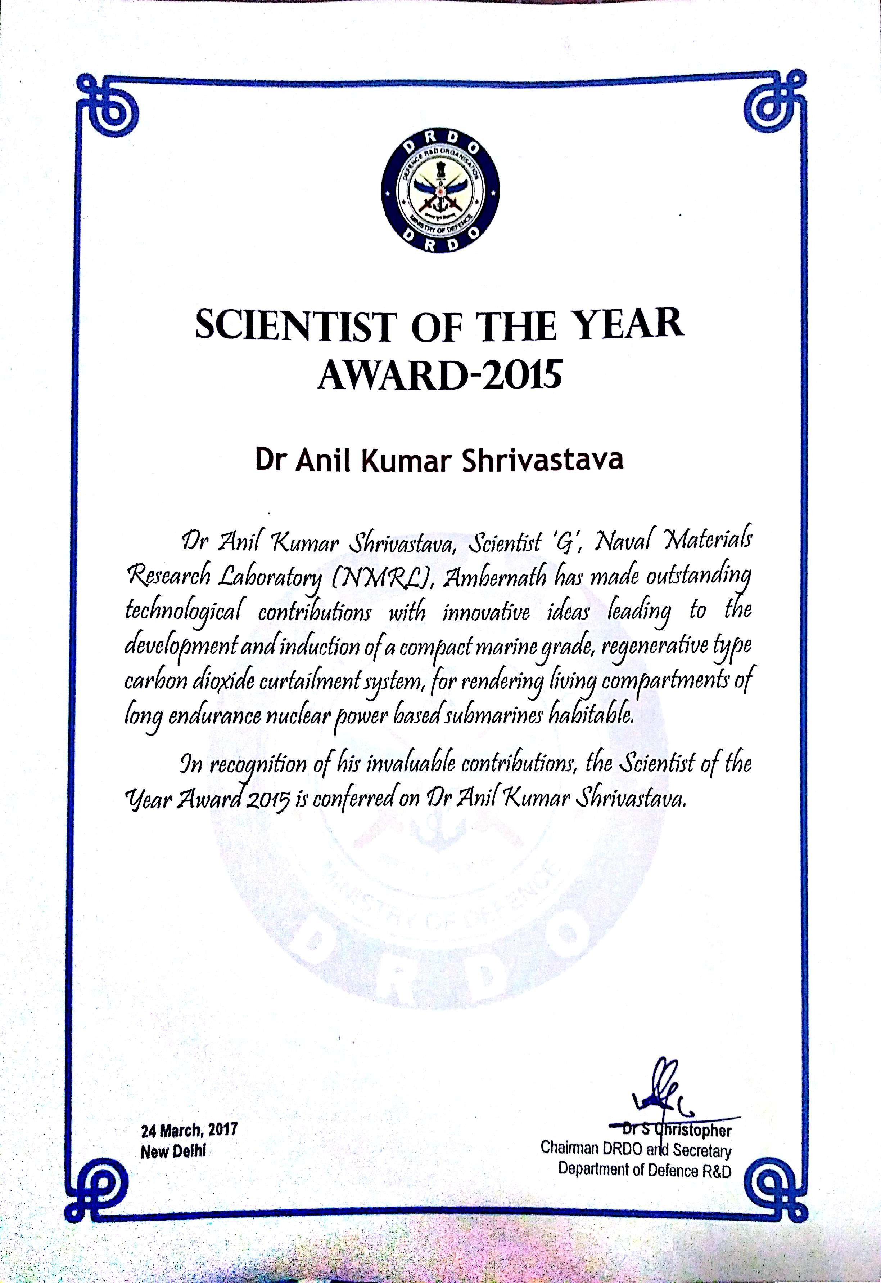

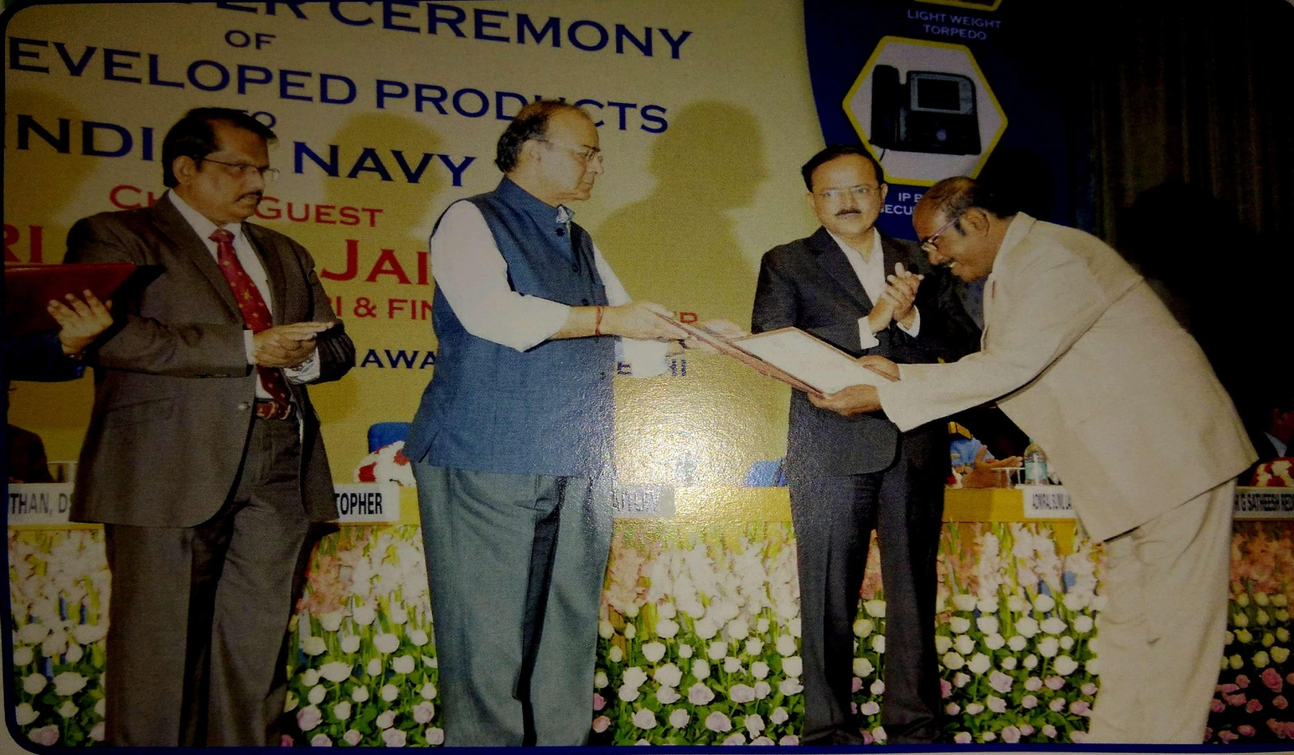

Dr ANIL K. SHRIVASTAVA RECEIVING ‘SCIENTIST OF THE YEAR’ AWARD FROM SHRI ARUN JAITLEY, THE THEN DEFENCE & FINANCE MINISTER OF INDIA

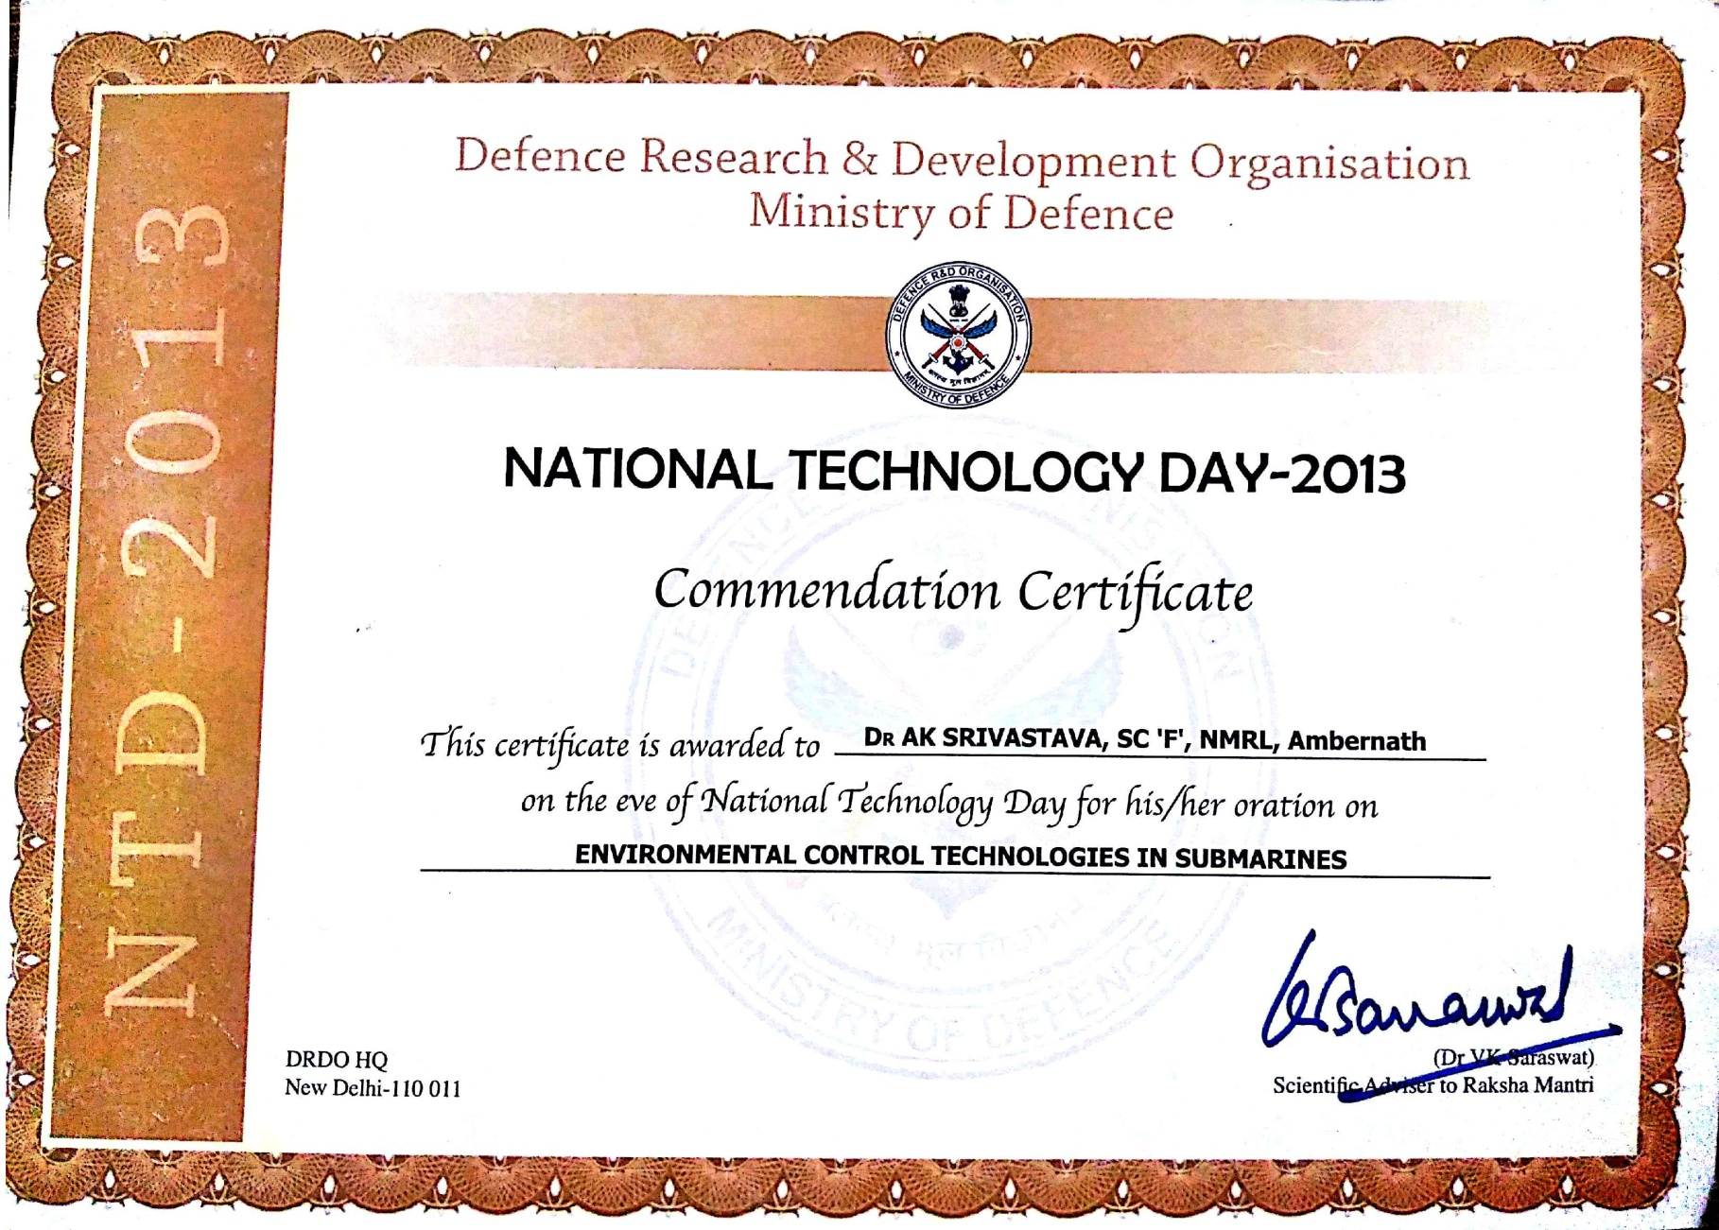

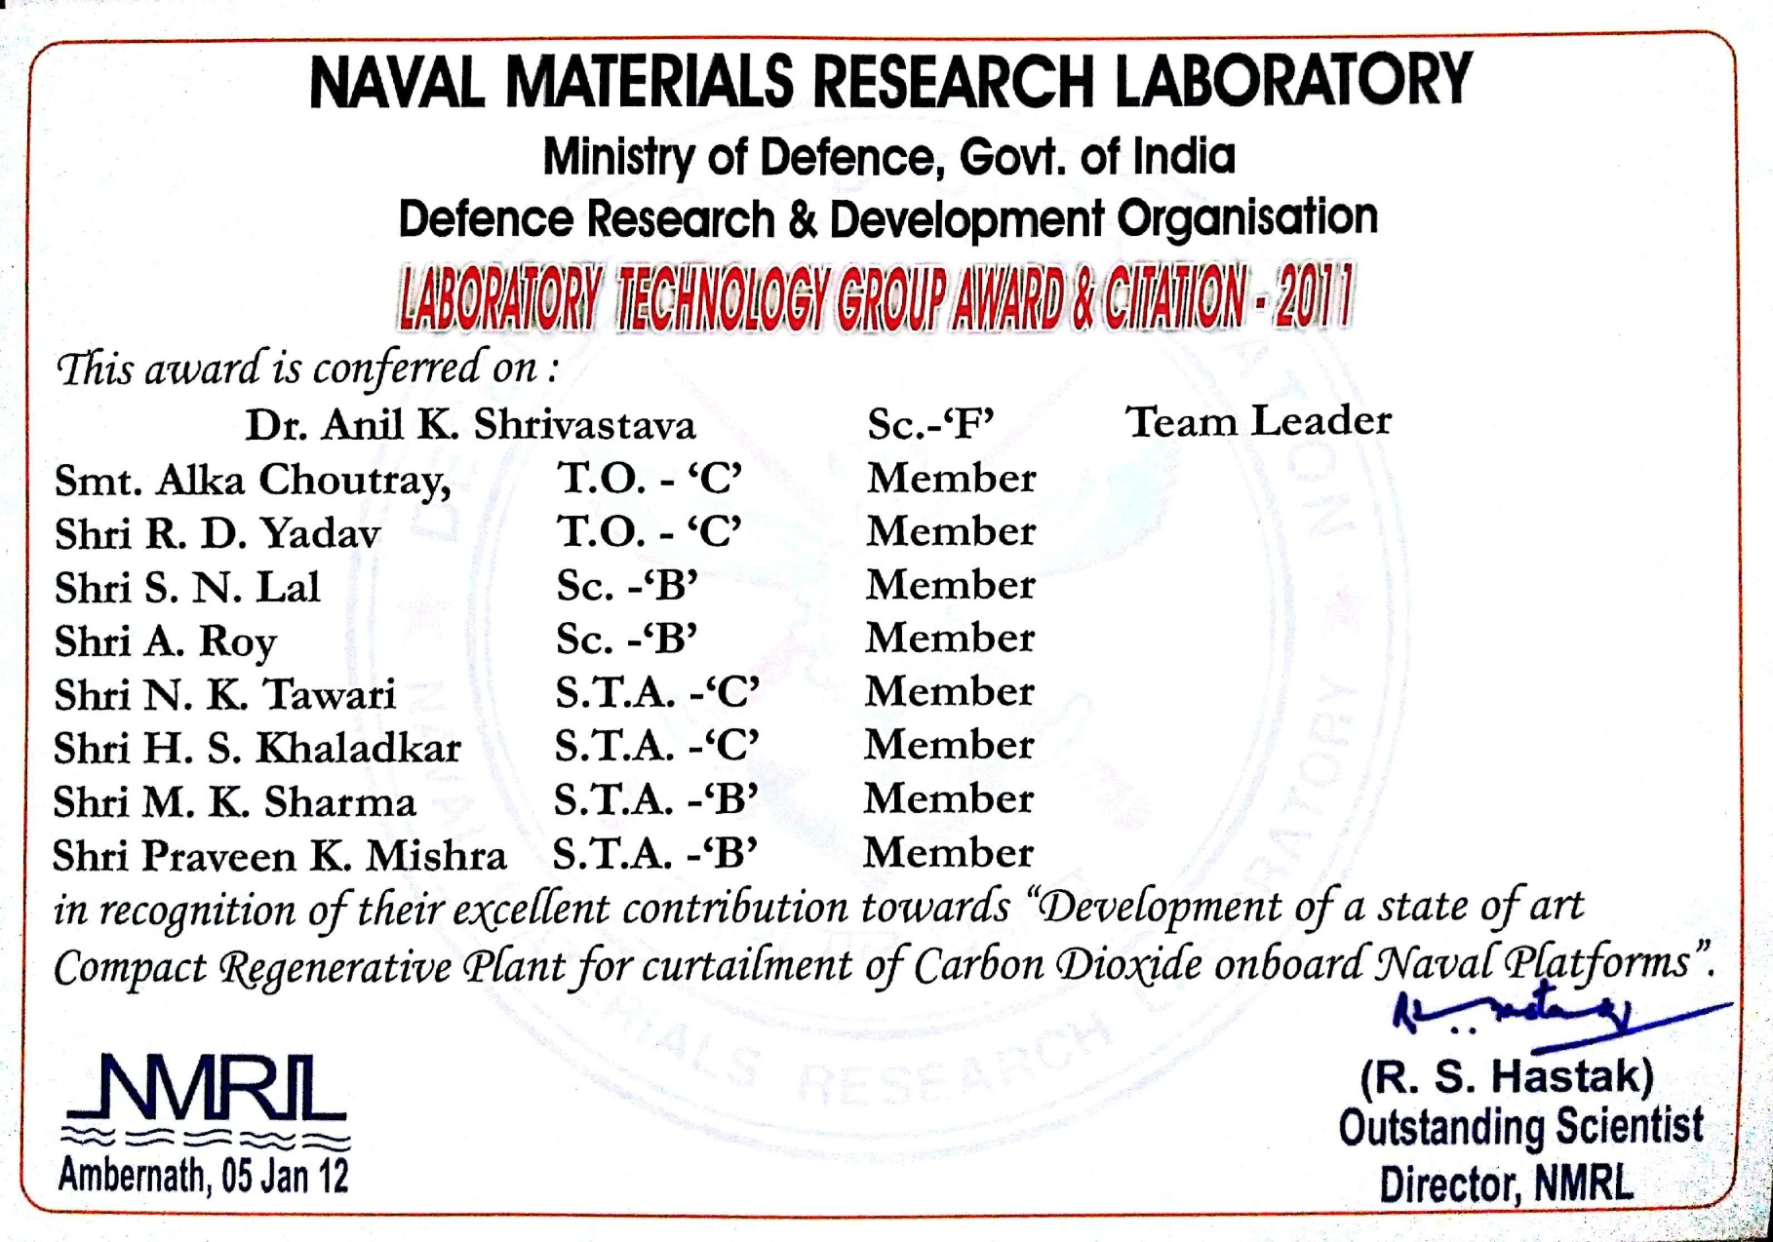

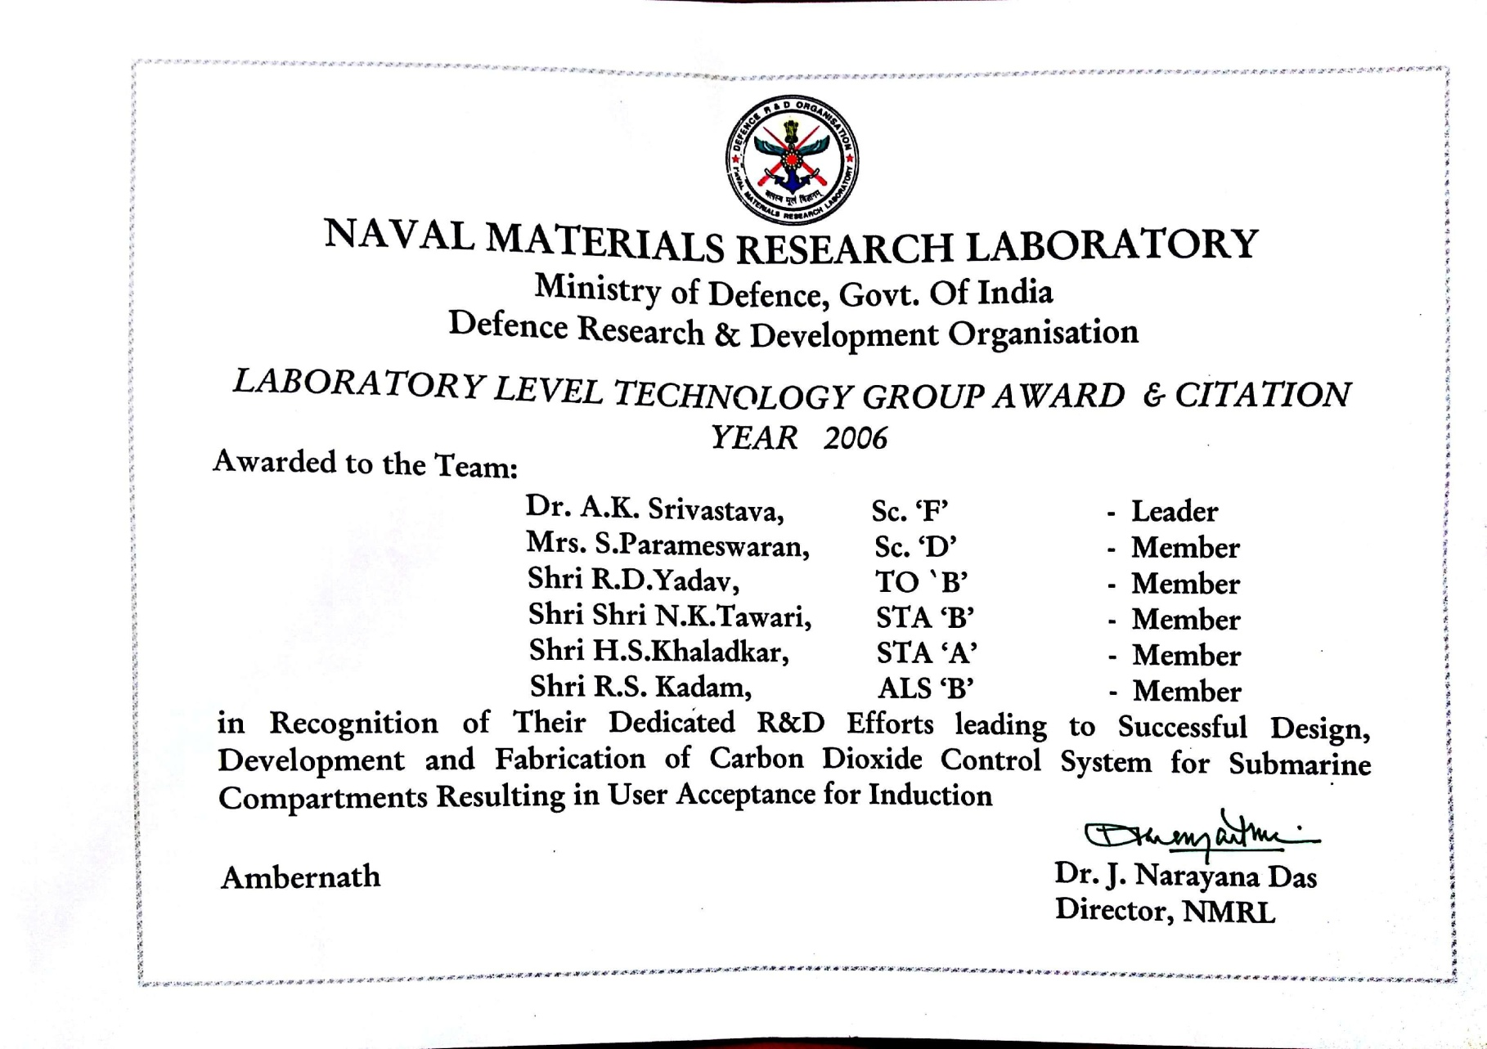
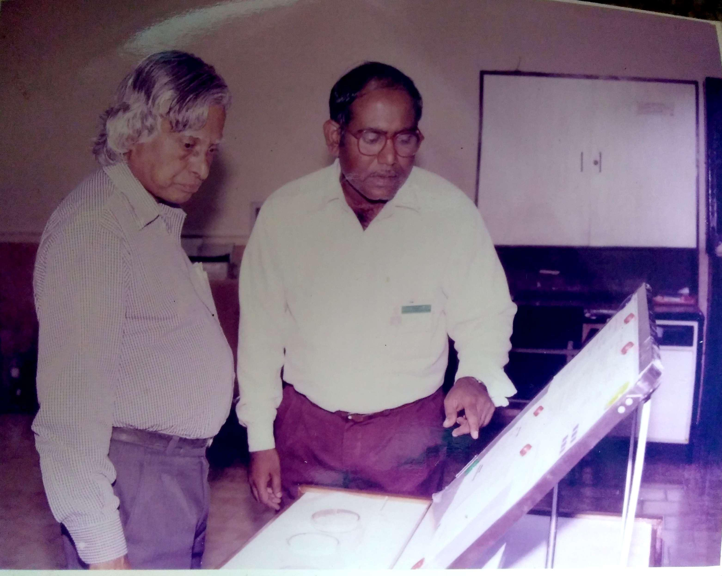

Dr ANIL K. SHRIVASTAVA EXHIBITING HIS PRODUCTS TO Dr A.P.J. ABDUL KALAM, THE FORMER PRESIDENT OF INDIA

ANNEXURE 1

LIST OF PUBLICATIONS OF ANIL K. SHRIVASTAVA

IN INTERNATIONAL JOURNALS:
- THE DETERMINATION OF MERCURY : A MINI REVIEW (Anil K. Shrivastava and S.G.Tandon) Toxicological and Environmental Chemistry Reviews, 1982, 5, 311-129.
- STUDIES ON MERCURY POLLUTION : MICRO DETERMINATION OF MERCURY IN BIOLOGICAL MATERIALS BY COLD VAPOUR ATOMIC ABSORPTION SPECTROMETRY (Anil K. Shrivastava and S. G. Tandon) International Journal of Environmental Analytical Chemistry, 1982, 11 (3 -4), 221-226.
- MICRODETERMINATION OF LEAD IN WATER SAMPLES : PRECONCENTRATION BY COPRECIPITATION FOLLOWED BY ITS ATOMIC ABSORPTION SPECTROMETRIC DETERMINATION (Anil K. Shrivastava and S. G. Tandon) International Journal of Environmental Analytical Chemistry, 1982, 12 (3-4), 169-176.
- STUDIES ON VANADIUM POLLUTION : SPECTROPHOTOMETRIC DETERMINATION OF VANADIUM IN PLANT SAMPLES USING A SINGLE EXTRACTION TECHNIQUE (Anil K. Shrivastava and S. G. Tandon) Indian Journal of Environmental Health, 1982, 24 (2), 89-94.
- STUDIES ON LEAD POLLUTION : ATOMIC ABSORPTION SPECTROPHOTOMETRIC DETERMINATION OF LEAD IN HAIR AND TEETH SAMPLES (Anil K. Shrivastava and S. G. Tandon) International Journal of Environmental Analytical Chemistry, 1984, 17 ( 3-4 ), 293-298.
- MICRODETERMINATION OF VANADIUM IN WATER SAMPLES : (Anil K. Shrivastava) International Journal of Environmental Analytical Chemistry, 1986, 27 (1 - 2), 1-7.
- ENVIRONMENT IN SUBMARINE COMPARTMENTS : (Anil K.Shrivastava and M. V. R. Koteswara Rao) Defence Science Journal, 1987, 37 (2), 257-267.
- ENVIRONMENTAL HEALTH STANDARDS FOR SOME TOXIC GASES : (Anil K. Shrivastava and M. V. R. Koteswara Rao) Indian Journal of Environmental Protection, 1988, 8 (1), 6 -10.
- LEAD PRADUSHAN SAMASYAAVAM NIRAKARAN (IN HINDI) (Anil K.Shrivastava&Rajiv Dayal) VigyanVaarta, 1992, NCML, Bombay. pp 17-22.
- CURRENT TRENDS IN DEVELOPMENT OF CARBON DIOXIDE CONTROL SYSTEM IN SUBMARINES (Anil K. Shrivastava, M. V. R. Koteswara Rao) National Conference on Marine & Allied medicines, Bombay, 1994, Aug., 20-21.THE PAPER WAS ADJUDGED AS THE BEST PAPER BY A NON MEDICAL SPEAKER.

- SYSTEM FOR CONTROL OF CHEMICAL & BIOLOGICAL WARFARES (Anil K. Shrivastava, M.V.R.Koteswara Rao) Workshop on Under Water System and Engineering, Naval Science & Technological Laboratory Vishakhapatnam, Aug, 17-18, 1994.

- CURRENT TRENDS IN DEVELOPMENT OF CARBON DIOXIDE CONTROL SYSTEM IN SUBMARINES (Anil K. Shrivastava, M.V.R.Koteswara Rao, Journal of Marine Medical Society, 1995, 2 (1), 8-11.

- ORGANIC CONTAMINANTS IN CLOSED COMPARTMENTS (Anil K. Shrivastava) Indian Journal of Environmental Protection, 1995. 15 (11), 801-803.

- OZONE CHHATARI ME CHHED, VISVAVYAPI SAMASYA (IN HlNDI) : VYGYANIK, 1995, 27 (2) 58-61.

- SPECIATION OF TRACE ELEMENTS IN ENVIRONMENTAL SAMPLES (Anil K. Shrivastava) Reviews In Analytical Chemistry, 1995, 14 (3), 143-166.

- NBC WARFARE AND CONTROL MEASURE (Anil K. Shrivastava) Indian Journal of Environmental Protection, 17 (2), 128-132 (1997).

- Micro Determination of Cadmium in Water Samples, Pre-concentration by co-
precipitation followed by AAS, Anil K. Shrivastavaand Harshal S. Khaladkar, Int.
Jour. Environ. Sci. 2011, 2(4), 563-570.

- Micro Determination of Vanadium in Water Samples by ICP-AES, Anil K. Shrivastava
and Ram Dular Yadav, Int. Jour. Environ. Sci. 2011, 2(4), 549-555.

- Fluoride Pollution: A Review, Anil K. Shrivastava, Int. Jour. Environ. Sci., 2012, 3(1),
55-76.

- Micro Determination of Copper in Water samples, Anil K Shrivastava and Nitin K.
Tawari, Int. Jour. Environ. Sci., 2012, 3(1), 111-119.

- An Innovative Technique for Removal of Fluoride from drinking water, Anil K.
Shrivastava and Manoj K. Sharma, Sci. Rev. & Chem. Comm., 2012, 2(2), 133-140.

- Novel Method for Micro Determination of Lead in Water Samples, Anil K. Shrivastava and
Harshal S. Khaladkar, Sci. Rev. & Chem. Comm. 2013, 3(1),43-53.

- Development of Novel Negative Ionic Air Purifier, Anil K. Shrivastava and R. D.
Yadav, Int. Jour. Environ. Sci., 2013, 4(1), 55-62

- ‘’वैदिक गणित के कुछ अनुप्रयोग’’, अनिल कुमार श्रीवास्‍तव, ‘’वैज्ञानिक’’हिंदी विज्ञान साहित्‍य
परिषद,भाभा परमाणु अनुसंधान केन्‍द्र से sप्रकाशित, मुंबई (संप्रेषित).

- Environmental Control Technology in Submarines, Anil K. Shrivastava, DRDO
Technology Spectrum, 2013, 187-193.

IN SEMINARS/CONFERENCES:
- TRACE ANALYSIS OF VANADIUM IN BIOLOGICAL AND ENVIRONMENTAL MATERIALS :(Anil K. Shrivastava and S. G. Tandon) 12th Annual Symposium on the Analytical Chemistry of Pollutants, Amsterdam, 1982, (Poster No. 73).
- A NOVEL METHOD FOR MICRODETERMINATION OF MERCURY USING COLD VAPOUR ATOMIC ABSORPTION SPECTROMETRY : (Anil K. Shrivastava and S. G. Tandon) Indian Journal of Environmental Health, Comm.
- STUDIES ON WATER POLLUTION : DETERMINATION OF VANADIUM IN MICRO QUANTITIES (Anil K.Shrivastavaand S.G.Tandon) 66th Session of Indian Science Congress Association, Hyderabad, 1979, Anal. Chem. Section, p 10, Abst. No. 25.
- STUDIES ON LEAD POLLUTION : ATOMIC ABSORPTION SPECTROPHOTOMETRIC DETERMINATION OF LEAD IN WATER SAMPLES (Anil K. Shrivastava and S. G. Tandon), 66th Session of Indian Science Congress Association, Hyderabad, 1979, Anal. Chem. Section, p 2, AbstNo.2.
- ENVIRONMENTAL EDUCATION AND TRAINING: (Anil K.Shrivastava) Regional Seminar on Environmental Education, Organised by Asian Environmental Society, Bangalore, 1979.
- ATOMIC ABSORPTION SPECTROPHOTOMETRIC DETERMINATION OF SOME TRACE METALS IN BIOLOGICAL MATERIALS (Anil K.Shrivastavaand S.G.Tandon) Symposium on Modern Aspects Bio-Inorganic Chemistry, Calcutta, 1980.
- STUDIES ON MERCURY POLLUTION: A MINI REVIEW (Anil K. Shrivastava andS. G. Tandon) Symposium on Current Activities in Analytical Chemistry, Allahabad, 1981, Abst No. 104.
- A NOVEL METHOD FOR SPECTROPHOTOMETRIC DETERMINATION OF VANADWM IN STEEL SAMPLES(Anil K.Shrivastava and S.G.Tandon) 51st Annual Session of the National Academy of Science, Cochin, 1981, p 73, AbstNo.209.
- A NOVEL METHOD FOR MICRODETERMINATION OF MERCURY USING COLD VAPOUR ATOMIC ABSORPTION SPECTROPHOTOMETRY (Anil K.Shrivastavaand S.G.Tandon) National Symposium on Current Activities in Analytical Chemistry, Allahabad, 1981, AbstNo.10.5.
- STUDIESON WATER POLLUTION, ATOMIC ABSORPTIONSPECTROPHOTOMETRIC DETERMINATION OF MANGANESE IN WATER SAMPLES(Anil K.Shrivastava and S.G.Tandon) 2nd Annual Conference of Indian Council of Chemists, Srinagar 1982.
- STUDIES ON LEAD POLLUTION, TRACE ANALYSIS OF LEAD:A CRITICAL REVIEW(Anil K. Shrivastava) International Symposium on Advanced Electro Analytical Techniques, Jodhpur, 1985, p15 Abst No. 27.
- STUDIES ON LEAD POLLUTION, DETERMINATION OF LEAD : A CRITICAL REVIEW (Anil K. Shrivastava) 22nd Convention of Chemists, Raipur, 1985, Anal. Chem. Section, P D 7, AbstNo.20.
- COLD VAPOUR ATOMIC ABSORPTION SPECTROPHOTOMETRIC DETERMINATION OF MERCURY IN FISH SAMPLES (Anil K. Shrivastava) 22nd Convention of Chemists, Raipur, 1985, Anal. Chem. Section, P D 9, AbstNo.25.
- DETECTOR TUBES AND TEST PAPERS IN AIR POLLUTION STUDIES (Anil K. Shrivastava, R D. Nabar And M. V. R. Koteswara Rao) National Symposium on Analytical Science for Environmental Studies, Burdwan, 1987, Abst No. p4.
- ENVIRONMENTAL ASSESSMENT AT OXYGEN GENERATION PLANT, VISAKHAPATNAM(Anil K. Shrivastava, M. V. R. Koteswara Rao, Suresh Chandra, M. T. Companywala, A. M. Rao, and G. C. Pandit) National Symposium on Environment, 1992, Bhabha Atomic Research Centre, Bombay, Feb, 3-5.
- VARANMITI VISHLESHAN (IN HINDI) (Anil K. Shrivastava&A.N.Tiwari)VigyanVaarta, 1992, NCML, Bombay. pp49-52.
- MARINE APPLICATIONS OF MOLECULAR SIEVES IN AIR REVITALIZATION: (Anil K. Shrivastava, M.V.R.Koteswara Rao, A. M. Isack, M. T. Companywala & S. Permeswaran),National Seminar on Materials for Marine Application, MMA-94, NCML, Bombay March, 3 – 4, 1994.

- RECENT ADVANCES IN AIR POLLUTION MONITORING TECHNOLOGIES (Anil K. Shrivastava) National Seminar on Modern Trends In Environmental Analytical Chemistry, Organised by Pt.R.S.S.University, Raipur, Abst No. 03, p 33, Nov., 1997. The paper presentation was awarded second prize in oral presentation session of the seminar.

- NOISE POLLUTION AND ITS CONTROL MESURES, Invited lecturer delivered by Anil K. Shrivastava at short term training programme on management and control of environmental constraints, organised by EngineeringCollege, Jabalpur, 1998, Oct., 3-15.

- INVITED LECTURERS : DELIVERED AT PT. RAVI SHANKAR SHUKLA UNIVERSITY, RAIPUR ON 18TH – 19TH MARCH, 2005.
“SOME ASPECTS OF AIR POLLUTION.”
FLUORIDE POLLUTION AND CONTROL.”
NOISE POLLUTION : A CHALLENGE OF THE DAY.

- Management of Environments in Confined Areas, Anil K. Shrivastava and Dhirendra Kumar, National Seminar on Aerospace Technologies and Challenges, Organised by Aeronautical Society of India, Thiruvanthapuram Chapter, Thiruvanthapuram, 12-13 June, 2009, pp 10-11 of the proceedings.
- “राजभाषाकीस्‍थितिएवंकार्यान्‍वयन,’’अनिलकुमारश्रीवास्‍तव, अखिल भारतीय राजभाषा वैज्ञानिक संगोष्‍ठी, रक्षा शरीरक्रिया एवं सम्‍बद्ध विज्ञान संस्‍थान (DIPAS),दिल्‍लीद्वाराआयोजित, 08-09 दिसम्‍बर 2011, पेज क्रमांक 69.
- Current Trends in Environmental Management of confined Areas (Invited Lecture),Anil K. Shrivastava, International Conference on Bioremediation and Environmental Management, Organised by Presidency College, Bangalore, 28-29 December, 2011, pp 24 of the proceedings.
- Current Trends in development of Fluoride Removal Technologies in Drinking Water,Anil K. Shrivastava, Indian Analytical Science Congress- 2012, Organized by Indian Society of Analytical Scientists (ISAS), Kanyakumari, 27-28 January. 2012, pp 90-91.
- Air Purifier with Negative Ion Generator, Anil K. Shrivastava and Ram Dular Yadav, International Conference on Bioremediation and Environmental Management, Organised by Presidency College, Bangalore, 28-29 December, 2011, pp 90.
- Speciation of Trace elements in Environmental Samples: A Challenge for Analytical Scientists, Anil K. Shrivastava and Praveen K. Mishra, Indian Analytical Science Congress- 2012, organized by Indian Society of Analytical Scientists (ISAS), Kanyakumari, 27-28 January. 2012, pp 91-92.

- Environmental Management : An Overview of Modern Instrumental Methods for monitoring of Environmental Pollutants, Anil K. Shrivastava, International Conference on Environmental & Human Health, Organised by National Environmental Science Academy & Human Health, Jamia Hamdard, New Delhi, 28- 29 Nov. 2012, pp 201.

TECHNICAL REPORTS :
- DEVELOPMENT OF MICROPROCESSOR BASED ANALYSER AND CONTROL SYSTEM FOR CARBON DIOXIDE IN SUBMARINES (RD –P1- 91/NCM-197), 1995.
- STUDIES ON MONITORING OF TOXIC GASES AND THEIR CONTROL IN THE CLOSED COMPARTMENT OF SUBMARINES (RD –P1 -85/NCM -171), 1990, 1-58.
- DEVELOPMENT OF MOLECULAR SIEVES BASED CARBON DIOXIDE CONTROL SYSTEM, 1993
- STUDIES ON EFFECT OF BIOORGANISMS AND CHEMICAL SUBSTANCES INCLUDING TOXICANTS ON MARINE MATERIALS AND ENVIRONMENT (RD-P1-94/NCM-207), 1997.
- TRIALS ON BIOREMEDIATION OF FLOATINGGS OIL AT NAVAL HARBOUR, MUMBAI. (FROM 20th APRIL 2001 TO 4th MAY), 2001.
- EXTENDED TRIALS ON BIOREMEDIATION OF FLOATING OIL AT NAVAL HARBOUR MUMBAI. DEC. 2001.
- REPORT ON BIOREMEDIATION OF FLOATING OIL AT NAVAL HARBOUR MUMBAI. MARCH, 2002.
- ECOFRIENDLY CLEANING OF FLOTAING OIL AT NAVAL HARBOUR MUMBAI. MAY, 2002.
- BIOREMEDIATION OF FLOATING OIL AT NAVAL HARBOUR VISAKHAPATNAM. 2003.
- DESIGN, DEVELOPMENT, FABRICATION AND SUPPLY OF PROTOTYPE CARBON DIOXIDE EQUIPMENT (No. HSE/CO₂/RF/29), OCT. 2002.
- TRASFER OF TECHNOLOGY FOR ARSENIC REMOVAL FILTER
ISSUED TO M/S SAVE ENVIRONMENT (NGO), KOLKATA
M/S SHIVA ENGINEERING, KOLKATA AND
M/S S. B. EQUIPMENT, NEW DELHI. (JUNE, 2007 )
- PROJECT GUIDE OF A THESIS, “STUDIES ON ARSENIC POLLUTION

DEVELOPMENT OF ARSENIC CONTAINMENT SYSTEM USING SURFACE
MODIFIED MOLECULAR SIEVES ZEOLITE MATERIALS, “ A PROJECT
REPORT IN PARTIAL FULFILLMENT OF MASTER’S DEGREE IN
ENVIRONMENTAL SCIENCE & SUBMITTED BY MR. SAURABH T. JOSHI,
BIRLA COLLEGE, KALYAN, UNIVERSITY OF MUMBAI, MARCH, 2007.

- TRANSFER OF TECHNOLOGY DOCUMENT FOR CARBON DIOXIDE
CONTROL PLANT, ISSUED TO M/S GODREJ AND BOYCE MFG. CO. LTD. MUMBAI, JUNE, 2008.
- TRANSFER OF TECHNOLOGY DOCUMENT FOR AIR PURIFIER WITH NEGATIVE ION GENERATOR, ISSUED TO M/S SPAN FILTERMIST (INDIA) PVT. LTD., PUNE, FEBRUARY, 2009.
- PROJECT CLOSURE REPORT OF PROJECT ENTITLED, SCIENCE AND TECHNOLOGY FOR CONTROL AND MANAGEMENT OF MARINE ENVIRONMENT, 2010.
- TECHNICAL REPORT ON AIR PURIFICATION WITH NEGATIVE ION GENERATOR, OCT 2010.

