Automatic Tank Cleaning (Zero Hazardous Disposal)

Background

Saudi Aramco- Abqaiq Plants contains 13 floating roof crude oil tanks at Tank Farms ATF-1 and ATF-2. The main purpose of these tanks is to provide storage volume in case of any limitations in downstream facilities. The crude oils stored in these tanks are vary in composition and physical properties based on their crude types: Gas Condensate, Arab light and Arab Extra Light. These tanks have a capacity of 180,000 BBL each operating at atmospheric condition. Abqaiq Plants have a program to maintain the integrity of the tanks by performing Testing and Inspection (T&I) every 10 years. However, due to the nature of the crude oil, oily sludge accumulates in tank’s bottom over the years.

Introduction

APOD is utilizing Automated Tank Cleaning (ATC) technology to clean oil sludge inside the tanks instead of Traditional Manual Method. (ATC) is an advanced Tank cleaning technology which can recover the oil with capacity of 95% from the hydrocarbons sludge with ZERO hazards material disposal. ATC solution is considered by far the most effective solution when it derives to Safety, Economy & Environmental aspect of the industries standards. In term of safety ATC requires “no man entry” to the tank, which in return reduces the high risk it involves having personnel enter confined spaces. Economically, ATC requires little time to clean a tank compared to manual cleaning. Oil Recovery is considering as an Environmental protection. Since the recovery rate by using ATC is more than 95% compared to current standards (Traditional Manual Method) were zero (0) oil is recovered.

ATC Process:

The Automatic Tank Cleaning (ATC) is based on a closed loop principle utilizing fresh oil from a secondary storage tank which operates as a delivery and reception tank during the cleaning process. Fresh oil from the delivery tank is heated via the ATC system to approximately 55⁰ C and introduced at a pressure of around 6 Bar via specially designed jet-washer nozzles into the tank via the roof legs, manhole covers or other suitable openings. This oil under pressure agitates, fluidizes, dissolves and mixes the sludge into the oil which is then recovered and pumped to the secondary tank, ensuring that maximum valuable hydrocarbons are recovered and returned to the company for reuse or resale.

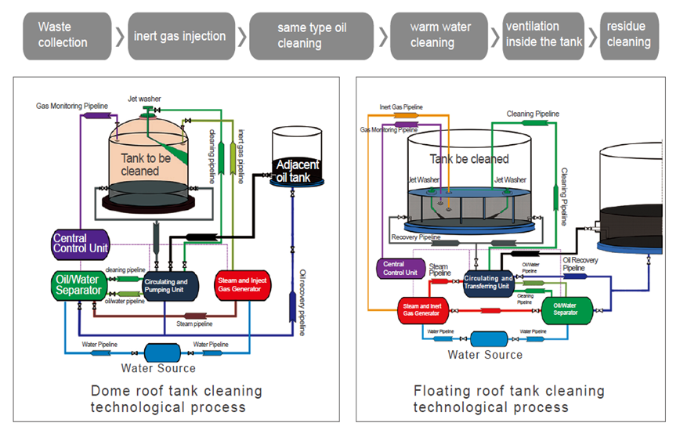

Tank Cleaning Available Options:

Option: 1- Traditional Manual Method

Disadvantages
- Long duration of operations
- High risk to personal safety
- Loss of valuable hydrocarbons
- High cost for waste disposal
- Additional costs for waste transportation
- High impact on the environment
Benefits
- Perceived Low contract cost
- Low skill level required

Option: 2- Automatic Tank Cleaning

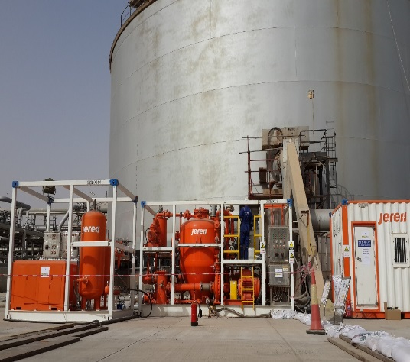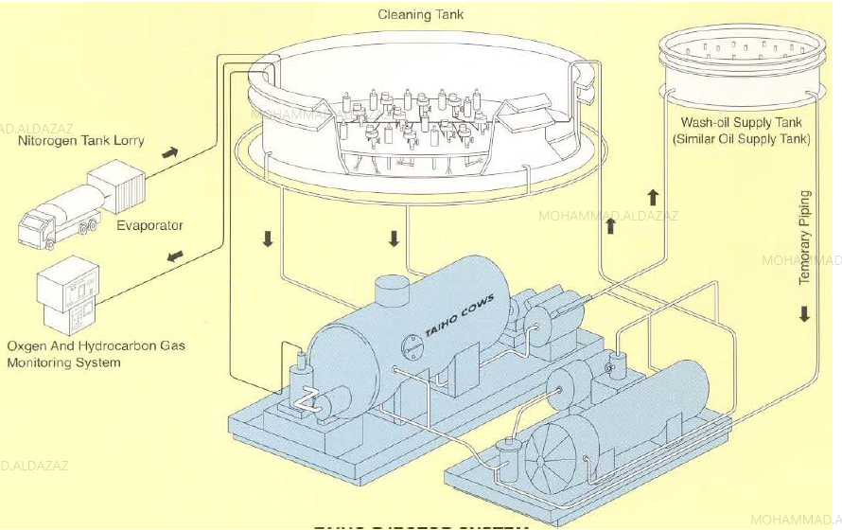
Disadvantages
- Perceived High contract cost
Benefits
- Shortened duration of operations
- Low risk to personal safety
- Above 95% of hydrocarbons recovered for resale
- Reduced cost of residue disposal
- Low environmental impact

ATC Process Outcomes:

Safety:
ATC requires “no man entry” to the tank, which in return reduces the high risk it involves having personnel enter confined spaces.

Environment
The recovery rate using ATC is more than 95% compared to Traditional Manual method. Furthermore, zero hazards material was disposed outside the Plant

Economy:
Down Time, ATC requires little time to clean a tank, for example 180,000 BBL tank would require 60 days from gate in to gate out using the ATC solution, compared to manual cleaning when it would require at least 150 days, to clean same size tank. In addition to that, APOD succeed to recover 4275 BBL from the sludge which is considered as a cost revenue with $ 277,875. Below table shows the detailed calculated revnue:

Crude Type | Sludge  Quantity (BBL) | Oil to be  Recovered (BBL) | Unit Price  (USD/BBl) | Total Revenue (USD)
AL | 4,500 | 4275 | 65 | 277,875

