18 Month Outcome of XEN45™ Implant in Primary Open Angle Glaucoma and Normal Tension Glaucoma with IOL Implantation
Vyhnalkova K, Delaney AM, Dragnev D
Department of Ophthalmology,
St Helens and Knowsley Teaching Hospitals NHS Foundation Trust, Merseyside, UK.

Abstract
Introduction: The aim was to support evidence on the safety and efficacy of XEN implant.
Methods: Subjects were 16 patients, 19 eyes with POAG (Primary Open Angle Glaucoma) and 2 with NTG (Normal Tension Glaucoma) treated with PhacoXEN or XEN implant. Outcome data for this study were collected retrospectively from EDMS (Electronic Document Management System) used as a main source. The implant insertions were performed by one surgeon in one hospital followed by a check-up after one week, one month, three months, six months, 12 months, and 18 months. The study focused on IOP reduction and the number of medications used before and after XEN45™ Implant insertion. IOP reduction of ≥20% at 18 months and complete elimination of medications was deemed to be successful.
Results: IOP dropped from 21.00 ± 5.33mmHg pre-operatively to 16.22 ± 5.18mmHg (19.54%), 15.65 ± 4.32mmHg (23.60%) and 15.54 ± 4.77mmHg (29.71%) in 6 months, 12 months and 18 months, respectively. There was a statistically significant reduction in IOP in 56% of eyes at 18 months. Mean number of medications decreased from 3.06 pre-implant to 0.80, 1.00 and 0.50 post implant in 6, 12 and 18 months respectively.
Discussion: This subconjunctival device provides a safe and efficient treatment of POAG by long-term IOP lowering. It significantly reduces the need for topical medication.

Image

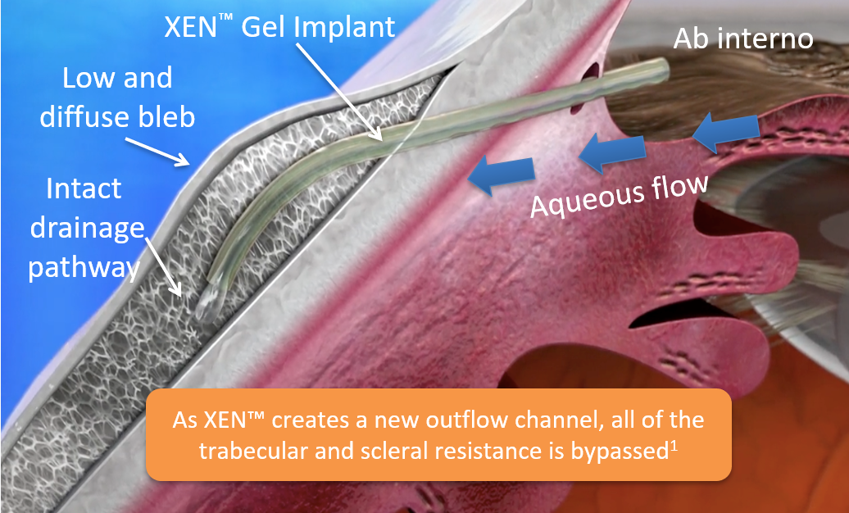
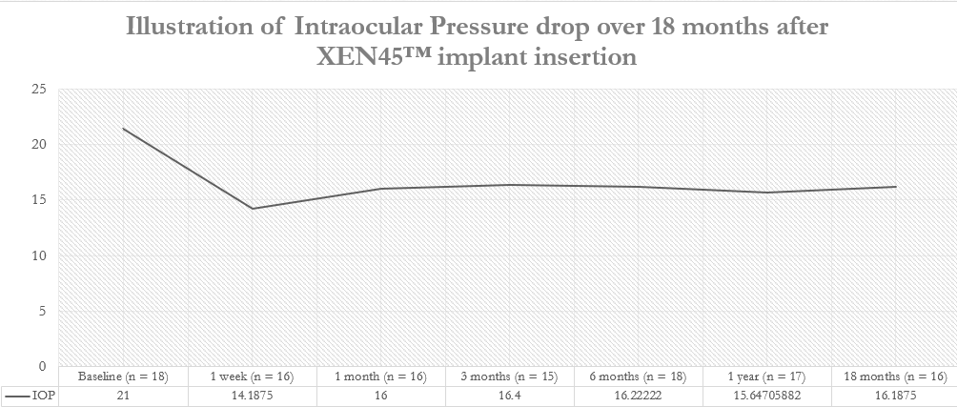

Biography
Dr Katerina Vyhnalkova completed her undergraduate medical studies at Masaryk University School of Medicine in Brno, Czech Republic in 2017. During this time she undertook training in paediatric LASIK and strabismus preocdures at The Children’s Hospital Department of Ophthalmology, Brno. She is a junior doctor in the North West of the UK where she continues to develop a research profile through collaboration with the Whiston Hospital Department of Ophthalmology, UK, and will continue her training in paediatric ophthalmic surgery in the UK and abroad.

Email: vyhnalkovakat@gmail.com

Image reference

- Vera, Horvath. In: Samples, Ahmed (eds) Surgical Innovations in Glaucoma. Springer Science and Business Media, New York, 2014

