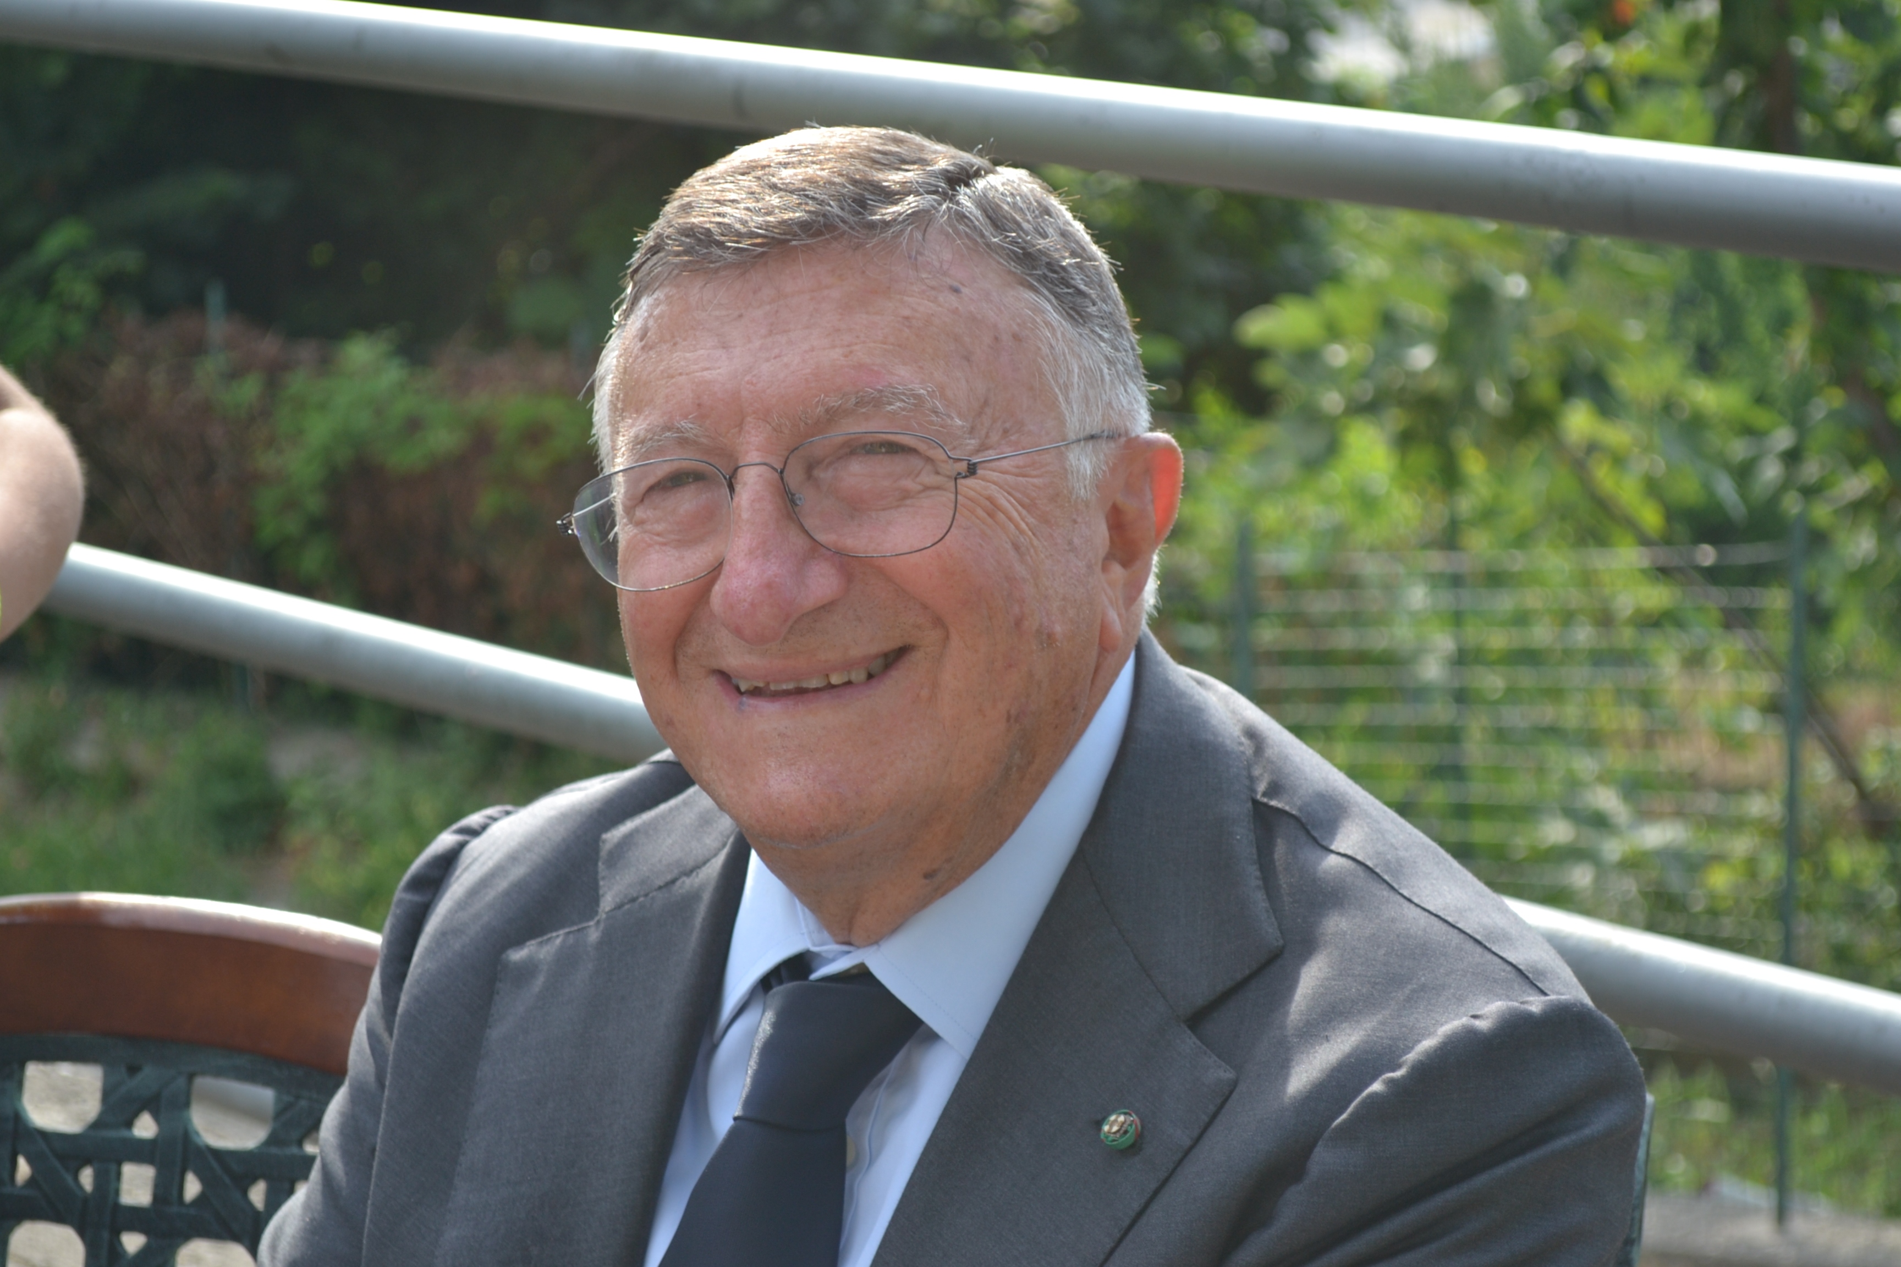
Title: Migratory Phenomena, Bioethics and Vaccinations
Name: Giulio Filippo Tarro
Foundation T. & L. de Beaumont Bonelli for cancer research, Naples, Italy

The evolution of the HIV following migratory phenomenons is reported in an interesting study carried on for 15 years. Polymerase Chain Reaction (PCR), is a technique in molecular biology that amplifies a specific region of deoxyribonucleic acid (DNA), and has been useful in the molecular characterization of viruses as poxviruses. In many countries - among which Italy - the vaccinations are included in the so-called sanitary obliged not coercive treatments. This means that the obligation is anticipated for all the subiects belonging to one determined range of age to undergo to some vaccinations, but that these are not subministrated by force in case of refusal. The legitimacy of the imposition of the obligatory vaccination against the smallpox, with all the risks connected, observing how such "risks were too much reduced to be seriously taken in consideration for the benefits produced on the collectivity". To ratify this obligation brings, however, to the reimbursement of the damages produced by the vaccination. Nevertheless, mass vaccination against smallpox continues to be a leading initiative in Western countries to guard against bioterrorist attack.

Biography

Giulio Tarro graduated from Medicine School, Naples University (1962). Research Associate, Division of Virology and Cancer Research, Children’s Hospital (1965-1968), Assistant Professor of Research Pediatrics, College Medicine (1968-1969), Cincinnati University, Ohio. Oncological Virology Professor, Naples University (1972-1985). Chief Division Virology (1973-2003), Head Department Diagnostic Laboratories, (2003-2006). D. Cotugno Hospital for Infectious Diseases, Naples; Emeritus, 2006 -. Since 2007 Chairman Committee of Biotechnologies and VirusSphere, World Academy Biomedical Technologies, UNESCO, Adjunct Professor Department Biology, Temple University, College of Science and Technology, Philadelphia, recipient of the Sbarro Health Research Organization lifetime achievement award (2010). President Foundation de Beaumont Bonelli for Cancer Research.

Presenting author details
Full name: Giulio Filippo Tarro
Contact number: +39.3357758241 - +39.0815750090
Twitter account: @TarroGiulio
Linked In account: Giulio Tarro
Session name/ number:
Category: (Oral presentation/ Poster presentation)

