Association between presence of GAD65 and IA-2 Autoantibodies with Coxsackievirus B3 and B4 Infection in Type 1 Diabetic Children
Angila Ataei-Pirkooh*, Atefeh Kachooei Mohagheghi Yaghubi,

Abstract (300 word limit)

Background and Aims: It has been documented that in addition to the genetic susceptibility, environmental factors particularly viruses can also play an important role in the initiation or development of the pathogenesis of type 1 diabetes (T1D). However, findings from several epidemiological studies have shown conflicting results regarding the role of enteroviruses infections in this field of research. The purpose of the current study was to investigate a link between coxsackieviruses B3 and B4 infection and the development of T1D in children.
Materials and Methods: In this case-control study, 80 pediatric patients under 14 year of age with T1D and 80 non-diabetic children controls were enrolled between October 2017 to March 2018 from the Children's Medical Center in Tehran. Then, anti-GAD65 and anti-IA-2 autoantibodies were assessed in two groups using commercially available Enzyme linked immunosorbent assay (ELISA) kits. IgG antibodies of both Coxsackieviruses B3 and B4 were also measured by direct ELISA kits.
Results: The mean anti-GAD65 antibody titer in CV B3+ samples was 4.26 ± 2.46 IU/mL,
and was slightly higher than that found in the CV B3- samples with a mean titer of 3.62 ± 2.08 IU/mL (p = 0.22; 95% CI: -1.69 to 0.4). Also, the mean anti-IA-2 ELISA OD450 values in CV B3+ samples (0.260 ± 0.155) was similar with that of the CV B3- samples (0.260 ± 0.160) (p = 0.98; 95% CI: -0.079 to 0.077).
Conclusion: This study showed that the titer of autoantibodies in CVB3+ or CVB4+ samples were not significantly different compared to CVB- samples. The results of this study suggest that there is still a need for further investigations to prove the association of coxsackieviruses and diabetes.
Image
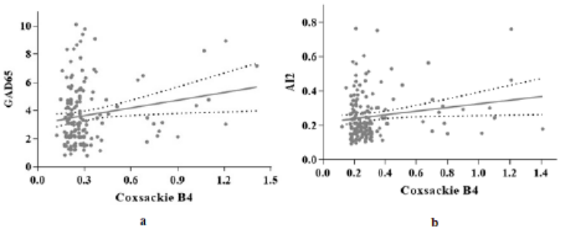 Fig. 1. Correlation between the levels of anti-CVB4 IgG antibodies and a) anti-GAD65 antibodies; b) anti-IA-2 antibodies
Recent Publications (minimum 5)
- Destruction mechanisms of ozone over SARS-CoV-2. Nature Scientific Reports, 2021
- Molecular identification of Leishmania RNA virus in cutaneous leishmaniasis patients and rodent -reservoirs in Isfahan province, Iran. Infection, Genetics and Evolution, 2022
- Disease waves of SARS-CoV-2 in Iran closely mirror global pandemic trends, medRxiv, 2021
- Inhibition of herpes simplex virus type 1 infection by Sambucus ebulus extract in vitro, Medical Journal of the Islamic Republic of Iran (MJIRI), 2021
- Detection and Phylogenetic Analysis of Hepatitis A Virus in the Wastewater Treatment Plant of Ekbatan Town in Tehran, Iran. Hepatitis Monthly, 2021

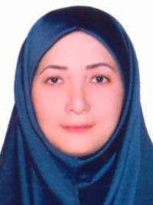Biography (150 word limit)

Dr. Angila Ataei-Pirkooh is an Assistant Professor of Virology at Iran University of Medical Sciences and the head of the Papilloma Department at the Research Center for Clinical Virology of Tehran University of Medical Sciences. She is also the head of the Papilloma Clinic at Lolagar Hospital in Tehran. She is a member of the University Consortium against Covid 19 and collaborates with Iranian Viral Disease Research Network.
Email:
ataei.a@iums.ac.ir

Notes/Comments:

Presenting author details
Full name: Angila Ataie Pirkouh
Contact number: 00989126812580
Twitter account:
Linked In account:
Session name/ number:
Category: Oral presentation

