Optimization of cold atmospheric plasma for the elimination of epidemic viruses

Asma Bouazizi^{ab*}, Klára Obrováª, Eva Vaňková^{b}, Josef Khun^{c}, Vladimír Scholtz^{c} and Thomas Lion^{a,e,*}
ª Children’s Cancer Research Institute (CCRI), Vienna, Austria
^{b} LR14SP02, Faculty of Pharmacy, University of Monastir, Tunisia
^{c} Department of Physics and Measurements, University of Chemistry and Technology, Prague, Czech Republic
^{e} Department of Pediatrics, Medical University of Vienna, Vienna, Austria

Abstract
Surface contamination with infectious and pathogenic viruses, such as SARS-CoV-2, Influenza A (InfA), human adenovirus (HAdV), or human rhinovirus (HRV), is a threat to public health.
Cold atmospheric plasma (CAP) is an emerging non-thermal technology for the decontamination of bacterial and viral pathogens. Along with its outstanding effectiveness, the CAP technology is inexpensive, gentle to the exposed material, and safe to humans and the environment.
Objectives: We intend to optimize the CAP technology for disinfection of heat- or liquid-sensitive objects to permit their repeated use upon decontamination. Moreover, our aim was to investigate the effect of increasing doses of CAP on different respiratory viruses (SARS-COV-2, InfA, HAdV, and HRV) by assessing the integrity of viral genomes, overall morphology, and infectivity in permissive cell lines.
Methods: We generated several devices for non-thermal plasma (NTP) production, optimized e.g. in size, chamber characteristics or discharge number. Individual devices are screened for efficiency against viruses and several properties are tested. The reduction of infectivity is tested in cell culture. To address the physical damage inflicted by NTP, samples are analyzed by qPCR. To distinguish different degrees of damage, we develop assays using DNAse treatment and filtering.

Results: Optimized NTP devices differ in their efficiency against viruses. The most efficient setup reduced the infectivity of HRV and HAdV to 100% and 80%, respectively, after 30 minutes. Genome copies are reduced more slowly and drop to 86% after 10 minutes and to 65% after 30 minutes. Analyses of InfA and HAdV are ongoing.

Conclusion: NTP devices require carefully adapted design for adequate efficacy of surface decontamination from different viruses.
Recent Publications
- Guo, L.; Yang, L.; Qi, Y.; Niyazi, G.; Huang, L.; Gou, L.; Wang, Z.; Zhang, L.; Liu, D.; Wang, X.; et al. Cold Atmospheric-Pressure Plasma Caused Protein Damage in Methicillin-Resistant Staphylococcus aureus Cells in Biofilms. Microorganisms 2021, 9, 1072.
- Hamada A. Aboubakr; Fernando Sampedro Parra, James Collins, Peter Bruggeman, Sagar M. Goyal, et al. Ìn situ inactivation of human norovirus GII.4 by cold plasma: Ethidium monoazide (EMA)-coupled RT-qPCR underestimates virus reduction and fecal material suppresses inactivation Food Microbiology 85 (2020) 103307
- Fongaro et al. Virology Journal 2013, 10:166
- Dobnik D, Kogovšek P, Jakomin T, Košir N, Tušek Žnidari ˇc M, Leskovec M, Kaminsky SM, Mostrom J, Lee H and Ravnikar M (2019) Accurate Quantification and Characterization of
Adeno-Associated Viral Vectors. Front. Microbiol. 10:1570
5. Li Guo, Yiming Zhao, Dingxin Liu, Zhichao Liu, Chen Chen, Ruobing Xu, Miao Tian, Xiaohua Wang, Hailan Chen & Michael G. Kong (2018): Cold atmospheric-pressure plasma induces DNA-protein crosslinks through protein oxidation, Free Radical Research, DOI: 10.1080/10715762.2018.1471476


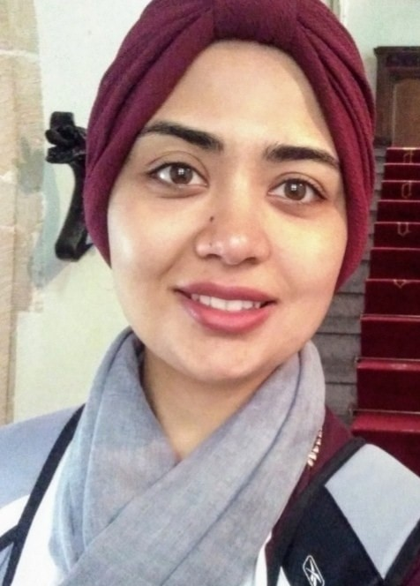

Biography
Asma BOUAZIZI is a fourth-year doctoral student in pharmaceutical sciences at the Faculty of Pharmacy, Monastir University. TUNISIA. The working title of her thesis is “Adenovirus infection: Epidemiological study of adenovirus infections and molecular characterization of circulating strains”. She has obtained a MA degree in genetics and biodiversity from the Higher Institute of Biotechnology in Monastir (2017). Before that, she received a BSc in natural sciences majoring in biology and geology, from the Faculty of Sciences of Gabes TUNISIA (2015). In 2019 and 2020, she contributed to two papers on the molecular characterization of group A Rotavirus among children. She has completed various internships in different laboratories, and worked on diverse research topics (Covid 19, NGS, cold atmospheric plasma).
Email: bouazizi.asma93@gmail.com

Presenting author details
Full name: Asma BOUAZIZI
Contact number: +4367764068877
Linked In account: https://www.linkedin.com/in/asma-bouazizi-125b04182
Session name/ number:
Category: Poster presentation

