Antidiabetic Evaluation of Pig Bile (Sus scrofa) Bile on Alloxan-induced BALB/c Mice
John Lyndon C. Lunnay, CSU-CVM, PHI
Bryan Jerome R. Bassig, DVM

Abstract
This study discerns to evaluate the antidiabetic efficacy of Pig Bile on Alloxan-induced BALB/c Mice, specifically: 1) To assess the antidiabetic effect of bile in BALB/c Mice. 2) To evaluate the effect of pig’s bile on fasting blood glucose level using a Glucometer. 3) To determine the oral glucose tolerance of pigs’ bile in Alloxan-induced mice using OGTT. 4) To determine the weight of Alloxan-induced BALB/c Mice supplemented with pig’s bile.
The experimental animals were divided and selected using RCBD into 5 groups (n= 4) receiving different treatments: T1 (negative control), T2 (1ml/kg), T3 (2ml/kg), T4 (3ml/kg) and T5 (Glibenclamide). Hyperglycemia was induced in mice by injecting 1% alloxan monohydrate intraperitoneally. Three (3) days after, blood glucose was measured using the tail blood sampling technique. Glucose tolerance test was performed using 2g/kg glucose solution and blood glucose levels were measured at 30 minutes, 60 minutes and 120 minutes post administration of treatments. 14 days of monitoring was also done to ensure effectivity and efficacy of the different treatments. Body weight was also determined. Results shows that administration of alloxan increases significantly the blood glucose levels of test mice as compared with the normal value which is 65-175 mg/dl. Administration of treatments on test animals significantly reverted the blood glucose levels of mice in 60 minutes and 120 minutes using oral glucose tolerance test. The data showed that all treatments has a reduction in blood glucose levels with T4 (3ml/kg) as the highest followed by T3 (2ml/kg) and T2 (1ml/kg) at 66.28 %, 58.68 % and 20.59 %, respectively at 120 minutes as compared with T5 (positive control) with 63.12 % reduction. After 14 days of monitoring, normal blood glucose levels were seen significantly on T2 (1ml/kg), T3 (2ml/kg), T4 (3ml/kg) and T5 (Glibenclamide) which only suggests the efficacy of pig bile on lowering glucose levels on alloxan-induced diabetic mice with mean percent reduction of 67.46 %, 56.11 % and 68.57 % at day 14 as compared with the positive control at 70.26 percent reduction, respectively. Body weight analysis shows no significant difference. DMRT (Duncan’s Multiple Range Test) shows comparable efficacy and effectivity between T3 (3ml/kg) and T5 (Glibenclamide) on lowering BGL at different day and time intervals.

Image
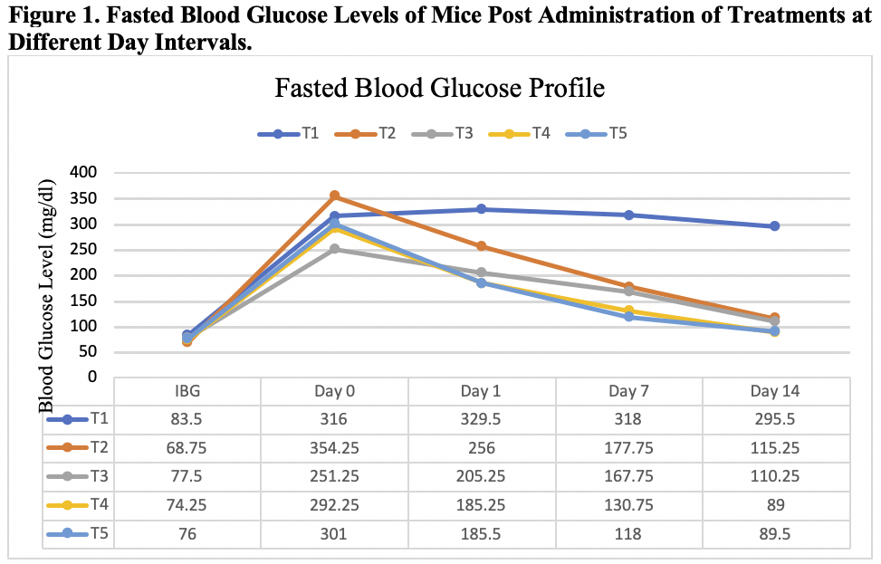

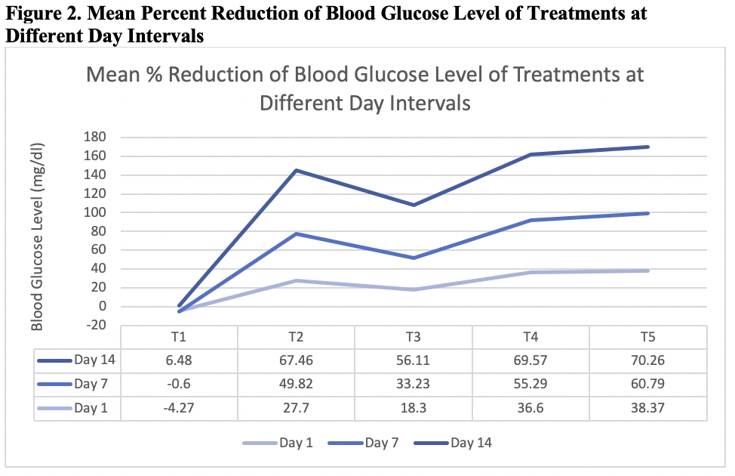

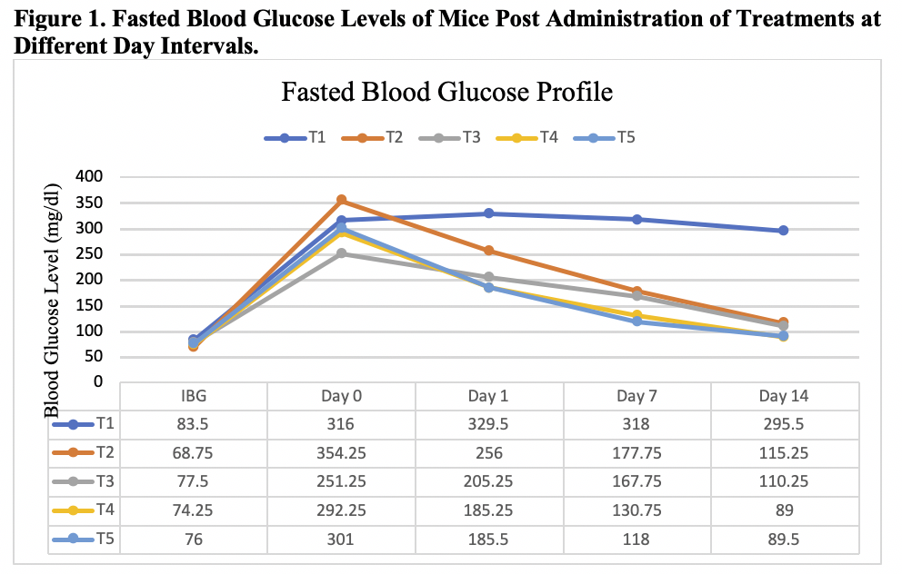
Recent Publications

Ankur Rohilla, Shahjad Ali. January 2012. Alloxan Induced Diabetes: Mechanisms and Effects.
Bays HE and Goldberg RB. (2007) The ‘forgotten’ bile acid sequestrants: is now a good time to remember. Am J Ther 14:567-580
Brendel C, Schoonjans K, Botrugno OA, Treuter E and Auwerx J. (2002) The small heterodimer partner interacts with the liver X receptor alpha and represses its transcriptional activity. Mol Endocrinol; 16:2065- 2076.
Brodbelt D., Mattin M., O’Neill D., Church D., McGreevy PD., Thimson PC., 2014. An epidemiological study of diabetes mellitus in dogs attending first opinion practice in UK. April 5; 174 (14): 349
Cabinta, L., Narag J., et al., 2012. Hypoglycemic effect of pig bile on hyperglycemic induced albino mice. UNPUBLISHED
Cao R, Cronk ZX and Zha W.(2010) “Bile acids regulate hepatic gluconeogenic genes and farnesoid X receptor via Gαiprotein- coupled receptors and the AKT pathway,” Journal of Lipid Research 51( 8): 2234–2244.
Cariou B, Van Harmelen K, Duran-Sandoval D, et al. 2005. Transient impairment of the adaptive response to fasting in FXR-deficient mice. FEBS Lett. ;579:4076–4080.
Collins, Bobby R., Kollias, George V and Jacobson, Elliot R. Contemporary Issues in Small Animal Practice. Exotic Animals. Common Diseases and Medical Management of Rodents and Lagomorphs. Vol. 9. 11, 261-316
Coniff, R.F. J.A. Shapir, T.B. Seaton, G.A. Bray. 1995. Multicenter placebo-controlled trial comparing acarbose (BAY g 5421) with placebo, tolbutamide, and tolbutamide-plus-acarbose in non-insulin-dependent diabetes mellitus. Am. J. Med.; 98: 443-451
Duran-Sandoval D, Mautino G, Martin G, et al. 2004. Glucose regulates the expression of the farnesoid X receptor in liver. Diabetes.;53:890–898.
Duran-Sandoval D, Cariou B, Percevault F, et al. 2005. The farnesoid X receptor modulates hepatic carbohydrate metabolism during the fasting-refeeding transition. J Biol Chem.;280:29971–29979.
Efanov AM, Sewing S, Bokvist K, et al. 2004. Liver X receptor activation stimulates insulin secretion via modulation of glucose and lipid metabolism in pancreatic beta-cells. Diabetes.;53(Suppl 3):S75–S78.
Einarsson K, Ericsson S, Ewerth S, et al. 1991. Bile acid sequestrants: mechanisms of action on bile acid and cholesterol metabolism. Eur J Clin Pharmacol.;40 Suppl 1:S53–S58.
Hagey LR. 1992. Bile acid biodiversity in vertebrates: chemistry and evolutionary implications. [Ph.D. thesis]. San Diego, CA: University of California.
Haslewood GA. 1971. Bile salts of germ-free domestic fowl and pigs. Biochem J.;123:15-18
Inagaki T, Choi M, Moschetta A, et al. 2005. Fibroblast growth factor 15 functions as an enterohepatic signal to regulate bile acid homeostasis. Cell Metab.;2:217–225
Kawamata Y, Fujii R, Hosoya M, et al. 2003. A G protein-coupled receptor responsive to bile acids. J Biol Chem.;278:9435–9940.
Katsuma S, Hirasawa A, Tsujimoto G. 2005. Bile acids promote glucagon- like peptide-1 secretion through TGR5 in a murine enteroendocrine cell line STC-1. Biochem Biophys Res Commun. ;329:386–390.
Kumar GPS, Arulselvan P, Kumar DS, Subramanian SP. 2006. Antidiabetic activity of fruits of Terminalia chebulaon streptozotocin induced diabetic rats. J Health Sci.;52(2):283–91.
Lefebvre P, Cariou B, Lien F, et al. 2009. Role of bile acids and bile acid receptors in metabolic regulation. Physiol Rev.;89: 147–191
Li YW, Zhu XY, But PP, Yeung HW: 1995. Ethnopharmacology of bear gall bladder: I. Journal of Ethnopharmacology, 47:27-31.
Ma K, Saha PK, Chan L, Moore DD. 2006. Farnesoid X receptor is essential for normal glucose homeostasis. J Clin Invest.;116:1102–1109.
Meenakshi P, Bhuvaneshwari R, Rathi MA, Thirumoorthi L,Guravaiah DC, Jiji MJ. (2010) Antidiabetic activity of ethanolic extract of Zaleya decandra in alloxan-induced diabetic rats. Appl Biochem Biotechnol 162: 1153-1159.
Mesiha, M.S., Ponnapula, S. & Plakogiannis, F. (2002a) Oral absorption of insulin encapsulated in artificial chyles of bile salts, palmitic acid and alpha-tocopherol dispersions. 249, 1-5.
Mikov, M. & Fawcett, J.P. (2006b) Chemistry, biosynthesis, analysis, chemical & metabolic transformations and pharmacology. 31, 133-134.
Nelson, Richard W., Edward Fieldman, and Stephen Ettinger (1995). Textbook of Veterinary Medicine of the Dog and Cat. Diabetes Mellitus, Vol. 2, 117, 1510-1537.
Nguyen A, Bouscarel B. 2008. Bile acids and signal transduction: role in glucose homoestasis. Cell Signal.;20;2180-2197
Osasenaga Macdonald Ighodaro, Abiola mohammed Adeosun, Oluseyi Adeboye Akinloye (2018). Alloxan-induced diabetes, a common model for evaluating the glycemic-control potential of therapeutic compounds and plantx extracts in experimental studies. Medicina-210.
Pareek H, Sharma S, Khajja BS, Jain K and Jain GC. (2009) Evaluation of hypoglycemic and antihyperglycemic potential of Tridax procumbens (Linn.). BMC Complement Altern Med; 9: 48.
Perino, Alessia, Thijs Willem Hendrik Pols, Mitsunori Nomura, Sokrates Stein, Roberto Pellicciari, Kristina Schoonjans. 2014. TGR5 reduces macrophage migration through mTOR-induced C/EBPβ differential translation. Journal of Clinical Investigation.
Piedrola, G. E. Novo, F. Escobar, R. Garcia-Robles. 2001. White blood cell count and insulin resistance I patients with coronary artery disease. Ann. Endocrinology.; 62:7-10
Rajani C., Jia W., 2018. Bile Acids and their effects on diabetes. Front. Med. University of Hawai Cancer Center, Honolulu, USA.
Sato H, Genet C, Strehle A, et al. 2007. Anti-hyperglycemic activity of a TGR5 agonist isolated from Olea europaea. Biochem Biophys Res Commun.;362:793–798.
Short AD, Holder A., Rothwell S., Massey j., Scholey., Kennedy L., Catchpole B., Ollier W. 2014. Searching for “monogenic diabetes” in dogs using a candidate gene approach. Canine Genet Epidemiology.: 1:8
Staels, B. Handelsman, Y. Fonseca V. 2010. Bile acid sequestrants for lipid and glucose control. Curr. Diab. Rep.; 10: 70-77
Stayrook KR, Bramlett KS, Savkur RS, Ficorilli J, Cook T, Christe ME, Michael LF and Burris TP. (2005) Regulation of carbohydrate metabolism by the farnesoid X receptor. Endocrinology 146: 984-991.
Resureccion, Salve Mae. 2016. The Efficacy of Makabuhay (Tinospora crispa) with Neem (Azadirachta indica) in lowering Blood glucose levels of hyperglycemic Alloxan-induced Mice. March UNPUBLISHED
Tao HJ. Variorum of Shen Nung’s Herbal Classic (Ben Cao Jing Ji Zhu). 1995. Shanghai: Shanghai Qunlian Publishing House, c. 492 CE,
Thomas C, Gioiello A, Noriega L, et al. 2009. TGR5-mediated bile acid sensing controls glucose homeostasis. Cell Metab.; 10:167–177. This paper evaluates the role of the TGR5 signaling pathway and a TGR5-specific agonist in the in vivo regulation of secretion of intestinal GLP-1.
Tiwari, Ashok K. and J. Madhusudana Rao. 2002. Current Science. Diabetes Mellitus and Multiple Therapeutic Approaches of Phytochemicals: Present Status and Future Prospects, Vol. 83, No. 1. July 2002
Wang, D. Carey, Marey. 2014. Therapeutic uses of animal biles in traditional Chinese medicine; An` ethnopharmalogical, biophysical chemical and medicinal review. World J. Gastroenterology.; 20; 9952-9975
Washington State University. Diabetes Mellitus. 2015. https://www.vetmed.wsu.edu/outreach/Pet-Health-Topics/categories/diseases/diabetes-mellitus
Wen Wu. 1975. Research Group of the History of Medicine, the Academy of Traditional Chinese Medicine. A brief study of four lost ancient medical texts contained in the silk manuscripts recovered from No. 3 tomb at Mawangdui. 1975; 6: 16-19
World Applied Sciences Journal 7 (10). 2009. 1231-1234, 2009 ISSN 1818-4952 © IDOSI Publications
Yaryuya-Tobias, J.A. A. Pinto, F. Nerziroglu. 2001. Anorexia nervosa, diabetes mellitus, brain atropy and fatty liver. Inter. J. Eat. Disorder.; 30: 350-353
Zhang Y, Lee FY, Barrera G, et al. 2006. Activation of the nuclear receptor FXR improves hyperglycemia and hyperlipidemia in diabetic mice. Proc Natl Acad Sci USA.;103;1006-1011


CURRICULUM VITAE

NAME: JOHN LYNDON CASIBANG LUNNAY
Contact number: 0926-298-3822
Email: lunnaylyndon@gmail.com
ADDRESS: TANZA, TUGUEGARAO CITY

PERSONAL BACKGROUND:
DATE OF BIRTH: APRIL 24, 1998 AGE: 21 GENDER: MALE
BIRTH PLACE: BAGAY, TUGUEGARAO CITY
CIVIL STATUS: SINGLE
FATHER: TOMAS B. LUNNAY JR.
MOTHER: MADELYNE C. LUNNAY
SIBLINGS: JOHN DOMINICK C. LUNNAY
JOHN ASLEY C. LUNNAY

EDUCATIONAL BACKGROUND:
ELEMENTARY: TUGUEGARAO NORTH CENTRAL SCHOOL (2004-2010)
SECONDARY: CAGAYAN NATIONAL HIGH SCHOOL (2010-2014)
TERTIARY: CAGAYAN STATE UNIVERSITY (2014-PRESENT)

AFFILIATIONS:
ORGANIZATIONS: VETERINARY STUDENT ACHIEVERS’ SOCIETY
CARIG CAMPUS STUDENT COUNCIL

Email: lunnaylyndon@gmail.com

