Evaluation of bovine (Bos indicus) ovarian potential preserved at 5°C for in vitro oocyte production
KOUAMO J.
School of Veterinary Medicine and Sciences, The University of Ngaoundere, Ngaoundere, Cameroon. PO BOX 454, Ngaoundere, Cameroon. Tel: (+237) 675376954

Abstract (300 word limit)
A study was carried out at the Ngaoundere municipal slaughterhouse (Adamawa-Cameroon) on 199 cycling zebu cows to evaluate the potential of ovaries preserved at 5°C for in vitro production of cultivable oocytes. Thus, two (02) experiments were performed. The first trial consisted in observing and classifying the oocytes according to their quality every hour (1-13 hours) in order to determine the optimal time of preservation of the ovaries at 5 °C. The second trial investigated the biochemical variations as a function of the preservation time of glucose, total cholesterol and calcium in the follicular fluid. The results indicated that the average weight of the ovaries did not change during 13 hours of preservation. The mean follicular population of the ovaries was 8.81± 5 (5-12) and it decreased significantly (P = 0.02) from 09 hours. After 11 hours of preservation, the mean oocyte yield was 10.24 ± 5.90 (3-12) and it decreased significantly (P = 0.00). The average of the cultivable oocytes (Q1 and Q2) was 7.30± 4.87 (2-8) and it decreased significantly after 12 hours. The mean concentration of glucose in the follicular fluid after 13 hours of preservation at 5°C was 29.25±16.19 mg/dl and it increased significantly (P = 0.00) after 10 hours. Total cholesterol decreased significantly (P = 0.00) after 10 hours and was 17.97±10.63 mg/dl. The average of calcium concentration was 2.86 ±2.01 mg /dl and increased significantly (P = 0.00) after 10 hours. This study indicates that the zebus cows' ovaries could be preserved at 5°C for 9 hours without any significant change in biochemistry, yield and quality of cultivable oocytes.


Image
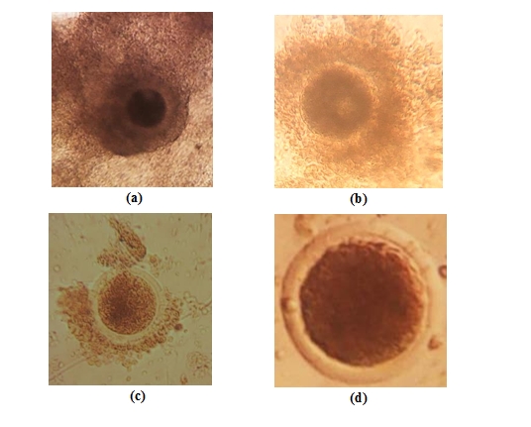
Figure 1. Oocyte quality, a= grade I; b= grade II; c= grade III; d= grade IV
Recent Publications (minimum 5)
Justin Kouamo, Nono Fambo SM and Zoli AP (2017) Effect of the Stage of Sexual Cycle, Harvesting Technique and Season on Follicular Dynamics and Oocyte Quality of Zebu Cattle under Sudano-Sahelian Climate. Integr J Vet Biosci Volume 1(1): 1–7.
J Kouamo, B Meyoufey, A.P. Zoli. Pathological study of female reproductive organs of local zebus in Adamawa Region. Bulletin of Animal Health and Production in Africa, Vol 64, No 1 (2016): 119-128.
J. Kouamo and S.D. Kharche. Effect of different gonadotropin on in vitro development of immature caprine oocytes. The Indian Journal of Animal Reproduction, Vol 36, No 1 (2015), 5-9.
J. Kouamo and S.D. Kharche. A comparative study of parthenogenetic activation and in vitro fertilization of in vitro matured caprine oocytes. Iranian J. Vet. Res. 2015, Vol. 16, No. 1, Ser. No. 50, Pages 20-24.
Kouamo J, Sow A, Kalandi M, Sawadogo GJ (2014) Sensitivity, specificity, predictive value and accuracy of ultrasonography in pregnancy rate prediction in Sahelian goats after progesterone impregnated sponge synchronization, Veterinary World 7(9): 744-748.

Biography
Justin Kouamo obtained a Doctorate degree in Veterinary Medicine (DVM) and a Master of Science at the EISMV of Dakar (Senegal). He has completed his PhD in Animal Reproduction at the age of 30 years from Polytechnic University of Bobo-Dioulasso (Burkina Faso). In 2012, he has been awarded with the prestigious C V Raman International Fellowship to join the Post-Doctoral Fellow (PDF) programme at CIRG, Makhdoom (India) on the topic “In vitro maturation, in vitro fertilization and culture of oocytes for caprine in vitro embryo production”. In 2016, he received an advanced training course in macroscopic anatomy and theriogenology at the Faculty of Veterinary Medicine of the University of Montreal (Quebec-Canada). Actually, he is Professor (Associate) and Head of Department at the School of Veterinary Medicine and Science of the University of Ngaoundere (Cameroon). He has published more than 35 papers in reputed veterinary journals particularly in the area of assisted reproductive techniques and has been serving as an editorial board member of repute.
.
Email: justinkouamo@yahoo.fr

Notes/Comments:

