Scanning Electron Microscopic (SEM) Observations of Fasciola Gigantica Soaked in Albendazole By In Vitro In Bali Cattle.

A.A. Gde Oka Dharmayudha, Faculty of Udayana University Udayana, Bali, Indonesia
Ida Bagus Komang Ardana, Faculty of Udayana University Udayana, Bali, Indonesia
Made Suma Anthara, Faculty of Udayana University Udayana, Bali, Indonesia
I Wayan Nico Fajar Gunawan, Faculty of Udayana University Udayana, Bali, Indonesia
Tjok Gede Oka Pemayun, Faculty of Udayana University Udayana, Bali, Indonesia

Abstract

This study aims to determine the scanning electron microscope image of the ovicidal effects of Fasciola gigantica worm eggs soaked with albendazole in vitro in different doses. This study uses a laboratory experimental approach with a completely randomized design (CRD) method with 4 treatments and 5 replications so that a total of 20 samples. Fasciola gigantica eggs soaked with albendazole with 4 different doses namely control (P0), P1 = 0.06ml / 40 ml aquades (0.15%), P2 = 0.12ml / 40ml aquades (0.30%), and P3 = 0.24ml / 40ml distilled water (0.60%).The results of scanning electron microscopy (SEM) showed that increasing the dose of albendazole in the immersion treatment in vitro has an impact on increasing damage to the structure of the Fasciola gigantica egg wall because the higher the drug dose the more active albendazole substances that work in damaging the egg wall of Fasciola gigantica

Image
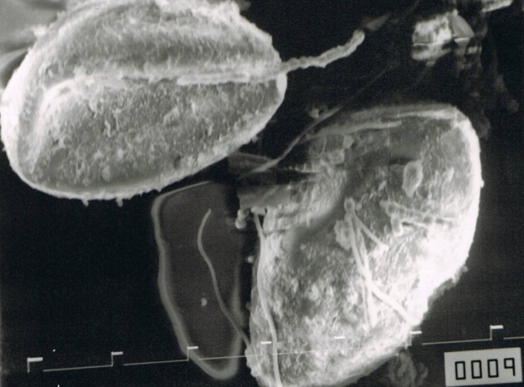
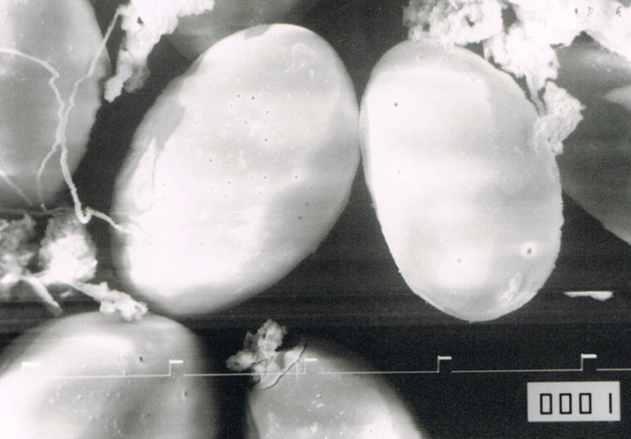
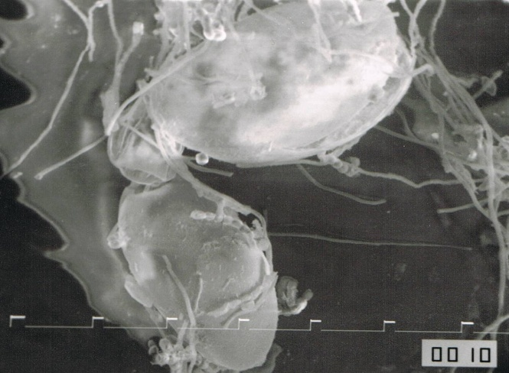
c

a
b

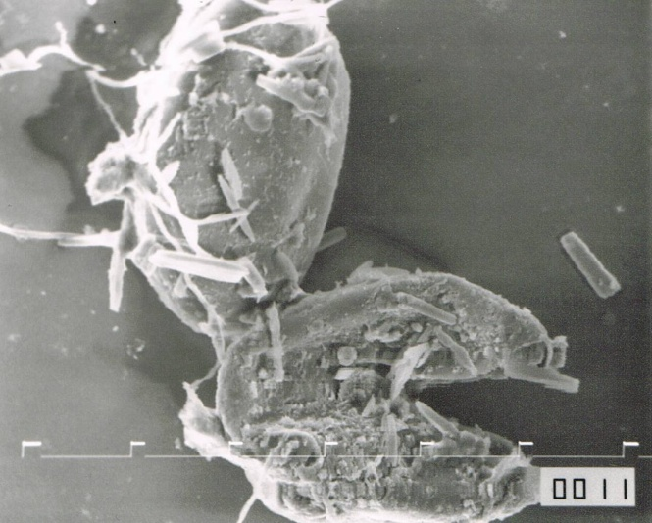

d

Figure 1: SEM of fasciola gigantica egg with different level Albendazole (a) Normal, (b) 0.06 ml of Albendazole, (c) 0.12 ml of Albendazole, (d) 0.24 ml of Albendazole,

Recent Publications
- Alvarez L., Mottier L., Sa´ nchez, S., Lanusse, C., 2001. Ex vivo diffusion of albendazole and its sulphoxide metabolite into Ascaris suum and Fasciola hepatica. J Parasitol. Res. 87, 929–934.
- Ardisasmita MS. 2000. Pengolahan Citra Digital Dan Analisis Kuantitatif Dalam Karakterisasi Citra Mikroskopik. Mikroskopi dan Mikroanalisis. 3(1) : 1410-5594
- Purwanta, Nuraeni, Hutauruk JD, Setiawaty S. 2009. Identifikasi cacing saluran pencernaan (gastrointestinal) pada sapi bali melalui pemeriksaan tinja di Kabupaten Gowa. Jurnal Agrisistem.5(1): 10-21.
- Shaikh AA, Bilqees FF, and Khan MM. 2004. Bile Duct Hyperplasia an Assosiated Abnormalities in Buffaloes Infected with Fasciola gigantica. Pakistan J. Zool 36(3): 231-237.
5. Suhardono. 2001. Epidemiology and control of fascioliasis by F.gigantica in ongole cattle in West Java. PhD Thesis. Biomedical and Tropical Veterinary Science. James Cook University of North Queensland, Australia.

Biography
Anak Agung Gde Oka Dharmayudha has his expert in Veterinary Radiology. He is a lecturer in Faculty of Veterinary Udayana University, Bali, Indonesia. His passion and research interest are in Radiology and Pharmaceutical. His recent research is in pharmaceutical against parasite in livestock.

Email: oka.dharma@unud.ac.id

Notes/Comments:

