Unilateral Cryptorchidism And The Relation To Semen Quality And Ultrasonography Appearance: Case Report In Kintamani Dog
I Wayan Nico Fajar Gunawan, Faculty of Veterinary Medicine Udayana University, Bali, Indonesia
A.A Gde Oka Dharmayudha, Faculty of Veterinary Medicine Udayana University, Bali, Indonesia
Tjok Gde Oka Pemayun, Faculty of Veterinary Medicine Udayana University, Bali, Indonesia
I Ketut Puja, Faculty of Veterinary Medicine Udayana University, Bali, Indonesia

Abstract

Unilateral (one-sided) cryptorchidism is the most common congenital reproductive defect in the dog. This is the condition whereby only one testicle is within the scrotal sac of the male animal, but the other one is retained and undescended. This case report the relation of unilateral cryptorchidism on volume, motility, DNA integrity and the of testicular parenchymal echotexture of the testes in kintamani dog. Ultrasound examinations of the testes using a real time B-mode ultrasound machine. Assessment of testicular parenchymal echotexture was performed on recorded digital images of testes. Each testis was classified into one of six categories according to the echotexture of the testicular parenchyma. Semen was collected by digital manipulation. Semen volume, motility and DNA integrity of spermatozoa were evaluation. The testicular parenchymal echotexture that appeared normal and were classified as normal echogenicity. The volume of the second fraction was 0,7ml. The DNA integrity was 98.0 and progressive motility was 91.0. The echotexture, DNA integrity and motility were not unaltered by this condition. These results suggest that unilateral cryptorchidism not causes the semen qualitative and the parenchyma defects in kintamani dog.

Image
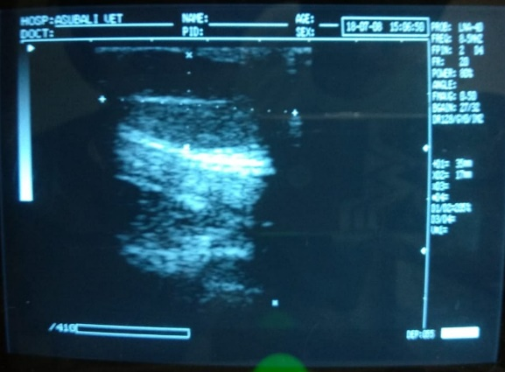

Figure 1: Ultrasonography imaging of unilateral cryptorchidism in Kintamani Dog.
Recent Publications
- England, GCW., Bright L., Pritchard B., Bowen IM., de Souza MB., Silva LDM., Moxon R., Canine reproductive ultrasound examination for predicting future sperm quality. Reprod Dom Anim 2016; 51 (Suppl. 3): 1–6.
- Felumlee AE., Reichle J., Hecht S., Penninck DG., Zekas L., Yeagar AD.,Goggin JM., Lowry J., 2012. Use of ultrasound to locate retained testes in dogs and cats . Veterinary Radiology & Ultrasound 53(5):581-5.
- Joon Ho Moon jh.,Yoo dy., Jo yk., Kim ga., Jung hy., Choi JH., Hwang IK., Jang G., 2014. Unilateral cryptorchidism induces morphological changes of testes and hyperplasia of Sertoli cells in a dog. Lab Anim Res. 2014 Dec; 30(4): 185–189.
- Pugh CR., Konde LJ., Park RD., 2005. Testicular Ultrasonography in the Normal Dog. Veterinary Radiology & Ultrasound 31(4):195 – 199.
5. Puja IK., Irion DN., Schaffer AL, Pedersen NC. 2005. The Kintamani Dog: Genetic Profile of an Emerging Breed from Bali, Indonesia. Journal of Heredity, 96 (7): 854–859.

Biography
I Wayan Nico Fajar Gunawan has expertise in small animal ultrasonography. He has passion in small animal radiology especially on Kintamani Dog. He also a staff in Laboratory of Veterinary Radiology in Faculty of Veterinary Medicine, Udayana University, Bali, Indonesia.His recent research are on Kintamani Dog Reproction Ultrasonography.
Email: nico_fajar_g@unud.ac.id

Notes/Comments:

