Isolation of Mycoplasma mycoides subsp mycoides Small Colony in North and South Kordofan State
.
Eslah, A. D.O¹, Neimat.M.E.E1, Elgadal.A,

1Ministry of Animal Resources. Animal Resources Research Corporation.

¹E.mail: eslahhabib@gmail.com

¹Email: neimatelnour68@ gmail.com
Abstract:
This study was carried out to study the presence of contagious bovine pleuropneumonia (CBPP) in North and South Kordofan States by in vitro isolation of Mycoplasma mycoides subsp. mycoides (small colony type). out of 150 lungs examined in slaughterhouses in the tow States were collected. fifty pneumonic lung tissue samples collected from animals showing typical signs and post-mortem lesions of CBPP. Two Mycoplasmas were isolated from infected cases one from Elobied (EK1) and the next one from Kadogli (EB). The two isolates were identified as Mycoplasma mycoides subsp. mycoides by their colonies morphology, cultural characteristics and growth inhibition tests and biochemical tests .The isolation and identification of the causative agents of CBPP recognize presence of the disease of CBPP in North and South Kordofan States.

Introduction
Contagious bovine pleuropneumonia (CBPP) is caused by the small colony form of Mycoplasma mycoides subspecies mycoides (MmmSC). Although other bovids are also affected, CBPP is a disease mainly of domestic cattle and is characterized in typical cases by a fibrinous interstitial pneumonia and pleurisy. Clinical signs of the disease are attributable to lesions that develop in the thorax, where large areas of the lungs may be involved. The disease was once widespread but has gradually been eradicated from most developed countries; The disease is now mainly confined to the African continent, although there have been a number of recent outbreaks reported in southern Europe. Provisional diagnosis of CBPP can be made on the basis of clinical and pathological findings. However, the disease can be confused with bronchopneumonia or pleuropneumonia resulting from mixed infections caused either by viruses or bacteria such as Pasteurella sp.The disease is usually confirmed using a number of methods, including culture and serology, although each can have its disadvantages. These mycoplasmas are slow growing, and culture can take up to 3 weeks for isolation and identification.(Bashiruddin &Taylor).
The Pan African control of Epizootics (PACE) in 2003 showed that the disease is currently endemic in most parts of the Sudan especially in areas below 15oN latitude with varying degree of severity and with highest prevalence incidence in the southern parts. The disease is frequently reported from eastern states near Ethiopian border in Doka and Al Galabat in Gedarif State. Al Managel (Gezira State), Al Dinder and Singa (Sinnar State), Al Rossires and Al Angasana (Blue Nile State) and Algabalin and Kosti (White Nile State) are the endemic areas in the Central States.
Southern Kordofan State is also endemic area and reports were received from Al Delling, Kadogli and Abu Gebiha in the Southern Kordofan State up Babanosa, Almoglad and Abeyei in the southern part of the Western Kordofan State. CBPP is widely spread in Southern Darfur State specially areas of El Dain, Buram and Radom. Sporadic cases were reported in Khartoum State (Mageed, 2003). The disease was not reported in the northern Sudan (River Nile and Northern and Red Sea States) for more than 15 year (Amira 2005).

Material and methods
Sterilization
All glassware used were soaked for an hour in warm 10% detergent solution, scrubbed and rinsed in running warm water. The glassware were then rinsed in distilled water and were put on clean surface to drain dry. Graduated and capillary pipettes, Petri dishes, forceps, scissors, glass syringes, needles and cotton swabs were sterilized in hot air oven at 160ºC for 2 h. Vials such as bijou, universal, and Seitz-filter were sterilized by autoclaving at 121ºC (15Ib/inch2) for 15 minutes.
Collection of the samples:
Fifty pneumonic lung tissue samples, out of 150 lungs examined in slaughterhouses in the tow States were collected. Five pneumonic lung tissue samples were also collected from animals showing typical signs and post-mortem lesions of CBPP in, North and south Kordofan states in June – October 2017.
Method of collection of samples
Specimens (5 cm3) were cut and placed in sterile plastic bags, labeled and transported in ice box to the Central Veterinary Research Laboratory, Soba; Khartoum.
Medium
A basic medium of brain heart infusion (Oxoid) supplemented with yeast extract (fresh and powder), horse serum, glucose, in addition to penicillin and thallium acetate was used. The medium was used as broth or solid medium.
Method of isolation
Lung tissue samples were minced in broth medium with antibiotics. The suspension was then diluted through tenfold steps (to 10-3) to minimize bacterial contamination. Dilutions were placed on solid medium.
Incubation
The inoculated broth cultures were incubated at 37ºC aerobically for three to ten days. The inoculated solid medium was incubated aerobically at 37ºC in a humid chamber for 3 to 15 days. Further incubation for up to 21 days was continued if no visible growth was seen.
Detection of growth
The inoculated liquid medium was examined daily. Tubes showing faint turbidity (compared with the control medium) after day 3 of incubation were subjected to further investigation by dark field microscopy for presence of filamentous microorganism or bacterial contamination and stereomicroscope to show the appearance of colonies of Mycoplasma mycoides subspecies mycoides (MmmSC). .
Purification and storage of isolate
Broth cultures were streaked on solid medium. The plates were then incubated as mentioned before. The surface of solid medium was examined under (x40) power lens of stereomicroscope for fried-egg type colony. When a fried egg appearance colony appeared after 3 days, agar cube containing single colony was incised and used to inoculate broth medium. After aerobic incubation at 37ºC and when
faint turbidity appeared, the culture was then inoculated on solid media without inhibitors to exclude the L-form bacteria. Fried-egg types of colonies were then used to inoculate broth media. When inoculated medium showed growth, the culture was stored at -20ºC.
Identification of the isolates
Cultural characteristics
Growth of the isolate into liquid medium and on solid medium and the growth conditions were fully described
Microscopy
The inoculated Petri dishes examined by stereomicroscope at low magnification after 8 days of incubation at 37oC, to show fried egg appearance
Biochemical tests
Including the digitonin test, glucose fermentation, hydrolysis of ariginine and tetrazolium reduction.
RESULTS
Isolation of Mycoplasma mycoides subsp. mycoides small colonies
A total of 50 pneumonic lung samples were collected from different slaughterhouses in North and South Kordofan States. Five samples of them showing clinical signs and post-mortem lesions of CBPP; Two isolates were obtained from them EK1 from Elobied and EB from Kadogli.
Identification of the isolates
Cultural characteristics
The inoculated Petri dishes when examined by stereomicroscope at low magnification after 8 days of incubation at 37oC, shown fried egg appearance (Figure 1) in only two plates which were cultured by the two of the five clinical samples.

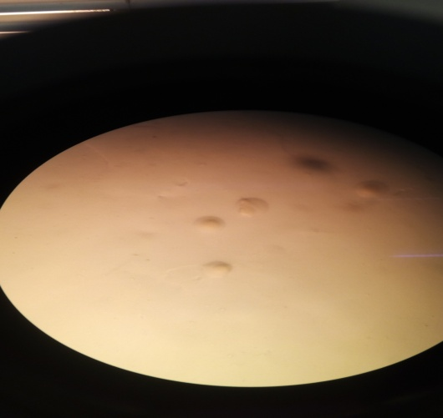
(Figure 1)

Digitonin test
- An inhibition zone of 10 mm around digitonin disk was noticed in two isolates (figure 2A,B&C).
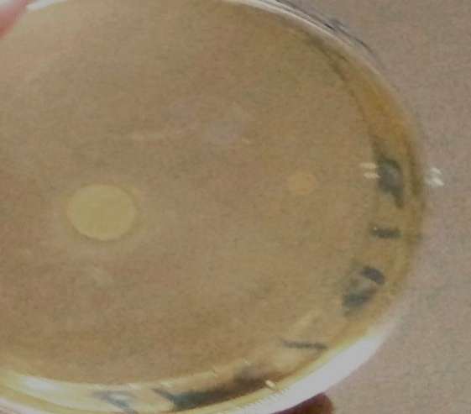
Figure 2A
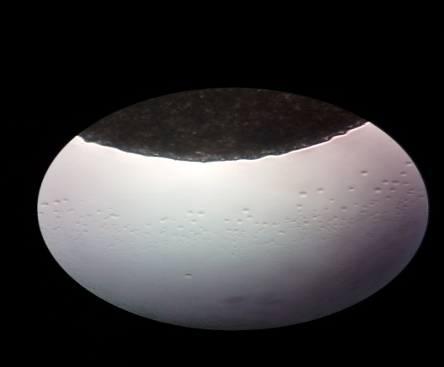
Figure (2B) 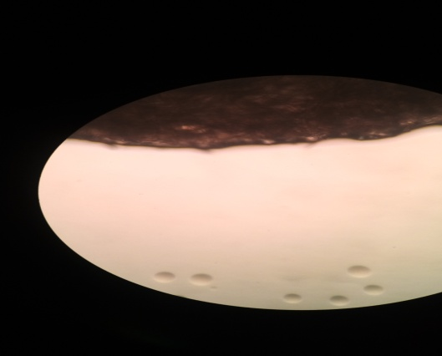
Figure (2C)

Glucose fermentation
Tow isolates of mycoplasma were ferment glucose and produce acid (Figure 3)
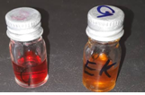
Hydrolysis of ariginine:
Tow isolates of mycoplasma were hydrolize arginine and shift the medium to alkaline (figure4).


f) Terazolium reduction:
Tow isolates of mycoplasma were reduce 2, 3, 5 Triphenyl tetrazolium chloride to brick red formozan (figure 5).
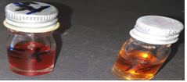
Figure (5)

Discussion
Detection of CBPP by Isolation and Identification of the causative agent is a hard commission, need more time and requires understanding and practice ; In this study 150 samples were collected from different Slaughterhouses in North and south Kordofan State, five out of 50 pleuropneumonic lunges of infected animals showed typical post-mortem findings of CBPP like Oedematous lung parenchyma, marbling appearance, sequestrum, consolidation, adhesion of the pleura and sizeable amount of pleural fluid. Two isolation of Mycoplasma mycoides subsp. mycoides Sc type. The isolation was performed on brain heart infusion medium.
The isolates were identified as Mmm SC based on microscopic (fried egg) appearance, cultural characteristics, digitonin sensitivity and biochemical tests including glucose fermentation, tetrazolium reduction and hydrolysis of arginine.
This isolation confirms the presence of the disease and this agrees with many investigators surveyed the prevalence of CBPP in other region in Sudan (Ameera, 2002; Karam, 2005; Amira, 2009) They reported the presence of the disease in Khartoum state. Reports of the Administration of Animal Health and Epizootic Control and Ministry of Animal Resources (2003) stated that sporadic cases of CBPP were observed in certain areas of Khartoum State.
Conclusions
Two isolates of Mycoplasma mycoides subs mycoides SC was isolated from infected lungs from North and South Kordofan states ,More isolates of MmmSC should be performed to help in epidemiological studies and control programmes of CBPP ,extensive and concentrated vaccination should also be carried out in all endemic areas of the country; for facilitation of genomic analysis of the isolates and the comparison with other isolates inside and outside Sudan; the implementation of molecular characterization and sequencing analysis which are more specific, simple, and quick tests is mandatory.
References
J. B. Bashiruddin, T. K. Taylor, A. R. Gould A PCR-based test for the specific identification of Mycoplasma mycoides subspecies mycoides SCJ Vet Diagn Invest 6:428-434 (1994)
Ameera,(2002)
Amira, S. (2009) Contagious Bovine Pleuropneumonia Isolation and Seroprevalence in Khartoum State, Sudan.MSc. Thesis.
Isam Eldin(2005) Studies On Contagious Bovine Pleuropneumonia In Khartoum State-Sudan, MSc. Thesis University of Khartoum .Sudan.
Mageed, I.E.A. (2003). Contagious bovine pleuropneumonia situation in Sudan (Workshop on control strategies of contagious bovine pleuropneumonia (CBPP) in Sudan), p. 22-36.

