Root canal therapy ,restoration of purge tissue with composite in inscisor teeth in the mandible of horse

Melika Mollabashi, Azad University Of Shahrekord, Iran

Dr.Reza Ghaffari, Urmia, Iran

Abstract

Nowdays dental problems in animals are one of the most important and sensitive parts of veterinary medicine tasks,that have different reasons such as nutritional problems,some diseases … and if they don’t been treated they can cause secoundary consequenses.

One of the animals exposed to dental injury are horses.

At 2019 we observed inappropriate nutrition in a mature Iranian stallion belong to the educational ,after getting permission from the head of clinic we did oral cavity macroscopic chekup and we observed deep fracture to the teeth root ,in order to getting ensure, radiologic graph was taken that showed opening of dental nurve.

The intended animal was off-feed for 24 hours and monitoring was done befor treatment.after generating general anesthesia we purged the frowzy tissue ;endodontic therapy and dental canal purge was done by rotary file.

Refering to radiologic graph and by using apex finder machine the length of nurve canal was measured in order to do dental restoration and then it filled by gutta-percha and then radiologic graph was taken for the second time in order to being ensure and then we reflied the purge tissue by dental composite(uv).

It should be noted that in all stages of surgery oral suction has been used.
Image
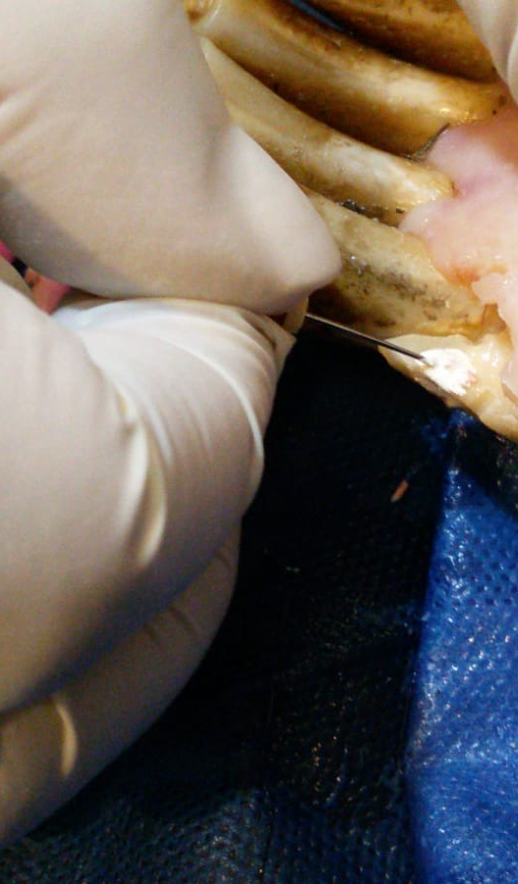
Recent Publications
- Girard N, et al. J Vet Dent. 2006.
- Golden, AL, Hennet, PR.Root canal obturation using thermafil endodontic obturators in dog teeth. J Vet Dent 1992;9: 4-7
- Kuntsi-vaattovaara H, et al. J Am Vet Med Assoc. 2002.
- Lyon KF, et al.Clin Tech Small Anim Pract. 2001.
- Reza ghaffari, et al. Root canal therapy, Carpal tissue repair with composite and fixed prosthesis in dogs, 12th Surgical Symposium Urmia 2016.

 Biography
My name is Melika Mollabashi;I was born at october 1995 and I have started my studies as veterinary medicine student in the year 2014 in one of the well-known universities in Iran .Now Im a veterinary medicine intern and my thesis is on dog surgery.I'm interested in working at the field of small animal surgery and internal medicine;I'm really intrested in gaining practical exprience of my academic knowledg.working as a beneficial veterinarian in the future is my biggest goal and I try hard in this way in order to catch my goal
Email: melika.mollabashi@yahoo.com

Notes/Comments:

