Investigation of fertility or dead statue of Hydatid cyst in lungs of slaughtered buffalo of Orumieh city – Iran
1-Armina khayat derafshi, DVM student, IRAN
2-Reza ghaffari, DVM student, IRAN

Cystic Echinococosis Granulosus is one of the most prominent problems for the health of human beings and animals, Echinococosis Granulosus is represented as one of the factors which has crystal clear effects on economy. Echinococosis Granulosus (hydatid cyst) larval stage causes a kind of harmful disease known as zoonose in both human and animals and the alternative users are canines. To see the big picture; hydatid cyst in livestock is diagnosed when buffalo is sent to butchery slaughtering, this is the only way to screen the disease. It is the purpose of this inquiry to denote the status of being viability and dead (1). To be more precise; in this research which is done January and February 2016, 1013 butchered buffaloes were examined and after the witness of cysts, the symptoms were taken to the Lab. Hydatic cyst after being centrifuged were colored with eosin 0.1% this is the case in which alive cysts are achromatic, dead ones are in red. Results indicate information that 149(14/70%) examined livestock out of 1013 were infected by Echinococosis Granulosus. After coloring with eosin approximately about 149 had infected lung, among of 149 lung 109 (73/15%)were fertile and 40(26/85%)were dead. Dead ones include both infertile and strile ones. The significant number of dogs living without any shelter is increasing, existing the sheepdogs in cattle and in its living area, not having industrial dairy, and last but not the least ranchers who are not interested in using anti-cestode leads to prevalence of this disease.(2)

Keywords: Echinococosis Granulosus, Lung, Hydatid Cyst,buffalo

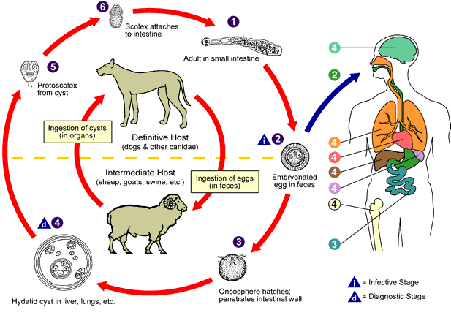
Recent Publications
- reza ghaffari wvc2015 istanbul-turkey.
- reza ghaffari, Mohammad Salimi Rad zoonose conference 2017 esfahan-iran 55-876.
3. H.J.Iqbal & et al. , Studies on hydatidosis in sheep and goats at Lahore ,Pakistan ,Journal of Animal & Plant Sciences ,22(4) :2012 page :894-897.
4. Regassa et al. ,2010 , Shahnazi et al. , 2013 , Wang et al. ,2014.

5. Budke , C.N ,P.Deplaxes and P.R Torgerson , 2006

 Biography
My name is Armina Khayat Derafshi, i was born on May 8th,1997,in Tehran-IRAN. I began to study veterinary medicine(DVM) in 2015,at the islamic azad university of Orumieh
Email: Armina.khayatderafshi@gmail.com

Notes/Comments:

