Periodontal disease in cattle raised extensively in Amazon region
Ana Carolina Borsanelli, DVM PhD, São Paulo State
University, Brazil
Ederson da Conceição Jesus, PhD, Embrapa, Brazil
Aline Pacobahyba de Oliveira, PhD, Embrapa, Brazil
Iveraldo Dutra, DVM PhD, São Paulo State University, Brazil

Abstract

Periodontal diseases are infectious polymicrobial, immuno-inflammatory diseases of multifactorial aetiology and can impact significantly on the welfare of animals since they can be a painful condition leading to inefficient mastication with consequential loss of body condition and weight, increased susceptibility to disease and decreased productivity of dairy and beef cattle. The importance of bovine periodontal disease has largely been overlooked by veterinarians and scientists and report studies are scarce. The aim of the current study was to conduct a preliminary evaluation of the presence of periodontal diseases in cattle raised extensively in farms in Amazon region of Brazil. We performed periodontal clinical evaluation of the incisor teeth of 334 animals from 15 farms in 6 counties and the criteria for diagnosing periodontal disease were the presence of gingival recession, the existence of periodontal pockets greater than 5 mm in depth, bleeding associated with probing (gingivitis) and tooth loss. Of the 334 animals, 79 (23.7%) had gingival recession, 24 (7.2%) had periodontal pockets with suppuration or bleeding, 47 (14.07%) had gingivitis and 27 (8.08%) lost at least one incisor tooth. Periodontal pockets and gingival recession were more prevalent at first incisor, while gingivitis was more frequent at second incisor. These results show the need to consider the impact of periodontal disease on productivity and animal welfare. Examination of the teeth of cattle in any clinical investigation or even in the routine procedures may contribute to elucidate the actual prevalence of periodontal disease in herds. This may alter the common perception that dental disease is of little consequence in the ruminant population. Findings of this study suggest that periodontal disease can be a major problem in Brazilian herds leading to hidden economic loss and early culling animals.

Image

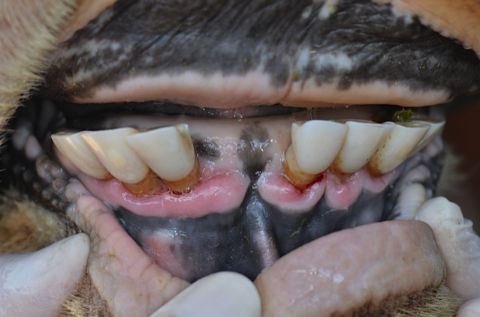
Figure 1 – Presence of gingival recession with root exposure and periodontal pockets deeper than 10 mm in the incisor teeth.
Recent Publications (minimum 5)
- Borsanelli AC, Lappin DF, Viora L, Bennett D, Dutra IS, Brandt BW, Riggio MP (2018) Microbiomes associated with bovine periodontitis and oral health. Veterinary Microbiology 218:1-6.
- Borsanelli AC, Viora L, Lappin DF, Bennett D, King G, Dutra IS, Riggio MP (2016) Periodontal lesions in slaughtered cattle in the West of Scotland. Veterinary Record Doi 10.1136/vr.103931.
- Döbereiner J, Dutra IS, Rosa IV, Blobel H (2000) “Cara inchada” of cattle, an infectious, apparently soil antibiotics-dependent periodontitis in Brazil. Brazilian Journal of Veterinary Research 20:47–64.
- Fadden AN, Poulsen KP, Vanegas J, Mecham J, Bildfell R, Stieger-Vanegas SM (2015) Dental pathology in conventionally fed and pasture managed dairy cattle. Veterinary Record 178:1-7.
- Ingham B (2001) Abbatoir survey of dental defects in cull cows. Veterinary Record 148:739–742.

Biography (150 word limit)
Email: acborsanelli@gmail.com

