The first report of cervix fibrosarcoma in a Rottweiler dog
Mahmoud Khajeh, Paytakht Pet Hospital, Iran, Tehran
Vahid Fathipour, DVSC, Paytakht Pet Hospital, Iran, Tehran
Reza Youssefi, DVSC, Paytakht Pet Hospital, Iran, Tehran
Mahan Bitaraf, Paytakht Pet Hospital, Iran, Tehran

Abstract (300 word limit)

A female Rottweiler 9-years old dog with anorexia, polydipsia, polyuria, vaginal discharge was referred to Paytakht Pet Hospital. After a precise clinical evaluation, the case was referred to perform abdominal radiography and sonography. A well circumscribed but nonencapsulated mass with 16×12 cm in size was detected in the cervix of the uterine. The mass had hemorrhagic and necrotic feature. The surgical procedure (OHE) was done and a mass was observed in the cervix. The mass was sent to pathology. Paraffin-embedded tissue sample was prepared and stained with H & E. The sections were surveyed by clinical pathologist and fibrosarcoma was diagnosed. Highly cellular fibroblastic proliferation in herringbone pattern was observed and cells had scant cytoplasm, tapering elongated dark nuclei with increased granular chromatin, variable nucleoli. Mitotic activity presents with normal forms.

In our knowledgement, this is first report of fibrosarcoma occurring in the cervix.
Image

A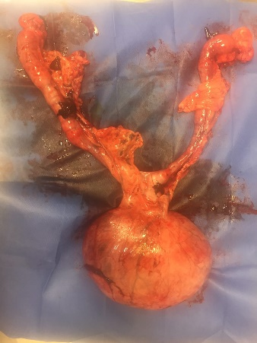 | B  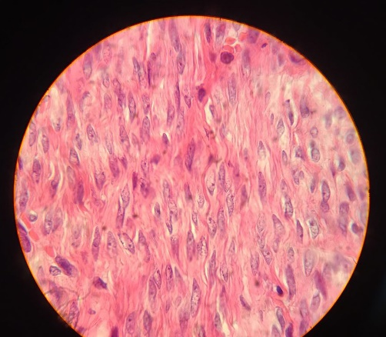

A) Macroscopic view of the mass in cervix
B) Spindle cells with granular chromatin, variable nucleoli
Recent Publications (minimum 5)
1. Maxie, Grant. Jubb, Kennedy & Palmer's Pathology of Domestic Animals-E-Book. Vol. 3. Elsevier Health Sciences, 2015, pp: 380-402.
2. Nelson, Richard W., and C. Guillermo Couto. Small animal internal medicine. Elsevier Health Sciences, 2014, pp:885-981.
3. McDonald, Leslie Ernest. "Veterinary endocrinology and reproduction." Veterinary endocrinology and reproduction. (1969).
4. Morris, Joanna, and Jane Dobson. Small animal oncology. John Wiley & Sons, 2008, pp:166-183.
5. Sapierzyński, R., et al. "Tumors of the urogenital system in dogs and cats. Retrospective review of 138 cases." Pol. J Vet. Sc 10 (2007): 97-103.

Email: Mh.kh212@gmail.com

