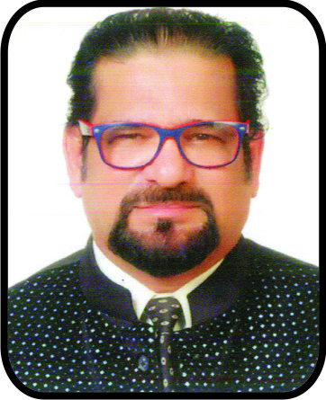

Title: Vascular Dementia and Neurodegenerative Disorders are not subjects of Allopathic but belongs to ancient Ayurvedic Science.
OBSTRACT
According to our long research & many case studies we have arrived to conslution that vascular dementia and neurodegenerative disorders like alzheimer dementia, parkinson etc. are soul related disorders. There is no defination of the soul in Allopathic Science that considers human body is an object. However ancient Ayurvedic science has a perfect defination for soul that navigate the body throught mind and invisible nerve system. We shall be discussing and uncovering the facts of these killer disorders human-race is suffering from and we know how to defeat them.
Biography
Name : Dr. Nazim Sattar Padvekar
Date of Birth : 03-03-1967
Educational Qualification :
(1) B.Com. Bombay University
(2) MBA - New Port University, California via K. C. College Mumbai.
(3) Ph.D. - in Environment Science with New Port University.
(4) Post Graduate Diplomas -
(A) Computer Management from C.T.C. Mumbai.
(B) Advertising & Marketing from R.C.C. Mumbai.
(C) Marketing Management from I.I.M. Delhi.
(D) Marketing & Laguage Command - W.T.C. Dubai.
Exeperience & Executions :
Visited more than 50 countaries and still travelling in the quest of knowledge & has vast academic & research execution and analytical experience. He is advocating negative carbon and neutral carbon world and to curb down carbon emission, green house gases and global warming. He is researching to combat and defeat cancer, cardiovascular diseases & neurological disorders everseens 1998 an invented Ayurvedic drugs. He would be speacking & presenting widely on these subjects.
Presenting author details
Full name: Dr. Nazim Sattar Padvekar
Contact number: 00918459422776
Twitter account: @DrPadvekar
Linked In account: Dr. Nazim Padvekar
Session name/ number: Vascular Dementia
Category: (Oral presentation/ Poster presentation/Workshop) All

