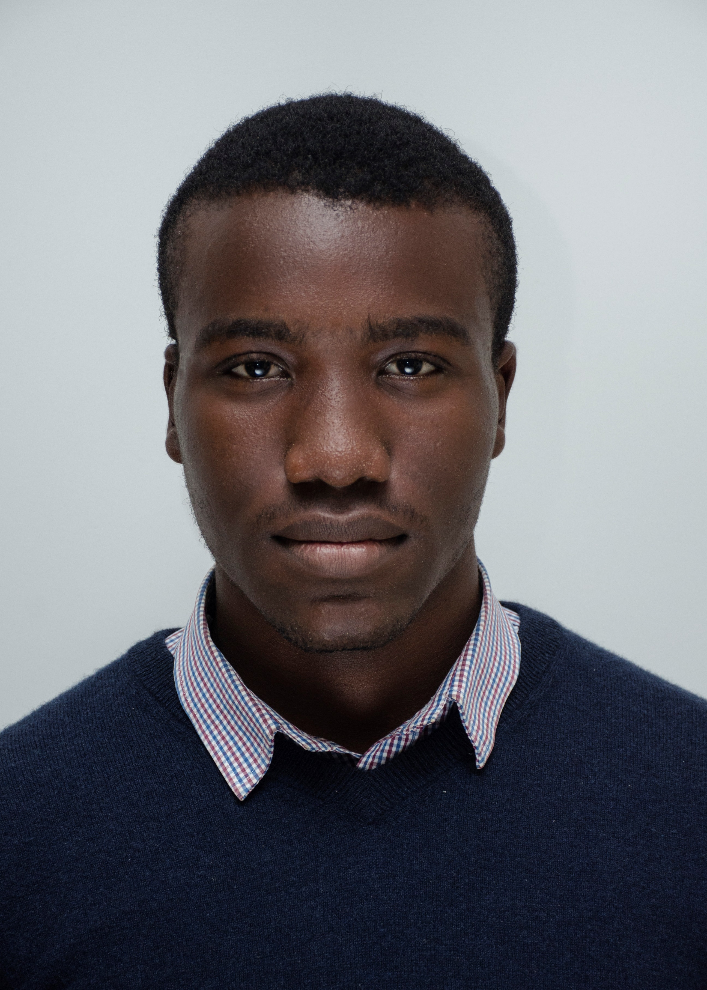
A STUDY ON THE CORRELATION AND IMPACT OF THE COVID19 PANDEMIC ON DEMENTIA IN AFRICA.
OTOBO D. Daniel
College of Medicine and Health Sciences, Bingham University, Nigeria
With an already poorly understood epidemiology of dementia in Africa, the aim of this study was to gather available evidence on the correlation between dementia and the covid pandemic. MEDLINE, PUBMED, Academia and Google Scholar were searched for epidemiological studies on correlation and impacts of the covid-19 pandemic on the burden and outcome of dementia in Africa. Crude estimates were pooled using random effects of meta-analysis. The keywords used for the search were Dementia, COVID-19 and Africa. The inclusion criteria were; An epidemiological study on Dementia, A study conducted in or with African data and A study on the Covid-19 pandemic and dementia. The searches returned 127 studies, of which 4 were selected based on the inclusion criteria. These included 100 536 individuals with a median age of 67.5 years. The Disability Adjusted Life Years (DALY) and the Death prevalence due to dementia were 124.36/100,000 [110.22-140.48] and 9.22/100,000 [8.06-10.47], respectively in sub-Saharan Africa. COVID19 Complicated Dementia mortalities were higher in High Income and High Middle-Income countries than in Lower middle income and Low-Income Countries. HIV was more associated with a fatal COVID19 outcome in Africa than dementia. However, this was also a risk factor for HIV Dementia. There was an increase in poor mental health and depression amongst patients with dementia during the lockdown.
Conclusion
The study shows that there was a positive correlation between COVID19 and the burden of dementia in Africa, but not Dementia Mortalities. Other comorbidities were associated with higher COVID19 complicated mortalities.

BIOGRAPHY
Daniel OTOBO is a 24-year-old final year medical student of the college of medicine, Bingham University. He is the Vice-President External of the International Students Surgical Network (InciSioN) Nigeria. He is also the Co-Director of the African Healthcare Students Summit (AHESS). He is an active member of over 10 international health associations globally. He has over 20 scientific publications to his name. His first medical public lecture was on Emergency Neurology and Neurosurgical interventions in ICP managements in Nigeria. He plans to go for his masters in Neuroscience after his graduation in February 2022. His specialty of interest is Neurosurgery.
PRESENTING AUTHOR
Full Name: OTOBO Daniel David
Contact Number: +2349031900225
Twitter Account: OTOBO D. Daniel
Linked In Account: Daniel D., OTOBO
Session name/number: Dementia Nursing
Category: Oral Presentation

