Animals models of Chronic Cerebral Hypoperfusion and its Impact on the Brain
Karim Khallout PhD, France

Abstract (300 word limit)
Various models have been advanced to study the effect of hypoperfusion on the brain. Stroke models have been used to investigate the short-term effects of vascular occlusion. Focal disruption of the blood supply to specific regions leads to an infarction, or pannecrosis, and neurological signs and symptoms appropriate to the territory irrigated. In apposition to stroke experiments, the chronic cerebral hypoperfusion model aims to investigate an extended period of global CBF (Cerebral Blood Flow) hypoperfusion without reperfusion where there is no ischaemic core and penumbral region, and the neuropathological outcome is less severe than that seen in “stroke” models (Farkas et al., 2007). Rodents have been commonly used as models for chronic cerebral hypoperfusion due to their economic and ethical acceptability (Ginsberg and Busto, 1989). Damage that occurs in those hypoperfusion models is not exclusive to the white matter. In rodents, the white/grey matter ratio is much lower than in human (Hagberg et al., 2002). A number of studies have demonstrated that chronic cerebral hypoperfusion is one of the primary causes that contributes to memory impairment and vascular dementia. In conclusion, chronic cerebral hypoperfusion, induced by a decrease in diameter of the conducting arteries, provokes clear white matter pathology without the necrotic infarction associated with stroke, and it is a major risk for cerebral white and grey matter injury. To further determine the mechanisms of white and grey matter pathology with time in this model, an extension of studies in the chronic cerebral hypoperfusion model is necessary. If one accepts the postulate that, in the face of a mild but long-lasting perfusion, white matter pathology is the most precocious precursor of later widespread, irreversible neuronal loss, then the possibility for future preventative and therapeutic approaches is opened. At this moment in time such approaches (modulation of the functionality of cerebral endothelial cells, stem cell grafts in critical white matter tracts) remain both hypothetical and conjectural.

Image
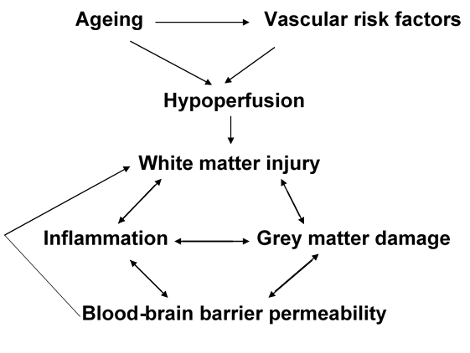
Proposed Pathway for the development of white matter pathology. Ageing associated with vascular risk factors are the main causes of the development of white matter damage. BBB permeability may occur at a later stage which would further exacerbate the injury to white matter.
Recent Publications
- Khallout K (2016) The Impact of Chronic Cerebral Hypoperfusion on the Brain Lambert Academic Publishing.
- Holland PR, Bastin M, Jansen MA, Merrifield GD, Coltman RB, Scott F, Nowers H, Khallout K, Marshall I, Wardlaw JM, Deary IJ, McCulloch J, Horsburgh K. (2011) MRI is a sensitive marker of subtle white matter pathology in hypoperfused mice. Neurobiology of aging.

 Biography (150 word limit)
Karim Khallout graduated with a PhD in Neuroscience at University of Edinburgh and as attested by his academic training, his career has been essentially centred on vascular biology and neurodegenerative diseases.
Email: k.khallout@gmail.com

Notes/Comments:

