Leading Transformation in Healthcare and the role of Emotional Intelligence
Jacqueline A. Hinds, MA (HRD) CEIC MCIPD, UK

Abstract (300 word limit)
Statement of the Problem: Leading transformation in healthcare has tremendous advantage in improving the services, patient experience and care within the National Health Service (NHS). It also bears the scars and, has had a significant impact on staff undergoing the transformation and, in a large majority of cases, impairing their duty of care to the patients and services under their care. The concept of Emotional Intelligence (EI) in healthcare, although not referred to or identified as an integral part of the healthcare infrastructure, is in reality interwoven into everything that is delivered as part of a service provision. In fact, EI is crucial throughout all levels of employees within healthcare and not just senior managers or leaders; the knowledge of EI enables individuals to understand their emotions, emotional meanings and to, reflectively regulate these emotions whilst transitioning through change initiatives and periods of significant and, sometimes, rapid transformation. Not all healthcare transformational projects have been successful in the past, some have been more transactional and results driven, which has led to employees feeling pressured and disturbed about the changes that were taking place and, more often than not, being emotionally unstable or stressed as a result of the changes at that juncture. Experiences within two of the largest merged healthcare organisations in the UK, has brought forth a cornucopia of knowledge and experience around leading transformational change in the healthcare and the role of emotional intelligence. Experiences in effective transformational change and, the fallout of transactional change initiatives, has resulted over the years in a significant rise in organisations requesting external consultants to deliver conflict resolution and more recently, anger management training within their establishments. The presentation will highlight some examples of where Emotional Intelligence has made a significant contribution to leading smoother transformation initiatives within the healthcare.

Image
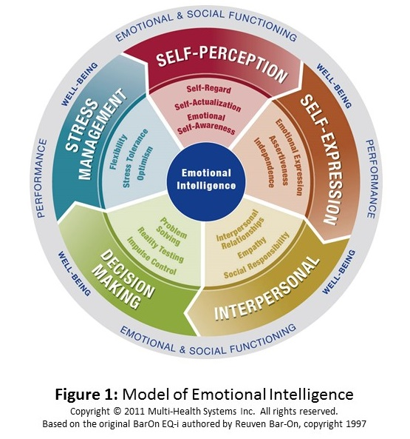


Biography (150 word limit)
Jacqueline is a certified Emotional Intelligence Coach (CEIC) and Leadership Consultant and, has worked within the National Healthcare Service for over 10 years; in two of the largest merged healthcare organisations in the UK. With thirty years’ experience working within the human resource development arena has been paramount whilst working with management and staff during organisational changes; establishing and enabling them to be emotionally intelligent during mergers and organisational changes. From 2006 – 2010 she was the Leadership Development Consultant pre and post merge of Imperial College Healthcare NHS Trust (circa 10,000 staff) and, from 2010 – 2015 she was Education Academy Training Manager pre and post merge of Barts Health NHS Trust (circa 15,000 staff). She is now chair of the Society of Emotional Intelligence, UK Chapter and an independent consultant working on various coaching assignments, women’s empowerment programmes, personal and leadership development projects in the community.
Email: jah@wilsonhindsconsulting.com

Notes/Comments:

