An mRNA-based vaccine technology for next generation prophylactic vaccines
Rauch S., Lutz J., Lazzaro S., Schmidt K., Petsch B., Baumhof P., Heidenreich H., Fotin-Mleczek M.
CureVac AG, Tübingen, Germany

Abstract
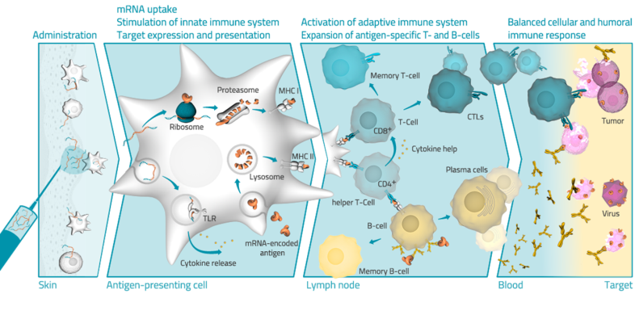
In recent years, messenger RNA (mRNA) based technologies have increasingly been applied in vaccine development (1). Such approaches have utilized mRNA for both therapeutic cancer vaccinations (2), and for prophylactic vaccines (3), drawing much attention from industrial and academic fields.
RNActive®, an mRNA based vaccination technology, has yielded promising results in the development of vaccines against a variety of viral pathogens such as RSV (respiratory syncytial virus), influenza, rabies, and ebola virus in several animal models. We have previously shown that intradermal (i.d.) application of RNActive® vaccines is able to confer protection against lethal influenza and rabies virus challenge infection in mice and induces protective levels of functional antibody responses against both viruses in domestic pigs (3, 4). However, having been optimized for i.d. application, immunological responses upon intramuscular (i.m.) injection of these mRNA vaccine formulations remained less efficient as yet.
Here, we describe an alternative formulation of RNActive® vaccines that is able to induce potent immune responses when applied intramuscularly using low doses (µg) of mRNA. Vaccination of mice with this RNActive® formulation encoding for influenza HA (hemagglutinin) or rabies G (glycoprotein) revealed an increase of both humoral and cellular immune responses, analyzed via functional antibody levels and ICS (intracellular cytokine staining) of T cells, respectively, compared to previous RNActive® formulations. Further experiments showed that this new vaccine formulation was able to induce potent and long lasting immune responses against influenza HA as well as high titers of rabies virus neutralizing antibodies in NHPs (non-human primates).

Image

Recent publications
- Schlake et al, (2012), Developing mRNA-vaccine technologies. RNA Biol. 9(11):1319-30
- Fiedler K, et al (2016), mRNA Cancer Vaccines, Recent Results Cancer Res.; 209:61-85
- Petsch et al. (2012), Protective efficacy of in vitro synthesized, specific mRNA vaccines against influenza A virus infection, Nat Biotechnol. 30(12):1210-6

Schnee et al. (2016), An mRNA Vaccine Encoding Rabies Virus Glycoprotein Induces Protection against Lethal Infection in Mice and Correlates of Protection in Adult and Newborn Pigs, PLoS Negl Trop Dis. 23;10(6)

Biography
Dr. Susanne Rauch works as a scientist at the CureVac AG where she is involved in the development of mRNA-based prophylactic vaccines. She has been trained as a postdoc at King’s College London and as a PhD student at the Universitätsklinikum Heidelberg where her work was focused on the biology of different viruses such as HIV-1, MLV and herpesviruses.
Email: susanne.rauch@curevac.com

Notes/Comments:

