Structural Basis for Recognition of Human Enterovirus 71 by a Bivalent Broadly Neutralizing Monoclonal Antibody
Yao Cong, National Center for Protein Science Shanghai, Shanghai Institutes for Biological Sciences, Chinese Academy of Sciences, Shanghai, China

Abstract (300 word limit)
Enterovirus 71 (EV71) is the main pathogen responsible for hand, foot and mouth disease with severe neurological complications and even death in young children. We have recently identified a highly potent anti-EV71 neutralizing monoclonal antibody, termed D5. Here we investigated the structural basis for recognition of EV71 by the antibody D5. Four three- dimensional structures of EV71 particles in complex with IgG or Fab of D5 were recon- structed by cryo-electron microscopy (cryo-EM) single particle analysis all at subnanometer resolutions. The most critical EV71 mature virion-Fab structure was resolved to a resolution of 4.8 Å, which is rare in cryo-EM studies of virus-antibody complex so far. The structures reveal a bivalent binding pattern of D5 antibody across the icosahedral 2-fold axis on mature virion, suggesting that D5 binding may rigidify virions to prevent their conformational changes required for subsequent RNA release. Moreover, we also identified that the com- plementary determining region 3 (CDR3) of D5 heavy chain directly interacts with the extremely conserved VP1 GH-loop of EV71, which was validated by biochemical and viro- logical assays. We further showed that D5 is indeed able to neutralize a variety of EV71 genotypes and strains. Moreover, D5 could potently confer protection in a mouse model of EV71 infection. Since the conserved VP1 GH-loop is involved in EV71 binding with its uncoating receptor, the scavenger receptor class B, member 2 (SCARB2), the broadly neu- tralizing ability of D5 might attribute to its inhibition of EV71 from binding SCARB2. Alto- gether, our results elucidate the structural basis for the binding and neutralization of EV71 by the broadly neutralizing antibody D5, thereby enhancing our understanding of antibody- based protection against EV71 infection.

Image

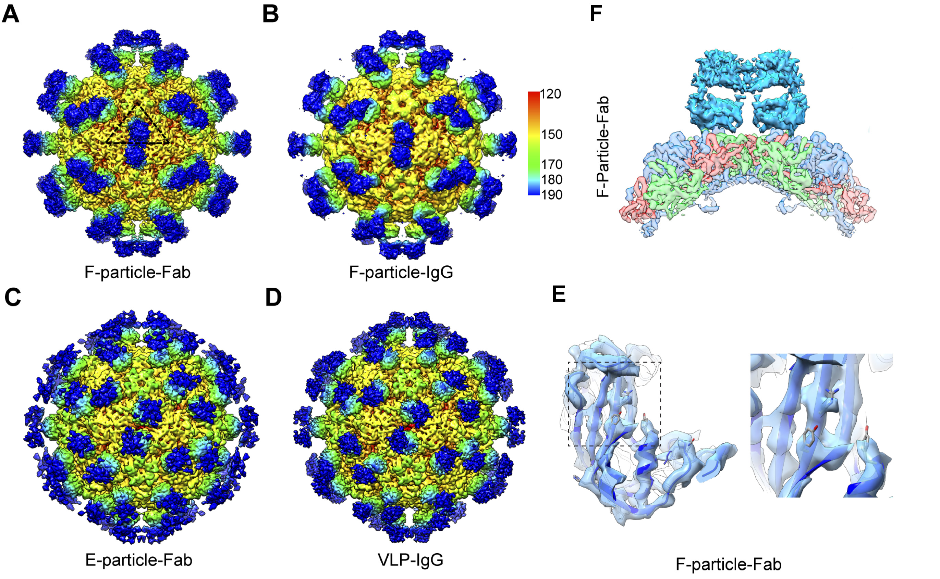
Figure 1. Cryo-EM maps of different EV71 particles or VLP in complex with D5 Fab or intact IgG and close-up views of the antibody-virus junction.
Recent Publications (minimum 5)
- Chen J, Zhang C, et al, Huang Z* and Cong Y* (2018) A 3.0-Angstrom Resolution Cryo-Electron Microscopy Structure and Antigenic Sites of Coxsackievirus A6-Like Particles. Journal of Virology, 92: e01257-17
- Fan C, Ye X, et al, Cong Y*, Huang Z*. (2017) Beta-propiolactone inactivation of coxsackievirus A16 induces structural alteration and surface modification of viral capsids. Journal of Virology 91:e00038-17.
- Ding Z, Fu Z, et al, Cong Y*. (2017) High-resolution cryo-EM structure of the proteasome in complex with ADP-AlFx. Cell Research, 27:373–385.
- Zang Y, Jin M, et al, Cong Y*. (2016) Staggered ATP-binding mechanism of eukaryotic chaperonin TRiC/CCT revealed by high-resolution cryo-EM. Nat Struct Mol Biol, 23(12):1083-1091.
- Ye X, Fan C, et al, Huang Z*, Cong Y*. (2016) Structural Basis for Recognition of Human Enterovirus 71 by a Bivalent Broadly Neutralizing Monoclonal Antibody. PLoS Pathogens, 12(3):e1005454.

 Biography (150 word limit)
Yao Cong and her laboratory are focused on elucidating the ATP-driven activation and substrate processing mechanisms of two protein quality control macromolecular machines including eukaryotic chaperonin TRiC/CCT and proteasome, and the structural basis for vaccine and drug development against causative agents of hand-foot and mouth disease. Accompanying this is an effort to develop new technologies for accurate subunit identification through cryo-EM analysis.
Email: cong@sibcb.ac.cn
Phone: +86-21-21778199

Notes/Comments:

