Cytokine storm in tuberculosis and IL-6 involvement
Funmilayo Grâce Boni, China

Abstract (300 word limit)
Statement of the Problem: Tuberculosis is probably the most seasoned illness of the humanity. Intricacies or subsequent death emerging from these infections are frequently connected with cytokine storm. Interleukin-6 (IL-6) plays a crucial role in the immune response to tuberculosis. Therefore, there is a need to research some new therapeutic approaches to block IL-6 signaling that are right now being applied to the M. tuberculosis. In this review, we investigate the implication of IL-6 in the context of tuberculosis research. Methodology & Theoretical Orientation: Summary of studies demonstrating the implication of IL-6 in the inflammation. The recapitulation of the repurposing of anti-IL-6 therapeutics for TB. Findings: in this study：Cytokine storm in tuberculosis can be targeted via the JAK/STAT pathways. Therapeutic avenues dampening IL-6 can quell the storm. Conclusion & Significance: An understanding of monocyte- and macrophage-mediated IL-6 release as part of the “cytokine storm” has played a role in a greater understanding of TB. IL-6 was identified as a major driver of disease severity in TB. TB patients should therefore be treated with anti-IL-6 therapeutics, as blunting IL-6 production may be advantageous in attenuating “cytokine storm” from TB. Researches on TB, are making tocilizumab and other anti IL-6 therapeutic approaches available to TB patients, who are believed to face an elevated mortality from complications of M. tuberculosis.

Image
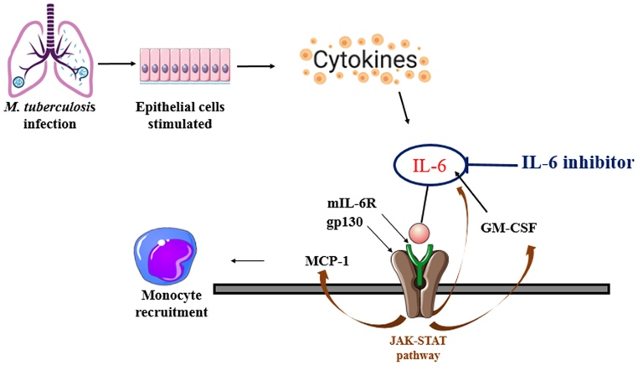
Figure. 1. Targeting cytokine storm in TB via the JAK-STAT pathway. During a cytokine storm, elevated concentration of IL-6 can lead to the formation of a complex with mIL-6R to act on gp130.

Recent Publications (minimum 5)
- Ai, J.-W., Ruan, Q.-L., Liu, Q.-H., Zhang, W.-H., 2016. Updates on the risk factors for latent tuberculosis reactivation and their managements. Emerg. Microb. Infect. 5, 1–8.
- Al-Aska, A.I., Al-Anazi, A.R., Al-Subaei, S.S., Al-Hedaithy, M.A., Barry, M.A., Somily, A. M., Buba, F., Yusuf, U., Al Anazi, N.A., 2011. CD4+T-lymphopenia in HIV negative tuberculous patients at King Khalid University Hospital in Riyadh, Saudi Arabia. Eur. J. Med. Res. 16, 285–288. https://doi.org/10.1186/2047-783x-16-6-285.
- Bhatt, M.L.B., Kant, S., Bhaskar, R., 2012. Pulmonary tuberculosis as differential diagnosis of lung cancer. South Asian J. Cancer 1, 36.
- Bost, P., Giladi, A., Liu, Y., Bendjelal, Y., Xu, G., David, E., Blecher-Gonen, R., Cohen, M., Medaglia, C., Li, H., Deczkowska, A., Zhang, S., Schwikowski, B., Zhang, Z., Amit, I., 2020. Host-viral infection maps reveal signatures of severe COVID-19 patients. Cell 181, 1475–1488.e12. https://doi.org/10.1016/j.cell.2020.05.006.
- Cantini, F., Nannini, C., Niccoli, L., Petrone, L., Ippolito, G., Goletti, D., 2017. Risk of tuberculosis reactivation in patients with rheumatoid arthritis, Ankylosing spondylitis, and psoriatic arthritis receiving non-anti-TNF-targeted biologics. Mediat. Inflamm. https://doi.org/10.1155/2017/8909834.

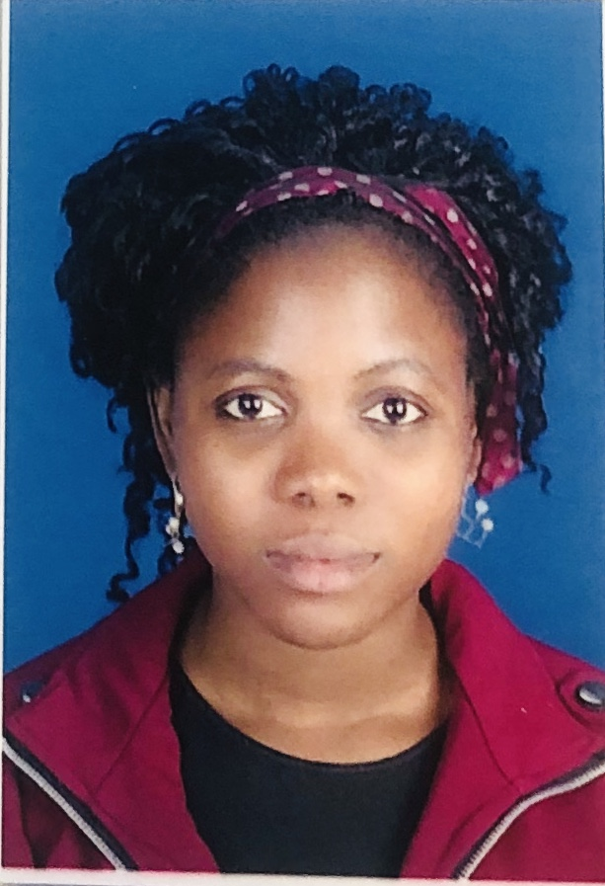Biography (150 word limit)
Paste your Logo here
Funmilayo Grâce Boni is currently a third year PhD student in Biochemistry and Molecular Biology at Southwest University, working under Professor Jianping Xie. Her thesis title is: Isolation and characterization of ethambutol resistant from transposon insertion library of M. tuberculosis. Her research is focused on ethambutol drug resistance. She is particularly interested in cytokine, drug resistance, and diagnosis and treatment of tuberculosis. She has spoken at a number of conference and has published book reviews. She can be contacted at:
Email: bonigrace22@gmail.com

Notes/Comments:

Presenting author details
Full name: Funmilayo Grâce Boni
Contact number: +22952510685 or +22953451450
Twitter account: DrLagrace
Linked In account: BONI Grace
Session name/ number:
Category: (Oral presentation/ Poster presentation)

